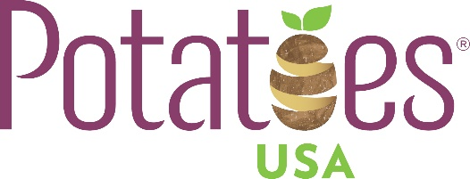

Diversity Statement

The National Potato Promotion Board, d/b/a Potatoes USA, does not discriminate on the basis of race, color, national origin, sex, religion, age, disability, protected genetic information, or reprisal. Potatoes USA agrees that it will fully comply with any and all applicable Federal, State, and local equal employment opportunity statues, ordinances, and regulations, including, but not limited to, Title VII of the Civil Rights Act of 1964; the Americans with Disabilities Act of 1990; the Age Discrimination in Employment Act of 1967; Genetic Information Act of 2008; and the Equal Pay Act of 1963.

Persons requiring alternative means of program communication (Braille, large print, audiotape, etc.) or mobility assistance should contact Potatoes USA at (303) 369-7783. Additionally, program information may be made available in languages other than English.

To file a program complaint, a complainant should complete the form AD-3027, USDA Program Discrimination Complaint Form, found at: https://www.usda.gov/oascr/how-to-file-a-program-discriminationcomplaint, from USDA by calling (866) 632-9992, or by writing a letter addressed to USDA. The letter must contain the complainant’s name, address, telephone number, and a written description of the alleged discriminatory action in sufficient detail to inform the Assistant Secretary for Civil Rights (ASCR) about the nature and date of an alleged civil rights violation. The completed AD-3027 form or letter must be submitted to USDA via mail, fax, or email. Contact information provided below.

Mail: U.S. Department of Agriculture
Office of the Assistant Secretary for Civil Rights
1400 Independence Avenue, SW
Washington, D.C. 20250-9410

Fax: (202) 690-7442

Email: program.intake@usda.gov

