South of the Border Mashed Potato Board
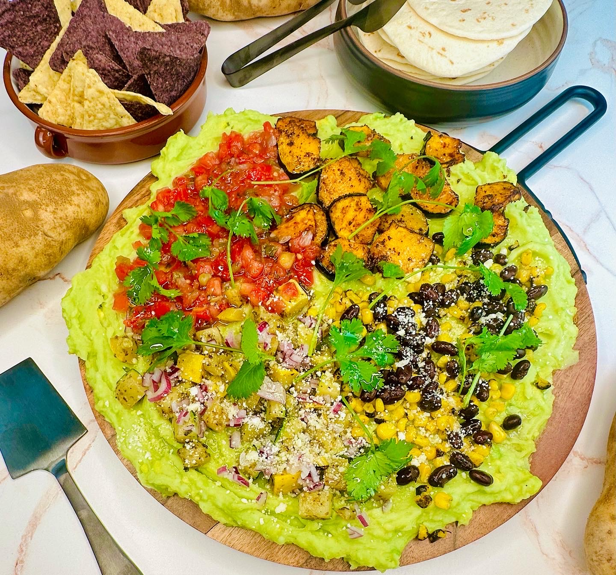

Program: Consumer
Short Description: south of the border inspired mashed potato dip
Long Description: Avocado mashed potatoes topped with fire-roasted corn, black beans, chili lime spiced acorn squash, sauteed zucchini, and yellow squash with oregano and cumin, Pico de Gallo, red onion, queso fresca, and cilantro
Servings/portion size: 10
Preparation Time: 20 minutes
Cooking Time: 20 minutes
Total Time: 40 minutes
Potato Type: Russet potatoes
Course: Brunch, Lunch, Dinner, Snack, Side, Appetizer
Ingredients:
Avocado Mashed Potatoes
- 5 each (726 g) Russet Potatoes
- 3 each (450 g) Avocados
- ½ cup (118 ml) Lemon Juice
- ½ tbsp (9 g) Salt
- ½ tbsp (7 g) Black Pepper Ground
- ¼ cup (60 ml) Olive Oil
On the side:
- 1 package Flour tortillas, Street (Optional)
- 1 package Corn Tortilla Chips (Optional)
Toppings:
- ½ cup (86 g) Black Beans
- ½ cup (75 g) Fire Roasted Corn
- ¼ cup (13 g) Red Onion (Diced)
- ¼ cup (30 g) Queso Fresca, Crumbled

Chili Lime Spiced Acorn Squash:
- 1 cup (205 g) Acorn Squash (Sliced)
- 1 tbsp (15 ml) Olive Oil
- 1 tbsp (17 g) Chili Lime Seasoning
- ½ tbsp (6 g) Cumin
- ½ tsp (4 g) Salt
- ½ tsp (2 g) Black Pepper, Ground
- ½ tsp (2 g) Smoked paprika
- ½ tsp (2 g) Chili powder
Sauteed Zucchini and Yellow Squash:
- ½ cup (87 g) Zucchini (Diced)
- ½ cup (87 g) Yellow Squash (Diced)
- 1 tbsp (15 ml) Olive oil
- 1 tbsp (12 g) Cumin
- 1 tbsp (3 g) Oregano, Dried
- ½ tsp (4 g) Salt
- ½ tsp (2 g) Black Pepper, Ground

Preparation:
- Gather all ingredients and equipment needed.
- Preheat oven to 400°F (204°C).
- Rinse and peel russet potatoes, then cut them into small cubes, place in a large pot and fill with enough water to cover the potatoes. Then turn on to high heat and bring to a boil, then reduce heat to a simmer and cook potatoes for 30 minutes or until they are fork tender. Drain water and shake off excess liquids. And then place potatoes in a bowl, and add roasted garlic then using a food mill, hand/stand mixer, or a fork, mash potatoes until smooth or desired consistency. Let cool and set aside.
- To make chili lime spiced corn squash, in a bowl, add sliced acorn squash, olive oil, chili lime seasoning, cumin, salt, black pepper, smoked paprika, and chili powder and toss until fully mixed. place seasoned acorn squash onto a parchment paper lined baking tray and place into the oven. Roast acorn squash for 15 minutes or until slightly charred and soft. Remove the tray from the oven and let it cool.
- To make sauteed zucchini and yellow squash, in a large bowl, add diced zucchini and yellow squash and olive oil, salt, black pepper, cumin, and oregano then toss until fully coated. Then in a frying pan or skillet on medium-high heat, add a little olive oil and add seasoned zucchini and yellow squash, and sauté for 5-7 minutes. Then set aside.
- In a large bowl, add mashed potatoes, avocado, lemon juice, olive oil, salt, and black pepper, and using a fork, smash avocados into mashed potatoes until fully incorporated.
- To make board, spread avocado mashed potatoes on board evenly then top with black beans, fire-roasted corn, red onions, chili lime acorn squash, sauteed zucchini and yellow squash, pico de gallo, crumbled queso fresca and garnish with cilantro leaves.

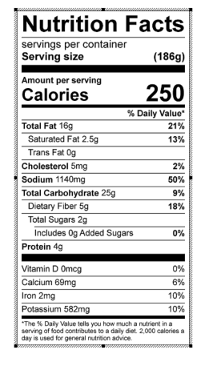
Vitamin C: 25.55 mg

