Greek Isles Mashed Potato Board
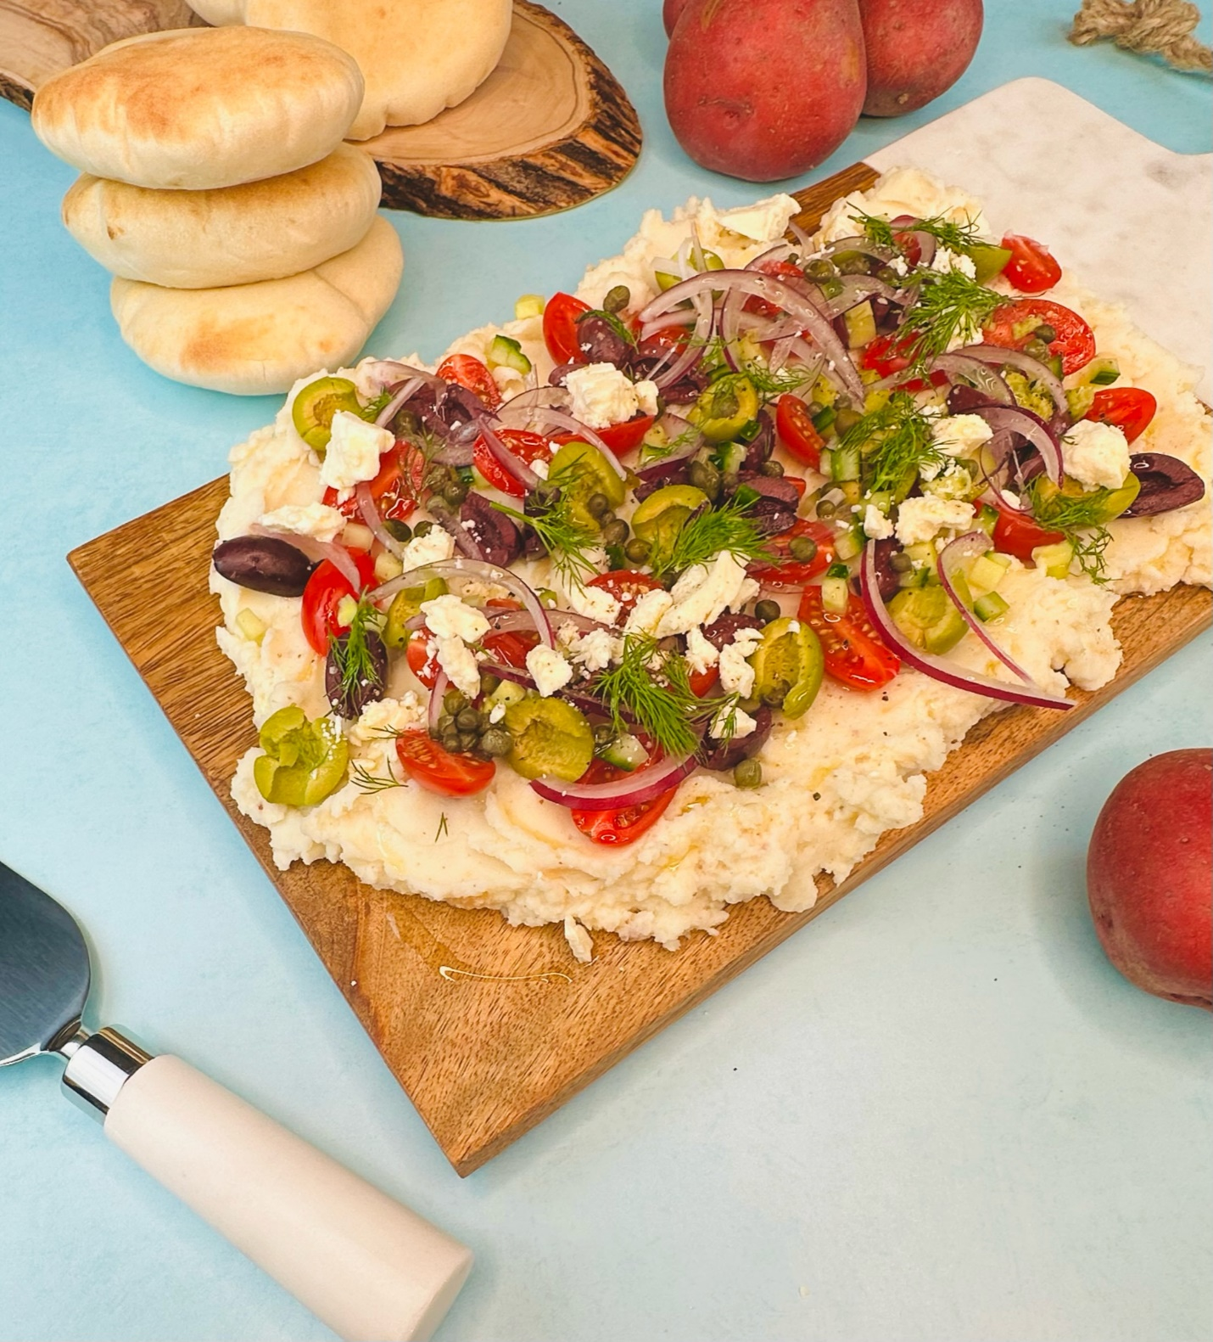

Program: Consumer
Short Description: A fun way to utilize leftover mashed potatoes!
Long Description: Red mashed potatoes flavored with roasted garlic and lemon juice topped with kalamata and green olives, thinly sliced red onions, cherry tomatoes, cucumbers, crumbled feta cheese, and dill.
Servings/portion size: 10
Preparation Time: 30 minutes
Cooking Time: 20 minutes
Total Time: 40 minutes
Potato Type: Red Potatoes
Course: Brunch, Lunch, Dinner, Snack, Side, Appetizer
Ingredients:
Roasted garlic mashed potatoes:
- 5 each (726 g) Red Potatoes
- ½ cup (48 g) Almond Meal
- ½ cup (152 g) Roasted Garlic
- ¼ cup (60 ml) Olive Oil
- ¼ cup (60 ml) Lemon Juice
Toppings:
- ½ cup (90 g) Kalamata Olives (Halves)
- ½ cup (90 g) Green Olives (Halves)
- ½ cup (120 g) Cucumbers (Diced)
- ½ cup (100 g) Cherry Tomatoes (Halves)
- ¼ cup (30 g) Capers
- ½ cup (75 g) Feta Cheese (Crumbles)
- ¼ cup (3 g) Dill, Fresh
- ½ tbsp (9 g) Salt
- ½ tbsp (7 g) Black Pepper, Ground
On the side:
- 1 package Pita Bread (Optional)

Preparation:
- Gather all ingredients and equipment needed.
- Rinse and peel red potatoes, then cut them into small cubes, place in a large pot, and fill with enough water to cover the potatoes. Then turn on to high heat and bring to a boil, then reduce heat to a simmer and cook potatoes for 30 minutes or until they are fork tender. Drain water and shake off excess liquids. And then place potatoes in a bowl, and add roasted garlic then using a food mill, hand/stand mixer, or a fork, mash potatoes until smooth or desired consistency. And let cool down and set aside.
- In a frying pan or skillet, on low medium heat, add oil and garlic cloves and slowly cook until soft and comes to a translucent light golden-brown color.
- In a large bowl, add mashed potatoes, roasted garlic, almond meal, lemon juice, salt, and black pepper, and mix incorporated fully.
- To serve, spread mashed potatoes evenly onto the board and top with cherry tomatoes, kalamata olives, green olives, red onions, cucumbers, capers, feta cheese crumbles, and dill, then finish with a drizzle of olive oil. Serve pita on the side (optional).

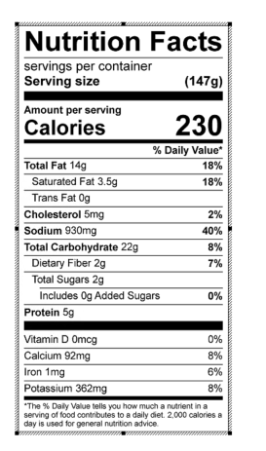
Vitamin C: 14.15 mg

