Fall Harvest Mashed Potato Board
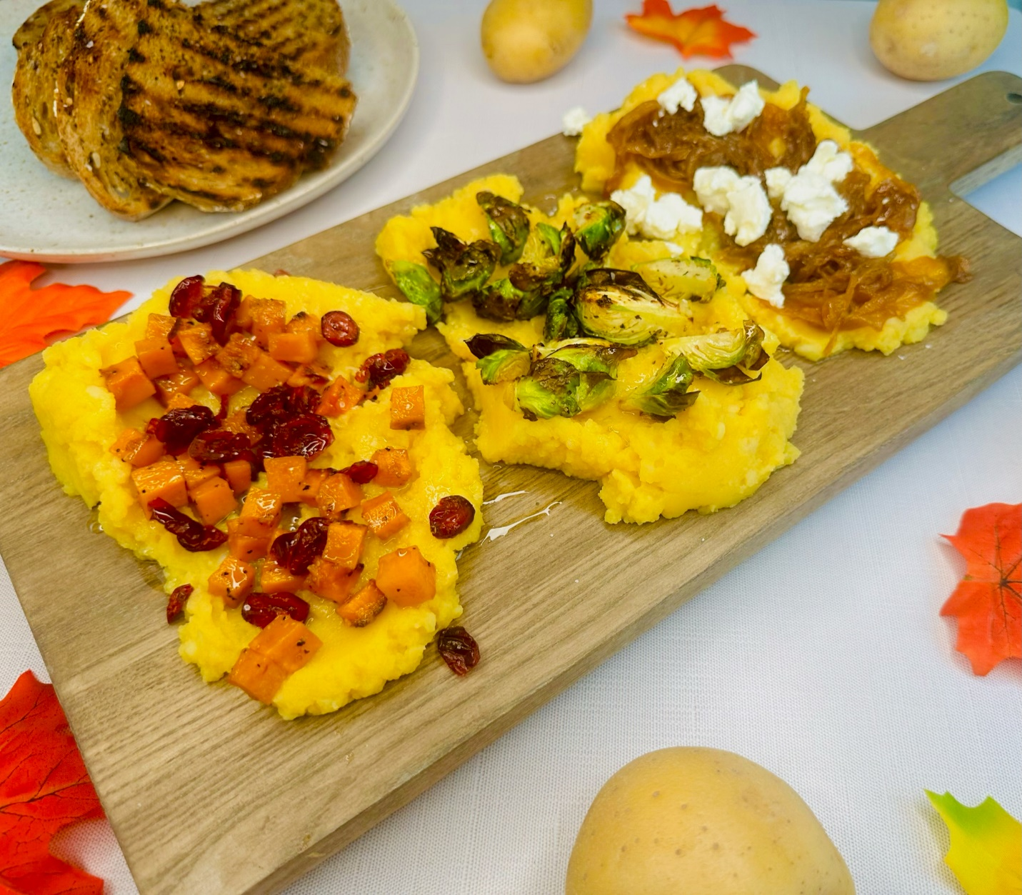

Program: Consumer
Short Description: All the flavors of Fall harvest on board
Long Description: A butternut squash mashed potato topped with maple glazed butternut squash, dried cranberries, roasted brussels sprouts, caramelized onions, and goat cheese.
Servings/portion size: 10
Preparation Time: 30 minutes
Cooking Time: 30 minutes
Total Time: 60 minutes
Potato Type: Yellow Potatoes
Course: Brunch, Lunch, Dinner, Snack, Side, Appetizer

Ingredients:
Butternut squash mashed potatoes:
- 5 each (726 g) Yellow Potatoes
- 1 cup (236 ml) Butternut Squash Soup, Pre-made
- ½ tsp (4 g) Salt
- ½ tsp (2 g) Black Pepper, Ground
Toppings:
- ½ cup (127 g) Goat Cheese, Crumbled
- ½ cup (65 g) Cranberries, Dried
Caramelized onions:
- 2 each (450 g) Yellow Onions
- 2 tbsp (30 ml) Olive Oil
- ¼ cup (60 ml) White Wine
- ½ tsp (4 g) Salt
Maple glazed butternut squash:
- ¼ cup (60 ml) Maple Syrup
- 1 cup (205 g) Butternut Squash, Diced
- 1 tbsp (15 ml) Olive Oil
- ½ tsp (4 g) Salt
- ½ tsp (2 g) Black Pepper, Ground
Roasted Brussels Sprouts:
- 1 cup (88 g) Brussels Sprouts
- 1 tbsp (15 ml) Olive Oil
- 1 tsp (7 g) Salt
- ½ tsp (2 g) Black Pepper, Ground
On the side:
- 1 package Multigrain Seeded Bread (Optional)

Preparation:
- Gather all ingredients and equipment needed.
- Preheat oven to 400°F (204°C).
- Rinse and peel yellow potatoes, then cut into small cubes, and place in a large pot and fill with enough water to cover potatoes. Then turn on to high heat and bring to a boil, then reduce heat to a simmer and cook potatoes for 30 minutes or until they are fork tender. Drain water and shake off excess liquids. And then place potatoes in a bowl, add roasted garlic then using a food mill, hand/stand mixer or a fork, mash potatoes until smooth or desired consistency. And let cool down and set aside.
- To make butternut squash mashed potatoes, in a large bowl, add mashed potatoes, butternut squash soup, salt, and black pepper and using a spatula or whisk, mix until fully incorporated. Set aside.
- To make maple glazed butternut squash, in a large bowl, add diced butternut squash, olive oil, maple syrup, salt, and black pepper and toss until fully coated. Then place butternut squash onto a parchment paper lined baking sheet and place in oven for 10-12 minutes or until soft and slightly charred. Remove from oven and let cool then set aside.
- To make roast brussels sprouts, rinse brussels sprouts and cut into quarters, place in a large bowl and add olive oil, salt, and black pepper and toss to fully coat. Then place on to a parchment paper lined baking sheet and roast on oven for 10-12 minutes or until crispy and slightly charred. Remove from oven, let cool, and set aside.
- To make caramelized onions, slice yellow onions, in a frying pan or skillet, on medium heat, add olive oil, yellow onions and salt and let brown for 10 minutes, occasionally stirring. Then add white wine and stir to deglaze, picking up the bits stuck on the bottom of the pan. Cook down for another 1-2 minutes until alcohol is cooked off and onions are brown in color. Turn off heat and set aside.
- To make the board, spread the butternut squash mashed potatoes evenly and top off with maple glazed butternut squash, dried cranberries, roasted Brussels sprouts, caramelized onions, crumbled goat cheese, and finish with a little drizzle of olive oil.
- Serve with toasted or grilled multigrain seeded bread (optional).

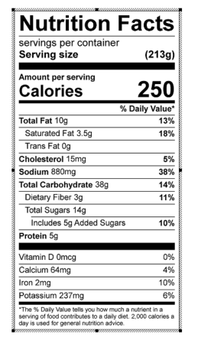
Vitamin C: 24.53 mg

