Bombay Sunset Mashed Potato Board
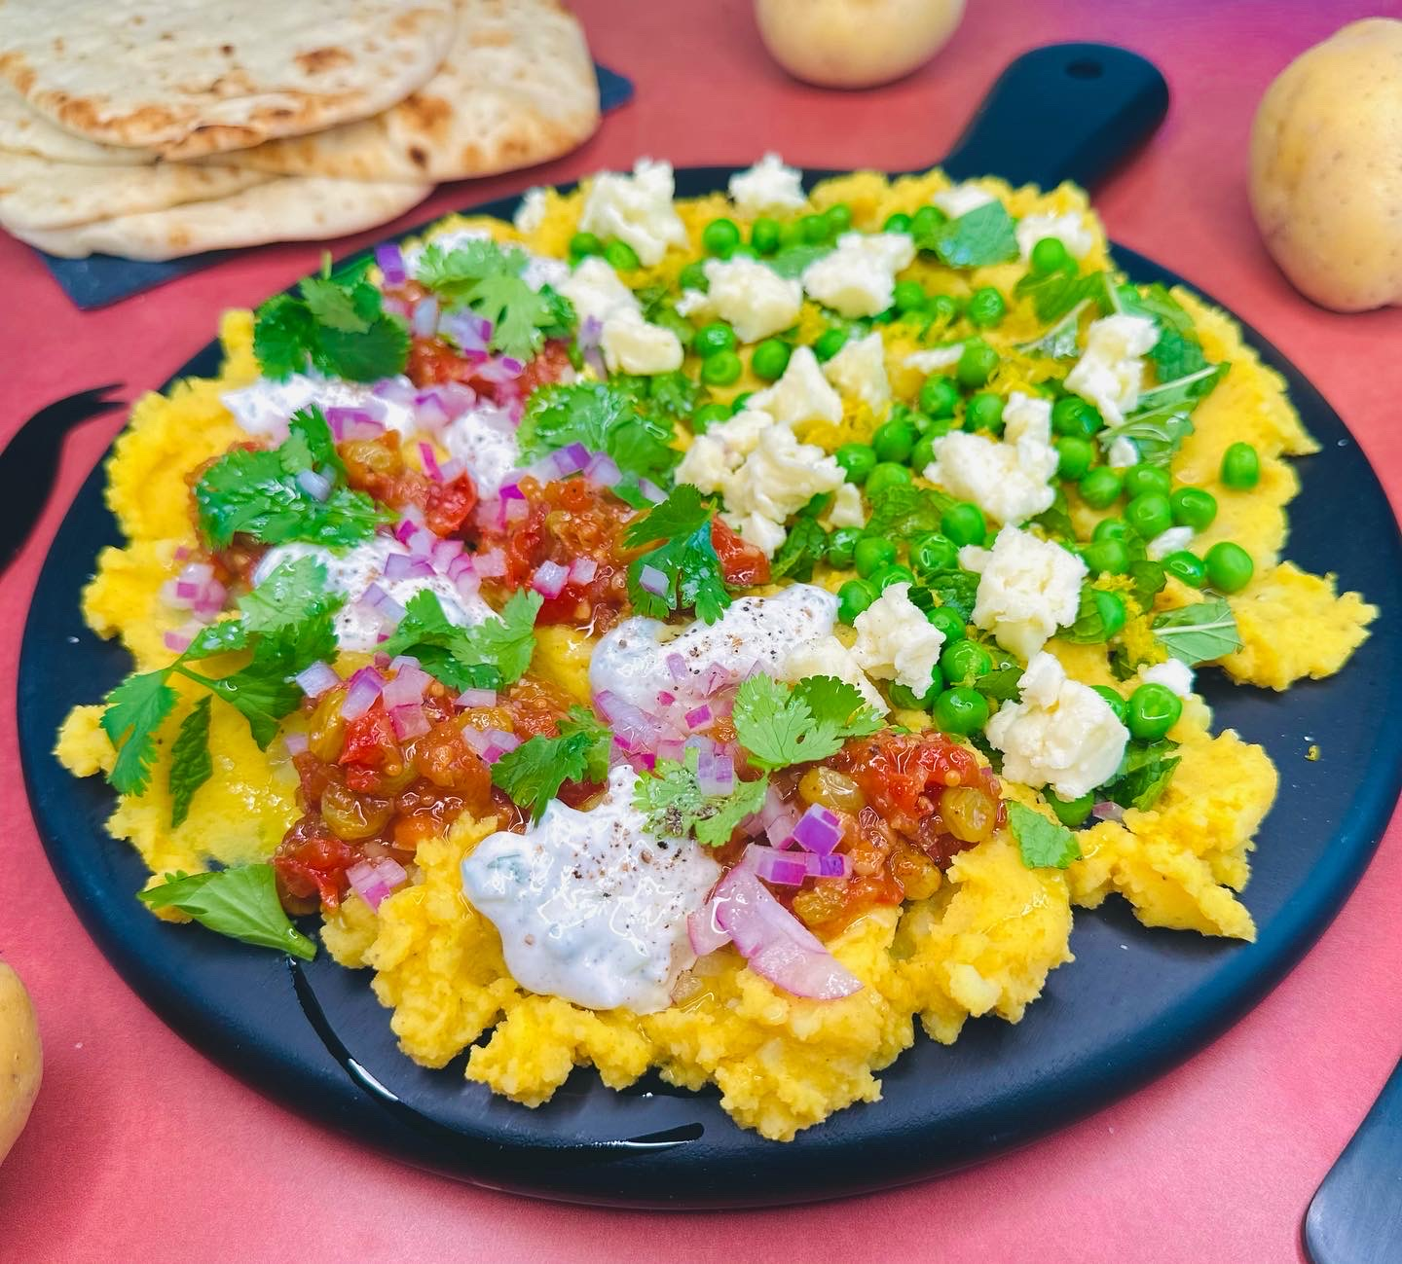

Program: Consumer
Short Description: Global flavors to spice up this fun way to present potatoes
Long Description: A coconut curried mashed potatoes topped with peas, paneer cheese, mint, lemon zest, raita, red onions, tomato chutney, and cilantro
Servings/portion size: 10
Preparation Time: 25 minutes
Cooking Time: 15 minutes
Total Time: 40 minutes
Potato Type: Yellow Potatoes
Course: Brunch, Lunch, Dinner, Snack, Side, Appetizer
Ingredients:
Coconut curried mashed potatoes:
- 5 each (726 g) Yellow Potatoes
- 2 tbsp (14 g) Curry Powder
- 1 cup (236 ml) Coconut Milk
- ½ tsp (4 g) Salt
- ½ tsp (2 g) Black Pepper, Ground
On the side:
- 1 package Naan Bread (Optional)
Toppings:
- ¼ cup (32 g) Peas
- 2 tbsp (4 g) Mint
- 2 tbsp (4 g) Cilantro
- ½ cup (100 g) Paneer, Crumbled
- ½ cup (26 g) Red Onions, Diced
- 1 tbsp (6 g) Lemon Zest
Raita:
- 1 cup (236 ml) Greek Yogurt
- 1 cup (120 g) English Cucumber, Fine Dice
- 1 tbsp (6 g) Cumin
- 2 tbsp (30 ml) Lemon Juice
- ½ tbsp (9 g) Salt
- 1 tsp (2 g) Black Pepper, Ground
Tomato chutney:
- 1 cup (200 g) Tomatoes, Diced
- 2 tbsp (30 ml) Olive Oil
- ¼ cup (13 g) Red Onion, Fine Dice
- 1 tbsp (8 g) Garlic, Fine Dice
- ¼ cup (40 g) Golden Raisins
- ½ cup (118 ml) Apple Cider Vinegar
- 2 tbsp (25 g) Brown Sugar
- 1 tsp (2 g) Curry Powder
- ½ tsp (1 g) Chili Powder
- ½ tsp (4 g) Salt

Preparation:
- Gather all ingredients and equipment needed.
- Rinse and peel yellow potatoes, then cut into small cubes, and place in a large pot and fill with enough water to cover potatoes. Then turn on to high heat and bring to a boil, then reduce heat to a simmer and cook potatoes for 30 minutes or until they are fork tender. Drain water and shake off excess liquids. And then place potatoes in a bowl, add roasted garlic then using a food mill, hand/stand mixer or a fork, mash potatoes until smooth or desired consistency. And let cool down and set aside.
- In a large bowl, add mashed potatoes, curry powder, coconut, salt, black pepper and mix until incorporated fully. Set aside.
- To make raita, in a medium bowl, add yogurt, cucumber, cumin, lemon juice, salt and black pepper then whisk together until fully mixed. set aside.
- To make tomato chutney, in a frying pan or skillet, on medium high heat, add olive oil, curry powder and chili powder and lightly toast spices until fragrant then add red onions and garlic and sauté. Then add red tomatoes, continue to sauté. Then add apple cider vinegar and brown sugar, golden raisins, and let reduce until chutney is thick. remove from heat and set aside.
- To make board, spread coconut curried mashed potatoes evenly on the board, and top off with peas, mint, paneer, raita, tomato chutney, and cilantro.
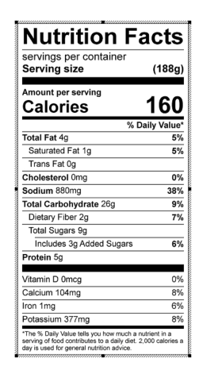
Vitamin C: 9.87 mg

