Turkey & Tater Trot Salad
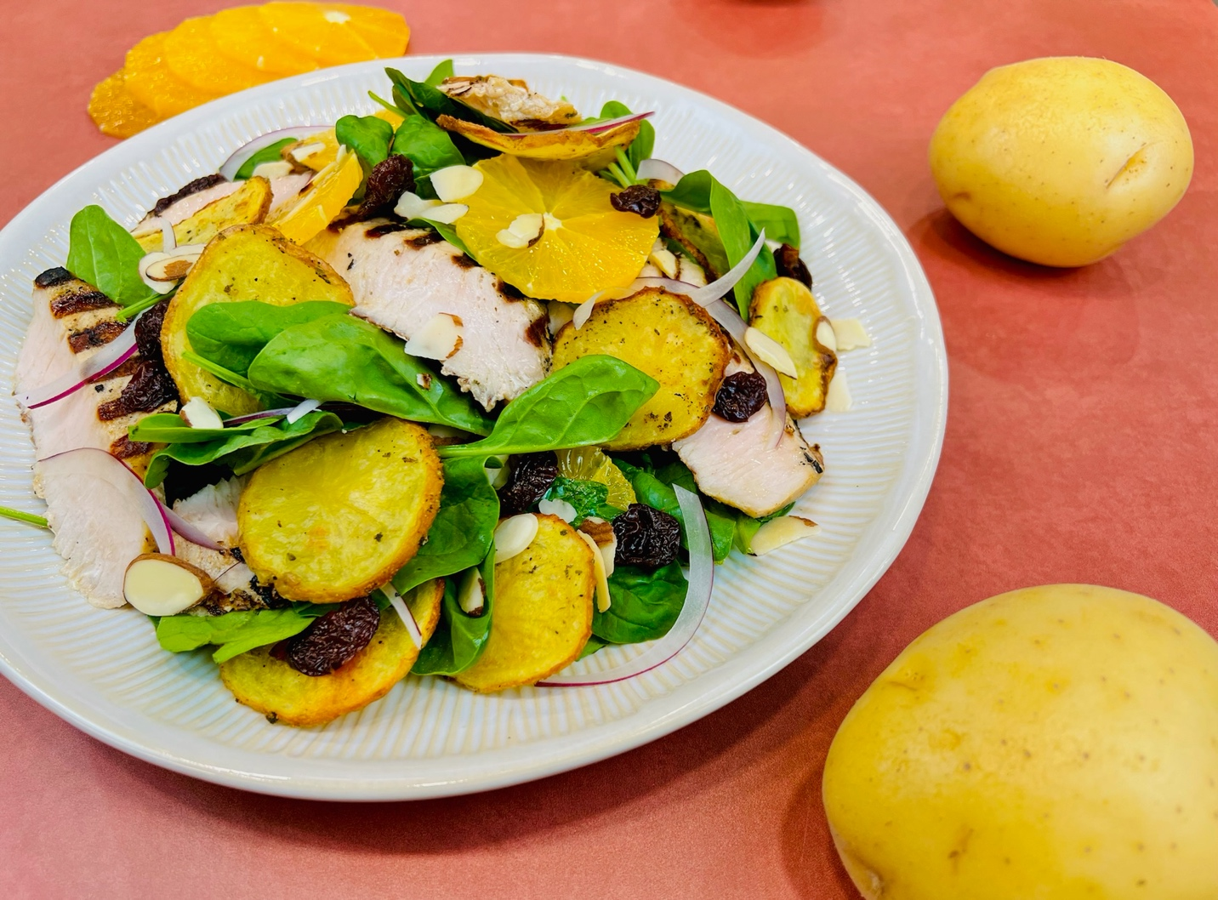
Program: Consumer
Short Description: A bright and delicious salad perked up by potatoes.
Long Description: Vibrant spinach, roasted potatoes, grilled turkey, almonds, cranberries, and oranges make this salad a fall treat. Enjoy the flavors of harvest while they last.
Servings/portion size: 4
Preparation Time: 15 minutes
Cooking Time: 25 minutes
Total Time: 40 minutes
Potato Type: Fresh Potatoes
Course: Salad, Side, Entrée, Lunch, Dinner

Ingredients:
Roasted Potato Slices:
- 1 pound (454g) Fresh Potatoes, sliced (any potato can be used in this recipe, we chose to use yellows)
- 1 tablespoon (15ml) Olive Oil
- 2 teaspoons (6g) Lemon Pepper Seasoning
- 2 teaspoons (4g) Rubbed Sage
Grilled Turkey Breast:
- 1 pound (454g) Turkey Breast, sliced into ½-inch pieces
- 1 tablespoon (15ml) Olive Oil
- 2 teaspoons (2g) Poultry Seasoning
- 2 teaspoons (6g) Sea Salt
Salad:
- 6 cups (180g) Baby Spinach
- ¼ cup (37g) Red Onion, thinly sliced
- ½ cup (92g) Sliced Almonds
- 2 each (120g) Navel Oranges, peel removed and sliced thin
- ¼ cup (32g) Dried Cranberries
Maple Mustard Vinaigrette
- 3 tablespoons (45ml) Maple Syrup
- 2 tablespoons (30ml) Whole Grain Mustard
- 3 tablespoons (45ml) Apple Cider Vinegar
- ¼ teaspoon (~1g) Cayenne Pepper
- 4 tablespoons (60ml) Avocado Oil (Any Neutral Oil can be subbed)

Preparation:
- Gather and scale all ingredients.
- Preheat the oven to 375 F (190 C).
- In a large bowl combine the potato slices along with the olive oil, lemon pepper seasoning, and sage. Toss until the potatoes are well coated and arrange the slices on a baking sheet and bake for 20 minutes or until the potatoes are golden and slightly crisp around the edges. Remove from the oven and set aside.
- While the potatoes are roasting, prepare the turkey by heating a grill or a grill pan to medium-high heat. While the grill is preheating slice the turkey breast into ½-inch pieces and season with olive oil, poultry seasoning, and sea salt.
- When the grill is ready place the turkey on the grill on each side for about 4 minutes, the turkey should still look moist and juicy with nice grill marks. If you have an instant-read thermometer the temperature should be 155 F (68 C), the meat will carry over cook to 165 F (74 C). Set aside until ready to use.
- To make the vinaigrette, combine the maple syrup, mustard, vinegar, and cayenne together in a bowl. While whisking slowly drizzle in the oil until all of it has been incorporated. This dressing can be made up to 3 days in advance for the best quality.
- You are now ready to build your salad. To get started, arrange 1 cup of baby spinach on each plate. Arrange ½ cup of sliced potatoes on and around the salad, followed by half an orange that has been sliced, a few pieces of red onion, 2 tablespoons of almonds, and 1 tablespoon of dried cranberries. Pair the salad with maple mustard vinaigrette.
- Serve immediately.

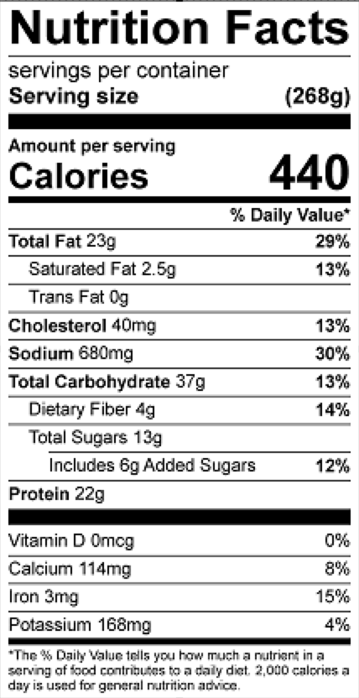
Vitamin C: 33 mg

