Thanksgiving Potato Chowder
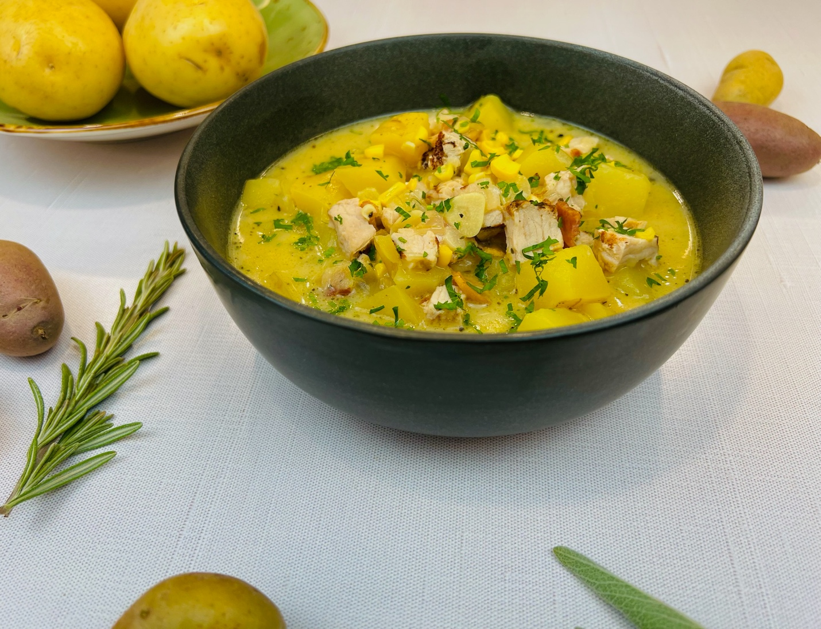
Program: Consumer
Short Description: Hearty bowl of chowder loaded with all the thanksgiving fixings
Long Description: Tender potatoes, juicy turkey breast, corn, fall herbs, and aromatic vegetables, slow simmered in a fragrant broth made from turkey stock and cream.
Servings/portion size: 12
Preparation Time: 20 minutes
Cooking Time: 40 minutes
Total Time: 60 minutes
Potato Type: Fresh Yellow Potatoes
Course: Soup, Side, Entrée, Lunch, Dinner
Ingredients:
Chowder:
- ½ cup (112g) Bacon, diced (Optional, if not using then sub 2 tablespoons of olive oil to sauté the vegetables in)
- 1 cup (150g) Yellow Onions, chopped ¼ inch
- 1 cup (150g) Celery, diced ¼ inch
- ¼ cup (30g) Garlic, sliced thin
- 1-1/2 pounds (680g) Yellow potatoes, diced into 1-inch cubes
- ½ cup (62g) All Purpose Flour
- 3 quarts (2.8L) Chicken Stock
- 1 pound (454g) Diced Turkey Meat (Roasted, Grilled, etc.)
- 2 cups (350g) Frozen Corn Kernels
- 2 tablespoons (4g) Rubbed Sage
- 1-1/2 teaspoons (2g) Dried Thyme
- 2 tablespoons (8g) Chicken Bouillon Powder (Optional)
- 1 quart (946ml) Half and Half
- 1 tablespoon (18g) Kosher Salt
- ¼ cup (15g) Fresh Parsley, chopped

Preparation:
- Gather and scale all ingredients.
- In a large heavy-bottomed pot over medium-high heat, begin cooking the bacon. Stirring often, cook the back until it is rendered and starts to brown. Add the onions, celery, and garlic and cook until the vegetables are translucent (about 2-3 minutes). Add the potatoes and stir, then add the flour and stir.
- Add the chicken stock, a little at a time while stirring until the stock is all added, continue to stir and allow the soup to come to a boil then immediately reduce to a simmer.
- Add the turkey, corn, sage, thyme, bouillon powder (if using), half and half, and salt.
- Simmer the soup until it is thick and creamy, and the potatoes are tender. Add the parsley and serve immediately.

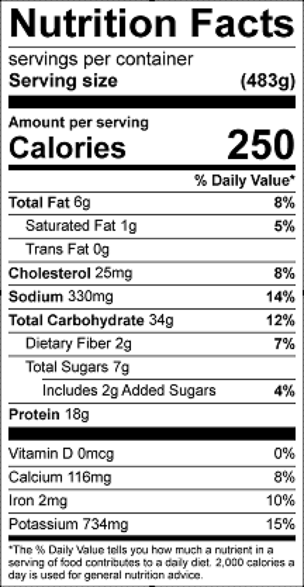
Vitamin C: 12 mg

