Tater Topped Turkey Meatloaf
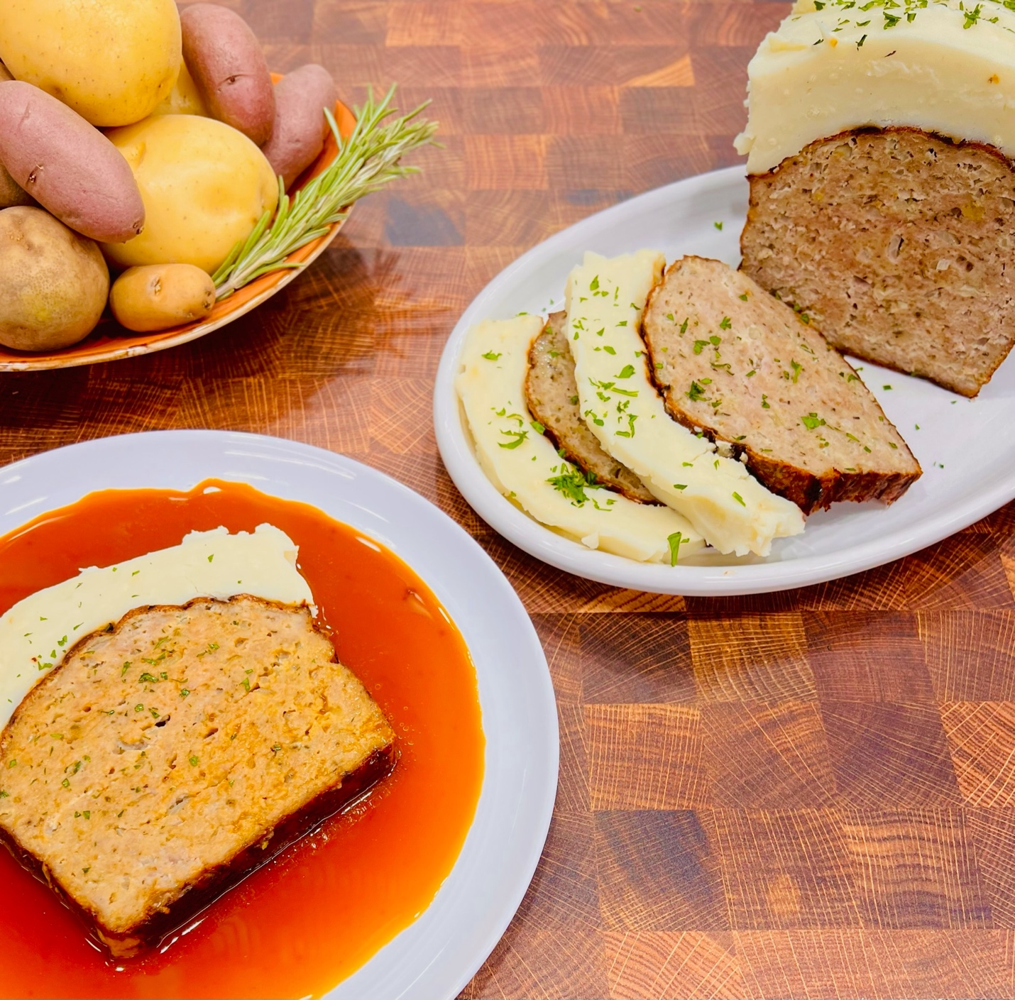
Program: Consumer
Short Description: Delicious turkey meatloaf topped with creamy taters!
Long Description: Moist and tender turkey meatloaf flavored with herbs, garlic, and onions, then topped with creamy mashed potatoes.
Servings/portion size: 12
Preparation Time: 20 minutes
Cooking Time: 45 minutes
Total Time: 65 minutes
Potato Type: Russet Potatoes
Course: Entrée, Lunch, Dinner

Ingredients:
Turkey Meatloaf:
- 2 pounds (908g) Ground Turkey (do not use very lean)
- ½ cup (30g) Panko Breadcrumbs
- 1/3 cup (80ml) Heavy Cream
- 3 each Large Eggs
- 1 cup (150g) Yellow Onion, finely chopped
- ½ cup (75g) Celery, finely chopped
- 1 tablespoon (4g) Fresh Rosemary, chopped
- 2 tablespoons (30ml) Dijon Mustard
- 2 teaspoons (4g) Dried Thyme
- 1 tablespoon (3g) Rubbed Sage
- 1 tablespoon (8g) Granulated Garlic
- 1 tablespoon (5g) Smoked Paprika
- 2 tablespoons (8g) Chicken Bouillon Powder (optional)
- 1-1/2 teaspoons (10g) Sea Salt
- 2 teaspoons (4g) Freshly Ground Black Pepper
Creamy Mashed Potato Topping:
- 1-1/2 pounds (680g) Russet Potatoes, peeled
- 3 tablespoons (45g) Unsalted Butter, softened
- 1/3 cup (80ml) Half and Half, heated
- 2 teaspoons (6g) Sea Salt
- 1-1/2 teaspoons (3g) Ground White Pepper
Preparation:
- Gather and scale all ingredients.
- Preheat an oven to 325 F (163 C)
- To make the meatloaf, place the turkey in a large bowl. In a smaller bowl combine the breadcrumbs, cream, and eggs and allow to sit for 3-5 minutes. Add the egg and breadcrumb mixture to the turkey and add the onions, celery, rosemary, mustard, thyme, sage, garlic, paprika, bouillon powder (if using), sea salt, and black pepper.
- Place the meatloaf mixture into a loaf pan and mound it higher in the center than on the sides.
- Place the meatloaf into the preheated oven and cook until the internal temperature is 155 F (68.3 C), the meatloaf will carryover cook to 165 F (74 C). Remove the meatloaf from the oven and keep warm until ready to serve.
- While the meatloaf is roasting in the oven, prepare the mashed potato topping by placing the peeled potatoes into a heavy-bottomed pot and covering them with cold water. Place the pot on the stove over high heat and allow the water to come to a boil. Reduce the heat to a simmer and cook the potatoes until they are fork tender.
- Drain the potatoes and add the hot cream and butter mixture. Whisk/mash the potatoes until light and fluffy and fold in the salt and white pepper until thoroughly combined. Be careful not to overmix or the potatoes may get gummy.
- Remove the meatloaf from the pan and top with the mashed potatoes.
- Slice the meatloaf into 12 equal portions.
- Serve right away and pair with your favorite kind of gravy and enjoy!

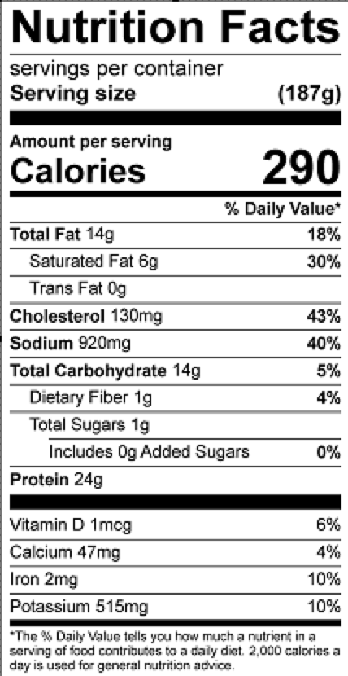
Vitamin C: 4.5 mg

