Skillet Hash Brown Stuffing
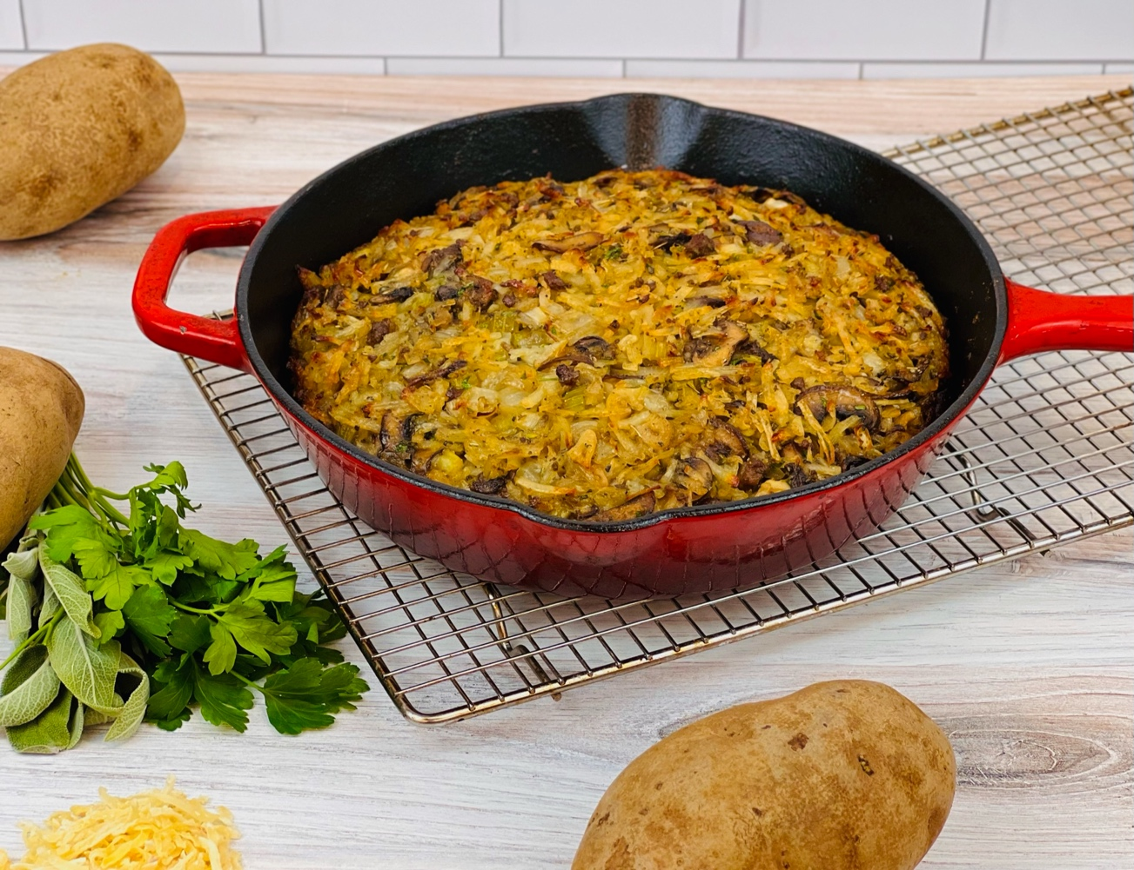
Program: Consumer
Short Description: Crispy potatoes as a savory stuffing? This stuffing make gluten
Long Description: Savory casserole of potatoes, aromatic vegetables, and fall herbs. The perfect side for roast poultry, game, or grilled meats.
Servings/Portion Size: 8
Preparation Time: 20 minutes
Cooking Time: 35 minutes
Total Time: 55 minutes
Potato Type: Dehydrated Potato Shreds
Course: Side Dish

Ingredients
Potato Stuffing:
- 4 cups (192g) Instant Shredded Hash Browns (Dehy Shredded Potato) *8 cups of frozen shredded potato can be subbed*
- 6 cups (1.44L) Hot Water *Omit the water if using frozen shredded potatoes)
- 3 tablespoons (45ml) Olive Oil
- 4 cups (352g) Cremini Mushrooms, sliced (White Button Mushrooms can be subbed)
- 2 teaspoons (12g) Salt
- 1 teaspoon (1g) Dried Thyme
- 1-1/2 cup (150g) Yellow Onion, diced ¼ inch
- 1-1/2 cup (150g) Celery, diced ¼ inch
- 2 tablespoons (2g) Rubbed Sage
- ½ tablespoon (2g) Ground Black Pepper
- 2 teaspoons (4g) Granulated Garlic
- 2 tablespoons (25g) Chicken Bouillon Powder (optional)
- 2 tablespoons (30ml) Vegetable Oil
Preparation
- Preheat the oven to 400 F (204 C).
- Rehydrate the potato shreds with hot water and set aside. If using frozen shreds, simply allow the shredded potatoes to thaw completely before using. Regardless of the potatoes that you are using set them aside in a large mixing bowl.
- Heat the olive oil over medium-high heat in a large cast iron skillet. Brown the mushrooms in the oil, stirring occasionally. The mushrooms should brown in 3-5 minutes. Season with salt and thyme. Add the onions and celery and continue to cook, stirring occasionally until the vegetables are slightly translucent but not brown.
- Add the sage, black pepper, granulated garlic, and chicken bouillon powder if using. Remove from the heat and stir this mixture into the shredded potatoes.
- Clean the cast iron skillet and place it into the oven for about 10-15 minutes. Add the vegetable oil to the pan and swirl the pan so the oil coats it evenly. Add the potato stuffing mixture to the pan with hot oil and mound it slightly in the center so it’s a little higher in the center than it is on the edges.
- Bake the stuffing for 30-35 minutes until it is golden brown, and the internal temperature is 155 F.
- Remove from the oven and allow to cool slightly before serving.
- Serve right away and enjoy.
Vitamin C: 9.8mg

