**Sheet Pan Roasted Turkey and Herbed Potatoes**

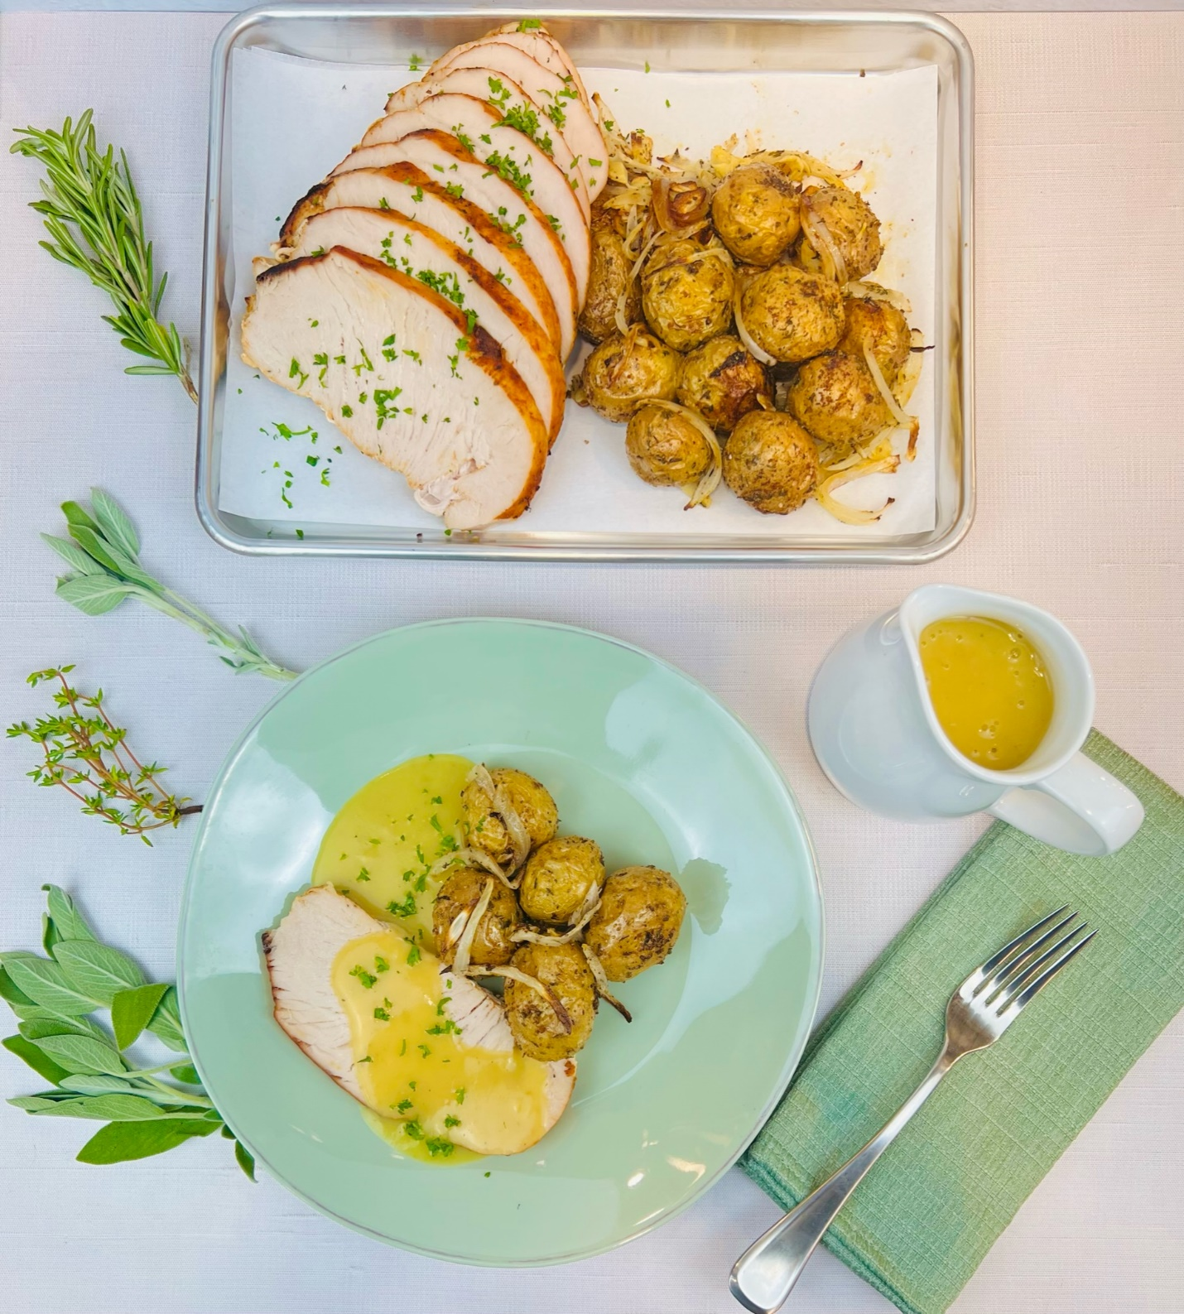

**Program:** Consumer

**Short Description:** A quick and simple one-sheet pan Fall potatoes and turkey recipe

**Long Description**: Small baby yellow potatoes seasoned with garlic and sage; marinated turkey breast roasted together on a sheet pan drizzled with turkey gravy.

**Servings/portion size:** 8

**Preparation Time:** 20 minutes

**Cooking Time:** 45 minutes

**Total Time:** 65 minutes

**Potato Type:** Small Baby Yellow Potatoes

**Course:** Brunch, Lunch, Dinner, Entree

**Ingredients:**

* 2 lbs. (906 g) Baby Dutch Yellow Potatoes
* 2 tbsp (30 ml) Olive Oil
* 1 tbsp (17 g) Salt
* ½ tbsp (9 g) Black Pepper, Ground
* 1 tbsp (5 g) Garlic Powder
* 1 tbsp (2 g) Sage, Rubbed
* 1 cup (52 g) Onions, Yellow (Sliced Thick, ¼ inch)
* 2 tbsp (16 g) Garlic (Smashed)
* 3 lbs. (1359 g) Turkey Breast, Oven Ready, Raw
* 1 tbsp (4 g) Parsley (Fine Chop)

Turkey Gravy:

* ½ qt (473 ml) Chicken Stock, Low Sodium
* 1 oz (28 g) Flour, All-Purpose
* 1 oz (28 g) Butter
* As needed Pan Drippings

**Preparation:**

1. Gather all ingredients and equipment needed.
2. Preheat the oven to 350°F (176°C).
3. Rinse potatoes and wipe off excess water, then place in a large bowl, add olive oil, salt, black pepper, garlic powder, rubbed sage, smashed garlic, and sliced onions, and toss until coated. Then place on a parchment paper-lined baking sheet.
4. Place oven-ready turkey breast beside potatoes on the same baking sheet.
5. Place baking sheet in preheated oven and roast for 45-50 minutes or until turkey breast internal temperature reaches 155°F (68°C) and let it carry over cook to 165°F (73°C). this step keeps the turkey juicy. And not overcooked. Remove the baking sheet from the oven and let the turkey rest for 10 minutes before slicing. Save pan drippings for gravy.
6. To make gravy, in a small skillet or pot, to make the roux, add butter and melt then add flour and whisk together until a loose paste is formed. Then in a separate pot, on medium heat, add chicken stock and saved pan drippings, and reduce slightly, then continually whisk in flour-butter mixture until gravy thickens to desired consistency.
7. To serve, slice turkey breast to desired thickness and place on a platter or serving dish and place potatoes next to it and serve with gravy on the side.

**Notes:**

* May substitute baby yellow potatoes for any small potato varietals i.e., baby reds, fingerlings, etc.

Vitamin C: 5.56 mg