Potato Gnocchi with Roasted Brussels Sprouts
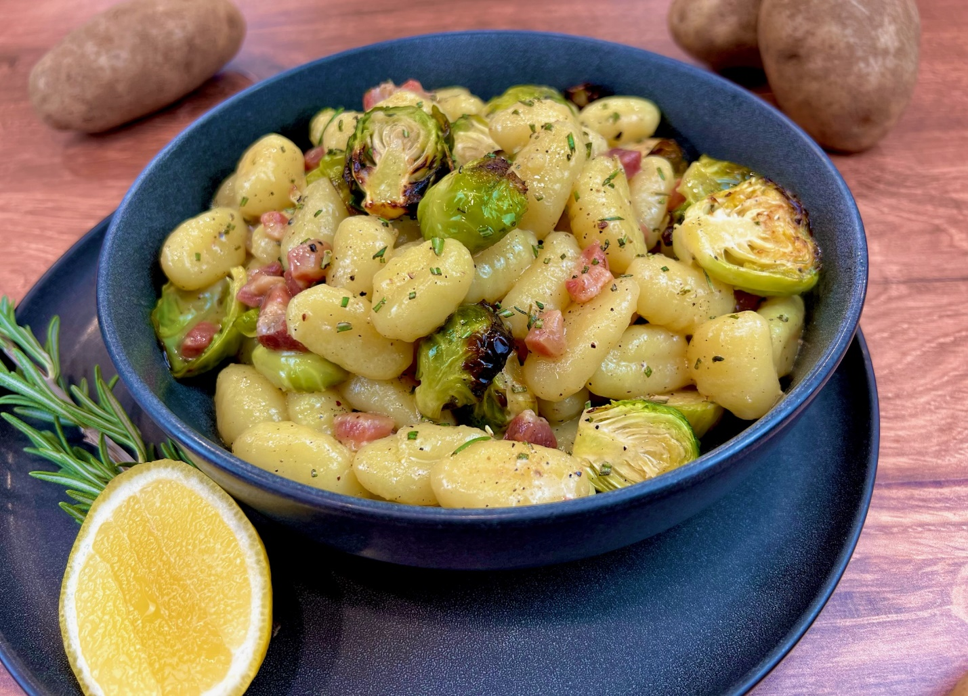

Program: Consumer
Short Description: The perfect vessel for pancetta and charred brussels sprouts
Long Description: soft pillowy gnocchi with crispy pancetta and charred brussels sprouts tossed in a lemony herb butter sauce.
Servings/portion size: 8
Preparation Time: 20 minutes
Cooking Time: 40 minutes
Total Time: 60 minutes
Potato Type: Dried Potato Gnocchi
Course: Brunch, Lunch, Dinner, Entrée
Ingredients:
- 2.2 lbs. (1000g) Potato Gnocchi, Dried
- ½ cup (72 g) Pancetta (Diced)
- 2 cups (176 g) Brussels Sprouts (Halves)
- 2 tbsp (30 ml) Olive Oil
- ¼ cup (60 ml) Lemon Juice
- 1 tsp (2 g) Lemon Zest
- 1 tbsp (2 g) Rosemary (Minced)
- 1 tbsp (8 g) Garlic (Minced)
- ½ cup (118 ml) Chicken Stock
- 2 tbsp (28 g) Butter
- 1 tsp (6 g) Salt
- ½ tsp (3 g) Black Pepper, Ground

Preparation:
- Gather all ingredients and equipment needed.
- Preheat the oven to 400°F (204°C).
- Rinse brussels sprouts and cut in half and place in a bowl, drizzle in oil, and add salt and black pepper and toss to fully coat. Evenly placed brussels sprouts on an oiled parchment paper lined baking tray and place in oven, and roast for 30 minutes or until slightly charred. Remove brussels sprouts from the oven and let cool slightly.
- In a large pot, on high heat, add water and salt to boil the gnocchi. Add gnocchi and boil for 2-3 minutes or until gnocchi floats to the top, using a slotted or strainer spoon, scoop out gnocchi and place in an ice bath for about 30 seconds to stop the cooking process and then place on an oiled baking tray, and repeat until all gnocchi is cooked.
- Then in a large skillet or frying pan, add a little bit of oil and crisp up diced pancetta, then add minced garlic and rosemary and sauté for 1 minute. Then add lemon juice, lemon zest, and chicken stock, with a wooden spoon, stir to remove browning bits on the bottom of the pan, and slightly reduce liquids. Then add in butter and stir. Add in gnocchi and brussels sprouts and toss until fully coated.
- Serve immediately and enjoy.

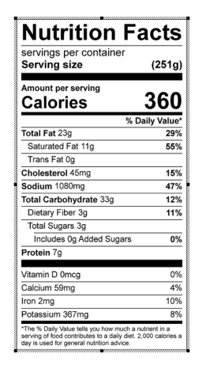
Vitamin C: 33.01 mg

