Parmesan Encrusted Potatoes
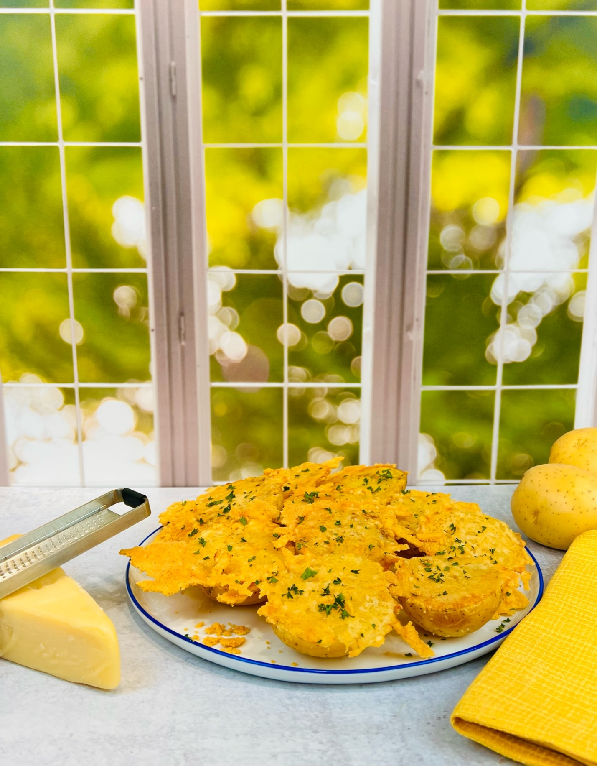

Program: Consumer
Short Description: An easy way to top off potatoes with parmesan cheese
Long Description: Roasted yellow potatoes encrusted with parmesan cheese and garnished with fresh parsley and thyme
Servings/portion size: 10
Preparation Time: 20 minutes
Cooking Time: 45 minutes
Total Time: 65 minutes
Potato Type: Yellow Potatoes
Course: Breakfast, Brunch, Lunch, Dinner, Snack, Side Dish
Ingredients:
- 2 lbs. (907 g) Yellow Potatoes (Halves)
- 1 qt (946 ml) Vegetable stock
- 1 ea (58 g) Lemon (Sliced)
- 4 ea (12 g) Garlic Cloves, Whole
- 1 tbsp (17 g) Salt
- 2 cups (180 g) Grated Parmesan Cheese
- 3 tbsp (44 ml) Olive Oil
- 1 tsp (1 g) Parsley (chopped)
- 1 tsp (1 g) Thyme leaves
Preparation:
- Gather all ingredients and equipment needed.
- Preheat the oven to 375°F (190°C).
- Rinse and peel potatoes, cut into halves.
- In a pot, add vegetable stock, sliced lemon, garlic, and yellow potato halves, and turn on the heat to high and bring to a boil; then reduce to a simmer and cook potatoes for 30 minutes or until just fork tender. Drain potatoes and shake off excess liquid and let cool slightly.
- On a non-stick baking sheet/tray, drizzle olive oil and parmesan cheese evenly, place potato halves, flat side down, and place in the preheated oven for 15 minutes or until parmesan cheese gets crisped and light golden in color.
- Remove the baking tray from the oven and let cool slightly; using a flat spatula, carefully lift off the potatoes and place them on the serving dish or platter, flat side up, and garnish with chopped parsley and thyme.

Notes
- For best results, use a silicone baking mat

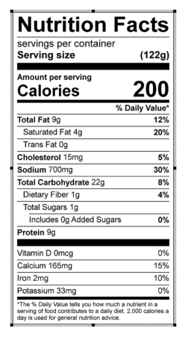
Vitamin C: 17.91 mg

