Oven Baked Potato Chips with Whipped Feta Dip
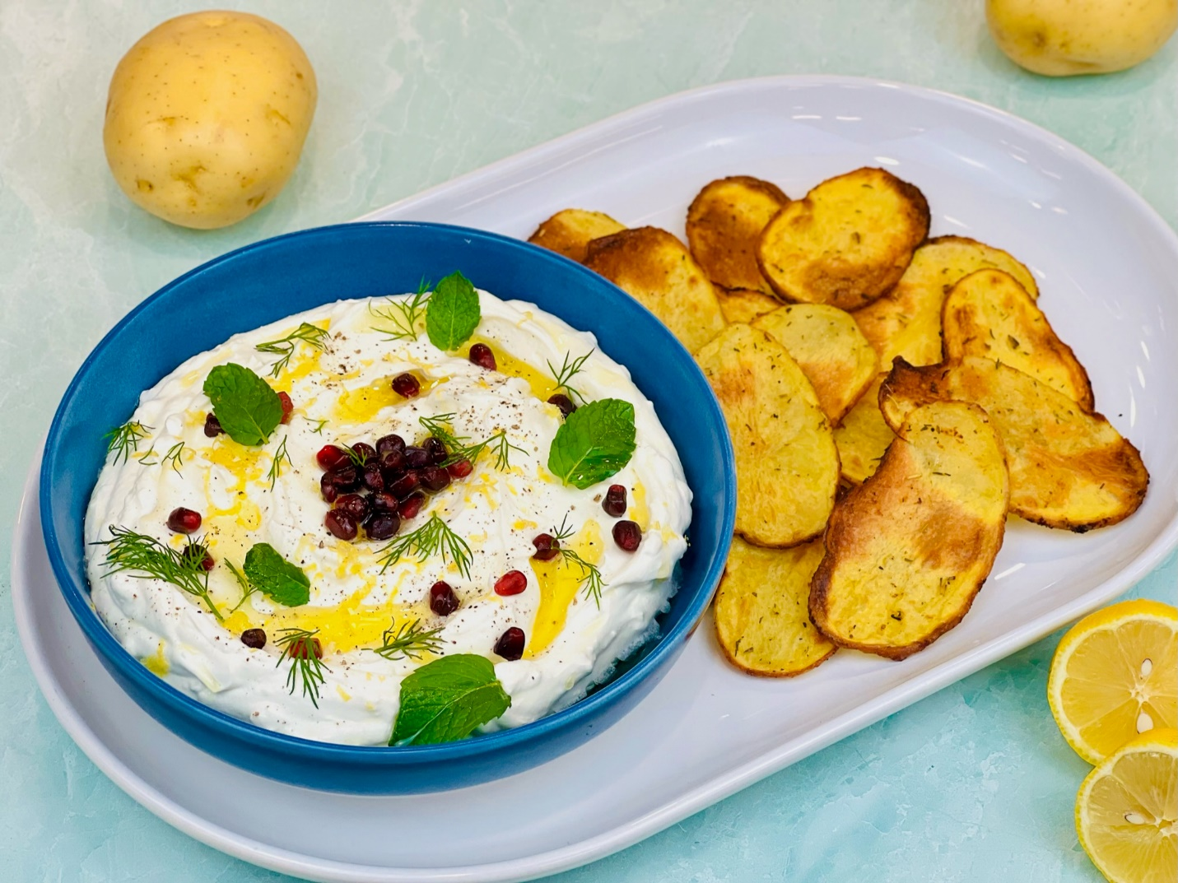

Program: Consumer
Short Description: Crispy potatoes with a refreshing whipped feta dip
Long Description: Crispy seasoned yellow potato chips served with a creamy whipped feta dip drizzled with olive oil, dusted with smoked paprika, and garnished with dill, mint, and pomegranate seeds.
Servings/portion size: 10
Preparation Time: 30 minutes
Cooking Time: 20 minutes
Total Time: 50 minutes
Potato Type: Yellow Potatoes
Course: Appetizer, Snack, Side Dish
Ingredients:
- 2 lbs. (1530 g) Yellow Potatoes
- 1 tbsp (5 g) Garlic powder
- 1 tbsp (4 g) Sage, Rubbed
- ½ tbsp (9 g) Salt
- ½ tbsp (7 g) Black Pepper, Ground
- 2 tbsp (30 ml) Olive oil
Whipped Feta Dip:
- 1 cup (225 g) Cream Cheese
- 1 cup (245 g) Feta Cheese
- 2 cups (473 ml) Non-Fat Greek Yogurt
- 2 tbsp (30 ml) Olive Oil
- 1 tbsp (2 g) Dill
- 1 tbsp (2 g) Mint
- 2 tbsp (56 g) Pomegranate Seeds
- As Needed Salt and Black Pepper (To Taste)
- As Needed Smoked Paprika (Garnish)
Preparation:
- Gather all ingredients and equipment needed.
- Preheat oven to 375°F (190°C).
- Rinse potatoes, and using a mandolin or a large sharp knife, thinly slice yellow potatoes and place in a large bowl. Then add olive oil, rubbed sage, garlic powder, salt, black pepper and gently tossed to fully coat potatoes.
- Place potatoes on a parchment paper lined baking tray and place in preheated oven and bake for 20 minutes or until light golden brown and crispy. Remove potatoes from oven and cool slightly.
- To make whipped feta dip, in a food processor or blender, add cream cheese, feta, yogurt, salt and pepper (to taste), and whip until combined. Place dip in serving bowl, drizzle olive oil, dust with paprika, and garnish with dill, mint, and pomegranate seeds.
- To serve, place potato chips on serving dish or platter, and place dip bowl on platter or on the side.

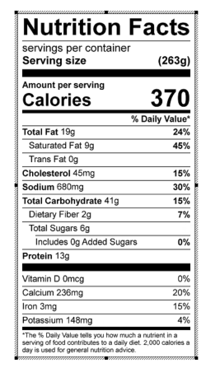
Vitamin C: 26.18 mg

