Mashed Potato with Brown Butter Crunchies
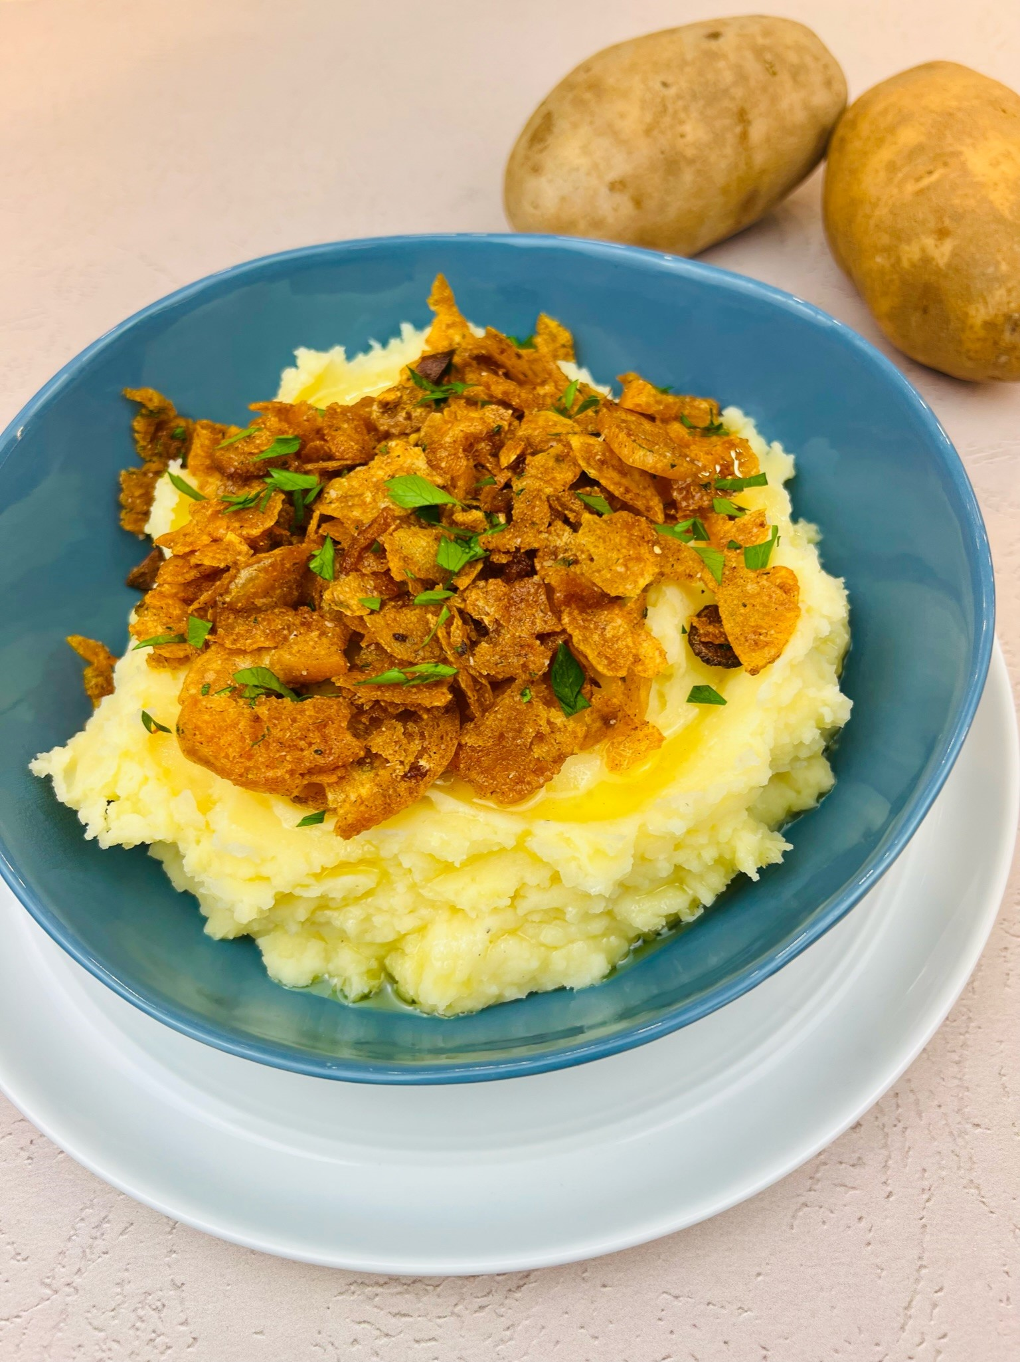

Program: Consumer
Short Description: Craving contrast in texture? Check this potato recipe out.
Long Description: Creamy roasted garlic mashed potatoes underneath a crunchy spiced topping, finished with fresh chopped parsley.
Servings/portion size: 8
Preparation Time: 20 minutes
Cooking Time: 45 minutes
Total Time: 65 minutes
Potato Type: Russet/ Yellow Potatoes
Course: Brunch, Lunch, Dinner, Side Dish
Ingredients:
- 1.1 lbs. (498 g) Yellow Potatoes
- 1.1 lbs. (498 g) Russet Potatoes
- 5 ea. (15 g) Garlic Cloves, Whole
- 2.5 sprigs (2 g) Thyme
- ½ cup (142 g) Butter, Unsalted
- 2 cups (473 ml) Whole Milk
- 1 tbsp (15 ml) Lemon Juice
- ½ tbsp (9 g) Salt
- 1 tsp (2 g) Black Peppercorns
- 1 tbsp (4 g) Parsley (Chopped)
- As needed Olive Oil
Brown Butter Crunchies:
- 1 cup (68 g) Potato Sandwich Bread (Torn)
- 1 cup (34 g) Kettle Chips
- 2 tbsp (28 g) Butter
- 1 tsp (1 g) Thyme leaves, Fresh
- ½ tsp (1 g) Smoked Paprika
Preparation:
- Gather all ingredients and equipment needed.
- In a small pot or frying pan, add whole garlic cloves, and then add enough oil to cover the garlic. Then turn on the heat at low, medium heat and cook garlic for 15 minutes or until the garlic has softened and is a light golden-brown color. Then set aside.
- Rinse, peel, and cut potatoes into ½ - 1-inch cubes and place in a large pot and add cold water enough to cover the potatoes. Turn on the heat and bring the water to a boil. Then reduce heat to a simmer and cook potatoes until fork tender. Then drain water from the potatoes, and using a food mill, mash potato press or a fork, mash potatoes with the roasted garlic.
- While waiting for potatoes to cook, in a separate small pot, add milk, butter, thyme, and black peppercorns and bring to a simmer.
- Strain the milk mixture and add to mashed potatoes and mix thoroughly. Then add salt to season.
- To make the brown butter crunchies, in a frying pan or skillet, on medium heat, add butter and slightly brown, then add in torn bread, potato chips, smoked paprika, and sauté until crispy, then turn off the heat and then sprinkle fresh thyme leaves.
- To assemble, scoop mashed potatoes on a platter or serving plate, add brown butter crunchies on the top, and garnish with chopped parsley.

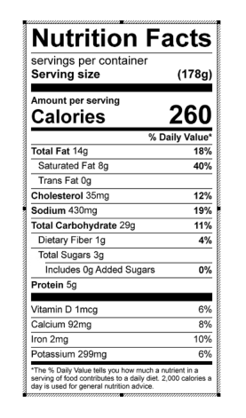
Vitamin C: 13.82 mg

