Mashed Potato Cinnamon Rolls
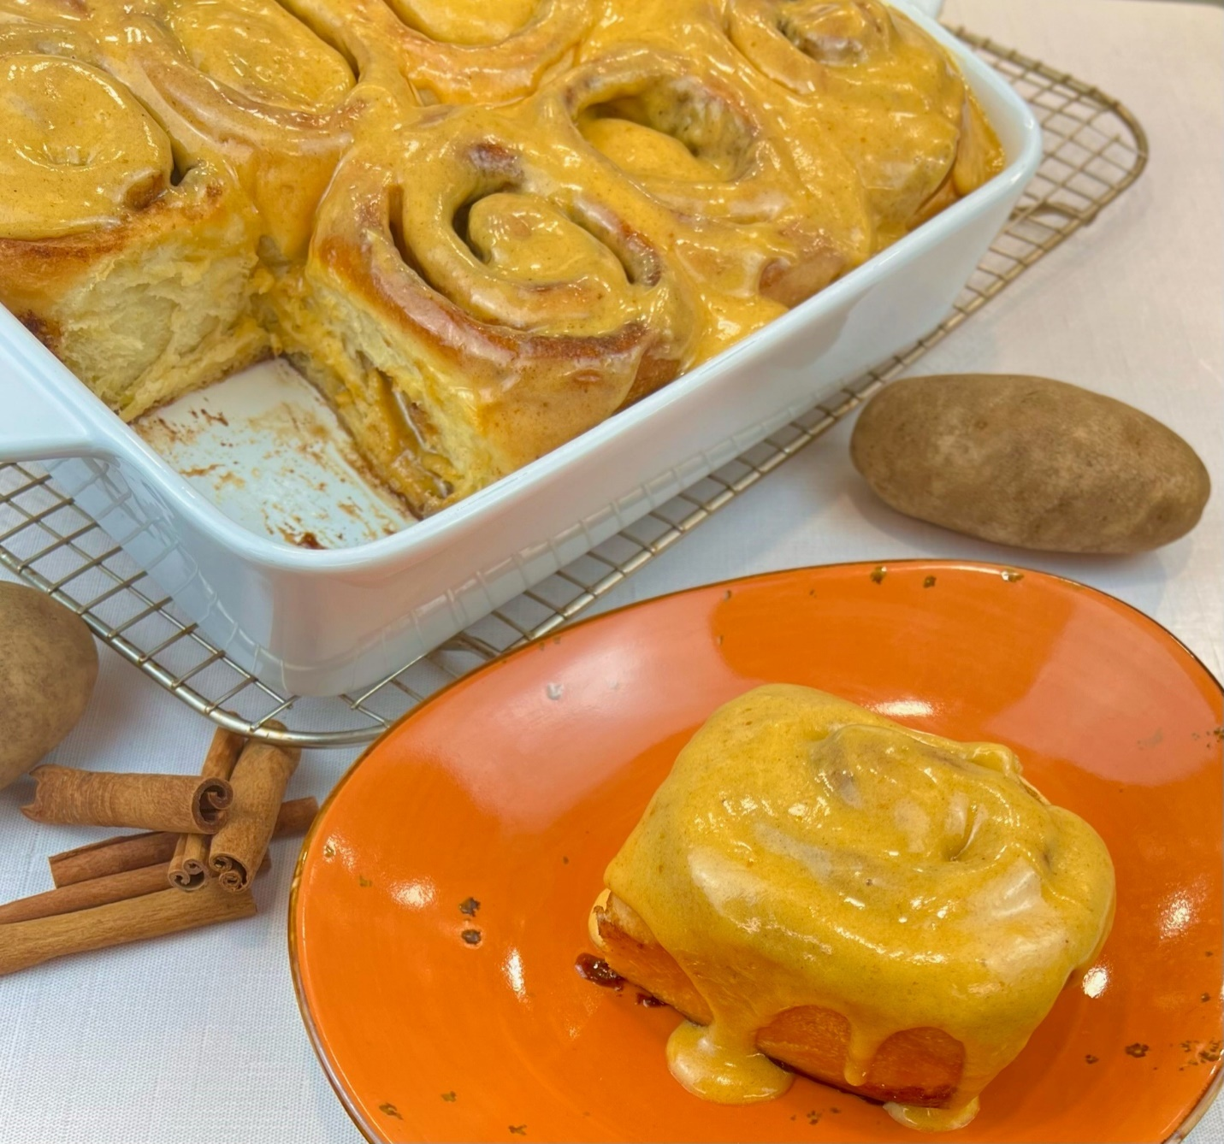
Program: Consumer
Short Description: Mashed potatoes in a baked good? Why not?
Long Description: Soft, sweet, and gooey mashed potato cinnamon rolls frosted with a pumpkin spiced cream cheese icing
Servings/portion size: 12
Preparation Time: 2 hours 30 minutes
Cooking Time: 22 minutes
Total Time: 2 hours and 52 minutes
Potato Type: Mashed Potatoes
Course: Breakfast, Brunch, Dessert
Ingredients:
Dough:
- 1 cup (240 ml) 115°F Water
- ½ cup (99 g) Granulated Sugar
- ¼ cup (60 g) Buttermilk
- ½ cup (120 g) Mashed Potatoes (Unseasoned)
- 2 each (112 g) Large Eggs
- 7 tbsp (99 g) Unsalted Butter, Melted
- 5 ¾ cup (690 g) All Purpose Flour
- 2 tsp (12 g) Salt
- 2 ¼ tsp (7 g) Yeast

Filling:
- 1 ½ cup (320 g) Dark Brown Sugar
- 3 tbsp (24 g) Cinnamon
- 1 tsp (2g) Potato Starch
- 8 tbsp (113 g) Unsalted Butter, Softened

Frosting:
- 4 oz (113 g) Cream Cheese
- 1/3 cup (80 ml) Heavy Cream
- ¼ cup (60 ml) Pumpkin Puree
- ½ tsp (2.5 ml) Pure Vanilla Extract
- 3 cups (390 g) Powdered Sugar

Preparation:
- Gather and scale all ingredients.
To make the dough:
- In the bowl of a stand mixer, whisk together the water, sugar, buttermilk, mashed potatoes, eggs, and melted butter at a low speed until fully incorporated. Then stop the mixer.
- Remove whisk and replace with dough hook. Set mixer on low speed and stir in flour salt, salt, and yeast into bowl with liquid mixture until it slightly comes to together.
- Then increase speed to medium low and knead dough until the dough pulls away from the sides of the bowl.
- Then increase speed and knead for 5 minutes. Stop mixer.
- Remove bowl from mixer and cover with a damp towel or plastic wrap and let rise for 90 minutes.
To make the filling:
- In a bowl, combine and mix, brown sugar, cinnamon, and potato starch. And set aside.
- Soften butter and set aside.
To make the Pumpkin Spiced Cream Cheese Frosting:
- In a stand mixer, with the paddle attachment, add cream cheese into the mixer bowl and paddle to soften cream cheese.
- Then add pumpkin puree, vanilla extract, heavy cream, and powdered sugar and mix until fully incorporated. Set aside.
To make the cinnamon roll:
- Preheat the oven to 350°F (176°C).
- Roll out dough to 18” x 24” using a rolling pin.
- Spread softened butter evenly onto the rolled-out dough and then sprinkle filling evenly onto the buttered dough.
- Roll out dough starting from the bottom to form a log.
- Cut log into 12 equal pieces and place them flat side down evenly spread onto a buttered parchment paper lined 12” x 9” x 2” large casserole dish.
- Proof dough at 70°F - 90°F (21°C - 32°C) for 60-90 minutes.
- Then bake in preheated oven at 350°F (176°C) for 22- 25 minutes or until when an inserted toothpick comes out clean.
- Remove cinnamon rolls and let cool slightly, then generously ladle pumpkin spice cream cheese frosting evenly on top.
- Serve and enjoy.
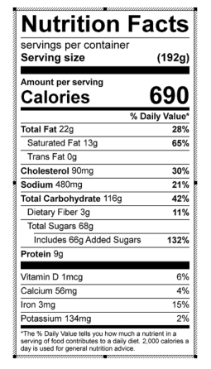

Vitamin C: .12 mg

