Lemon and Sage Potatoes
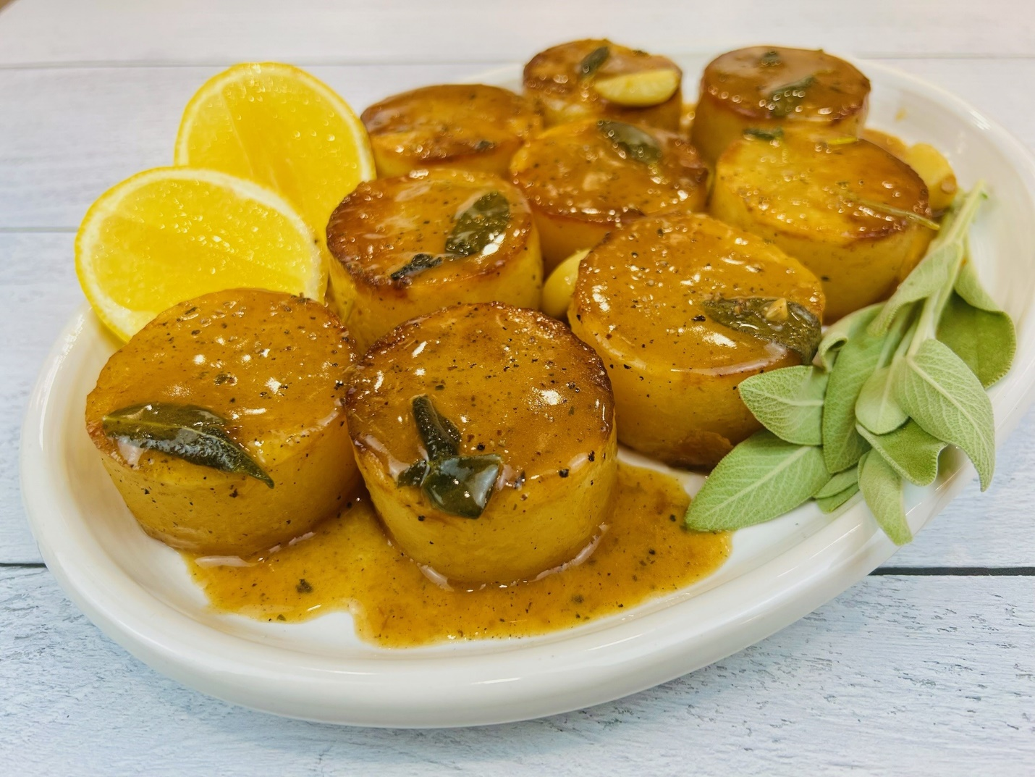
Program: Consumer
Short Description: Hearty rounds of potatoes braised in the oven with fall flavors
Long Description: Fondant potatoes served with a zesty sage butter sauce
Servings/portion size: 12
Preparation Time: 30 minutes
Cooking Time: 45 minutes
Total Time: 75 minutes
Potato Type: Yellow Potatoes
Course: Breakfast, Brunch, Lunch, Dinner, Appetizer, Side Dish

Ingredients:
- 2.2 lbs. (1000 g) Yellow Potatoes
- 2 tbsp (30 ml) Vegetable Oil
- 3 tbsp (42 g) Butter
- 4 each (12 g) Whole Garlic Cloves
- 6 each (5 g) Sage Leaf
- ¾ cup (180 ml) Vegetable Stock
- ¼ cup (60 ml) Lemon Juice
- 1 tsp (2 g) Lemon Zest
- 1 tbsp (17 g) Salt
- ½ tbsp (7 g) Ground Black Pepper
Preparation:
- Gather all ingredients and equipment.
- Preheat oven to 425°F (218°C).
- Slice potatoes on each side lengthwise to create a thick plank and using a metal ring cutter or round cookie cutter, stamp out yellow potatoes to form a puck-like shape. Then hold in cold water.
- In an oven-safe, nonstick, frying pan or skillet, turn on the heat to medium-high, and add vegetable oil and brown potatoes on each side 2-3 minutes.
- Then add butter, garlic, and sage, using a spoon baste potatoes, until butter lessens in bubbling, and it smells nutty and starting to brown about 1-2 minutes.
- Then add stock, lemon juice, and lemon zest, using a wooden spoon slowly whisk to remove caramelized bits from the bottom of the pan. Then cover pan with aluminum foil and place potatoes in the oven and roast for 30 minutes.
- Remove potatoes from oven and let cool slightly and serve.

Notes
- If you do not have a ring cutter, you may shape the potatoes using a paring knife.
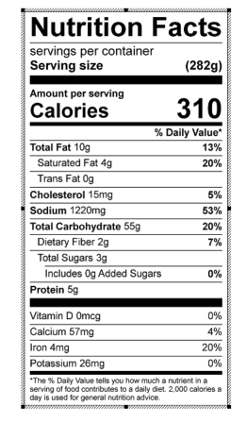
Vitamin C:

