Jalapeno Popper Mashed Potato Casserole
Program: Consumer
Short Description: Indulgent, creamy, spicy, smoky whipped potatoes with bacon, jalapenos, and cheddar.
Long Description: All the flavors of spicy jalapeno poppers but folded into creamy mashed potatoes. So good, you’ll want two servings.
Servings/portion size: 12
Preparation Time: 10 minutes
Cooking Time: 35 minutes
Total Time: 45 minutes
Potato Type: Fresh Yellows and Fresh Russets
Course: Side
Ingredients:
Mashed Potatoes:
- 2 pounds (1kg) Yellow Potatoes, peeled, cut into 2-inch chunks
- 1 pound (454g) Russet Potatoes, peeled, cut into 2-inch chunks
- As Needed Cold Water
- 2 tablespoons (36g) Kosher Salt
- ½ cup (114g) Unsalted Butter, softened
- ½ cup (120ml) Half and Half
- 8 ounces (240g) Cream Cheese, softened
- ½ cup (125g) Canned Jalapenos, diced or sliced
- 2 teaspoons (12g) Kosher Salt
- 8 ounces (240g) Shredded Cheddar Cheese

Candied Maple Bacon:
- 1 cups (225g) Bacon, diced, cooked
- 1/4 cup (60ml) Maple Syrup
- 2 teaspoons (3g) Smoked Paprika
- ½ teaspoon (~1g) Cayenne Pepper

Preparation:
- Gather and scale all ingredients.
- Preheat the oven to 350°F (176°C).
- Wash and scrub the potatoes and peel them, reserving the peels for other recipes if desired.
- Cut the potatoes into roughly 2-inch pieces and place them into a large heavy bottomed pot. Cover them with cold water and allow them to sit for 2-3 minutes. Drain the water, rinse the potatoes with cold water and cover them again with cold water until the water is about 1 inch over the top of the potatoes.
- Add the salt, and place on the stove over high heat.
- Bring the pot to a boil and reduce it to a simmer. Cook the potatoes until they are fork tender. Drain the potatoes well and allow the steam to dissipate them slightly. Give the potatoes a quick rinse/spray with hot water, this will remove any residual starch which could make the potatoes gluey or gummy. While your potatoes are draining, place a small saucepan with the butter, half and half, and cream cheese over medium heat until hot. Set aside.
- Return the potatoes to the pot and place the pot over medium heat, allow any excess moisture to evaporate off the potatoes. At this stage, you can pass the potatoes through a potato ricer, food mill, etc., or simply choose to use a potato masher, hand mixer, stand mixer, etc.
- Add the hot dairy mixture to the potatoes and mix/mash until smooth and creamy. If using a ricer or a food mill, pass the hot potatoes through first before adding the dairy. If using a masher, hand mixer or stand mixer add the potatoes along with the dairy and mix gently until creamy and fully mixed.
- Fold (gently mix) in the jalapenos and adjust the seasoning with the salt. Then transfer the mashed potatoes to a casserole dish and cover the potatoes with an even layer of shredded cheddar.
- To make the candied bacon, heat the maple syrup in a medium-sized pan, and add the bacon, cook the bacon over medium heat for about 3-5 minutes or until the bacon is glazed with the maple syrup.
- Allow the bacon to cool slightly. While the bacon is cooling, place the potatoes in the oven for about 5-7 minutes or until the cheese is melted and the inside of the casserole is 155 F (68.3 C). Remove from the oven and allow to cool slightly.
- Sprinkle the bacon over the top of the casserole and serve immediately.

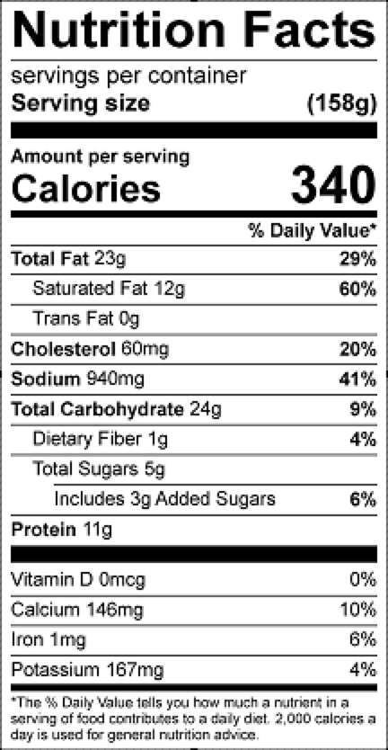
Vitamin C: 12 mg

