Grilled Potatoes with Miso Honey Butter
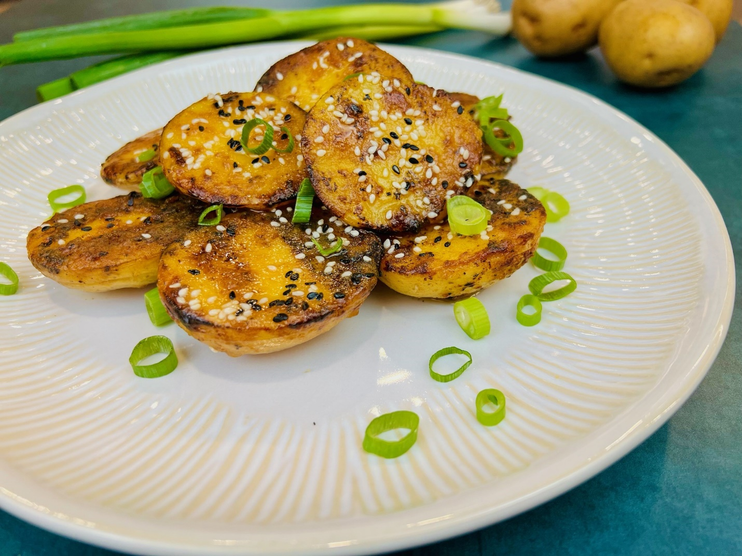
Program: Consumer Program
Short Description: Grilled potatoes with an Asian twist!
Long Description: Baby yellow potatoes cooked in flavorful vegetable stock, then slathered in miso honey butter then grilled, and finished with chopped green onions and sesame seeds.
Servings/portion size: 10
Preparation Time: 20 minutes
Cooking Time: 50 minutes
Total Time: 70 minutes
Potato Type: Yellow Potatoes
Course: Brunch, Lunch, Dinner, Appetizer, Side Dish
Ingredients:
- 3 lbs. (1360 g) Baby Yellow Potatoes
- 1 qt (946 ml) Vegetable Stock
- 1 tbsp (17 g) Salt
- 4 tbsp (56 g) Butter
- 2 tbsp (34 g) Miso
- 4 tbsp (85 g) Honey
- 1 tbsp (8 g) Garlic (Minced)
- ¼ cup (26 g) Green Onions (Chopped)
- 2 tbsp (17 g) Sesame Seeds
Preparation:
- Gather all ingredients and equipment needed.
- Slice baby yellow potatoes in half and hold them in cold water.
- In a large pot, add vegetable stock and baby yellow potato halves, and then turn on the heat, then bring to boil then reduce heat to a simmer and cook for 40 minutes or until fork tender. Drain well and place potatoes in an ice bath to stop the cooking process. Then drain and shake off excess liquid and set aside in a bowl.
- While waiting for potatoes to cook, melt butter on the stovetop or microwave, then add, minced garlic, honey, and miso and mix in a small bowl. And set aside.
- Set up the grill to medium-high heat 350°F - 400°F (176°C - 200°C).
- Then brush potatoes with miso honey butter mixture, and place on grill flat side down until charred grill marks, about 2-3 minutes. Then serve while hot.
- To serve, place grill potatoes on a plate/platter then sprinkle green onions, and sesame seeds.

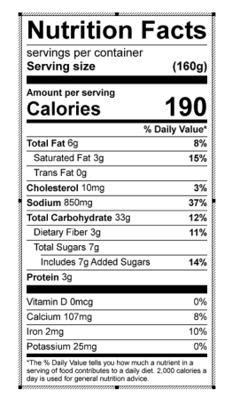
Vitamin C: 5.19 mg

