German Style Potato Dumplings
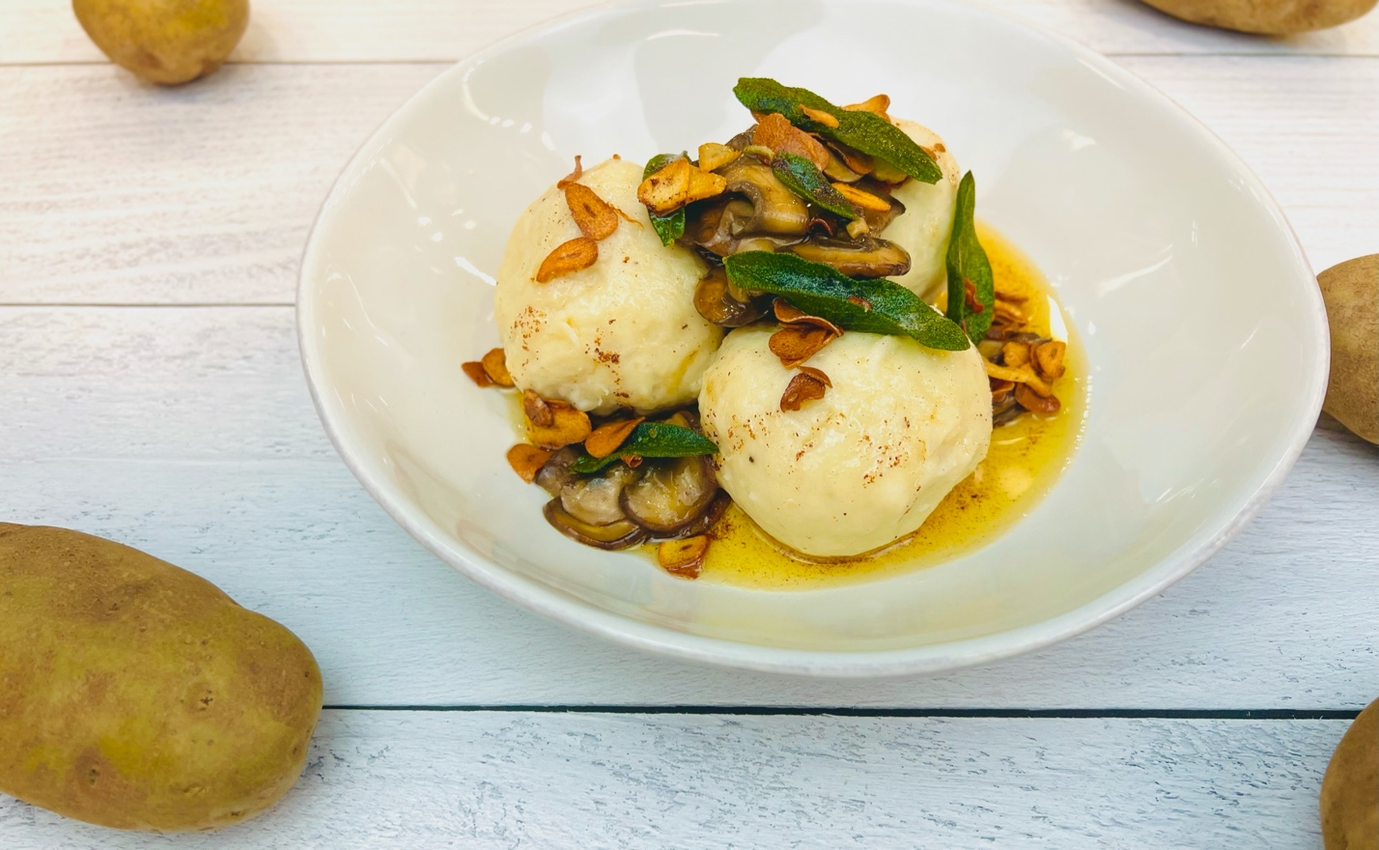
Program: Consumer
Short Description: Fluffy Mashed Potato Dumplings Stuffed with Roasted Mushrooms
Long Description: Rich and Satisfying Mushroom Stuffed Potato Dumplings Loaded with Sage, Brown Butter, Thyme, and Garlic.
Servings/portion size: 6
Preparation Time: 25 minutes
Cooking Time: 25 minutes
Total Time: 50 minutes
Potato Type: Dehydrated Potato Flakes/Instant Potatoes
Course: Entrée, Lunch, Dinner

Ingredients:
Potato Dumpling Dough:
- 1-1/4 cup (100g) Potato Flakes/Instant Potatoes
- 1-1/4 cup (310ml) Water
- 1 each Large Egg
- 1 each Egg Yolk
- ½ cup (84g) All Purpose Flour
Roasted Mushrooms:
- 2 tablespoons (30ml) Olive Oil
- 1 pound (454g) Cremini Mushrooms, sliced (White button mushrooms can be subbed)
- 2 teaspoons (12g) Sea Salt
- 1 teaspoon (2g) Black Pepper, freshly ground
- 1 teaspoon (2g) Fresh Thyme, chopped
- 1 cup (240ml) Chicken Stock
- 2 tablespoons (28g) Unsalted Butter, softened
Garlic and Sage Brown Butter:
- ½ cup (112g) Unsalted Butter
- 4 each (20g) Garlic Cloves, sliced
- 18 each (10g) Sage Leaves, fresh
Preparation:
- Gather and scale all ingredients.
- In a bowl place the potato flakes and pour the water evenly over the top. Stir to combine, allowing all the potato flakes to be hydrated by the water. Stir in the egg and the egg yolk. Add the flour sprinkling it evenly over the top of the potato and egg mixture. Mix the dough gently until it just comes together. The dough should be supple and soft with just enough resistance to hold an indent when pressed with your finger. The dough shouldn’t be sticky to the touch. Cover the dough and allow it to rest while you prepare the filling.
- In a large nonstick skillet, drizzle the olive oil and heat over medium high heat. Add the mushrooms and sauté until golden brown. Add the sea salt, black pepper, and thyme. Add the chicken stock and reduce until the mushrooms are just glazed with the stock. Turn down the heat to low and add the butter, gently swirling the pan until the butter coats the mushrooms. Set aside and allow to cool slightly.
- To make the dumplings, take a golf ball-sized piece of dumpling dough and flatten it out in your hand slightly until you get a circle. Place a tablespoon worth of chilled mushroom filling in the center and form the dough around the filling, making sure to seal it well. Repeat until all the dumplings are filled. Cover the dumplings with plastic wrap and place in the fridge for 30 minutes to rest.
- Heat a large pot of water to a boil. Add a pinch of salt to the water and reduce the heat of the water to a simmer.
- Add the dumplings and allow them to gently poach in the water until they float (about 2-3 minutes).
- While the dumplings are cooking. Heat a pan over medium-high heat and add the butter. When the butter is melted and just starting to turn brown, reduce the heat to medium, and add the garlic. Cook the garlic until it is golden brown then remove it. To the butter that has been flavored with garlic now, add the sage. Cook the sage until it’s crispy then remove it. Take the butter off the heat and set aside until ready to use.
- When the dumplings float, use a slotted spoon to remove them and place them directly onto some shallow bowls for serving. Three dumplings usually make a good dinner portion.
- Spoon some of the brown butter over the hot potato dumplings and then add some of the crispy garlic and sage leaves on and around the dumplings. If there was leftover mushroom filling, you can spoon some of that over the dumplings as well.
- Serve right away and enjoy!

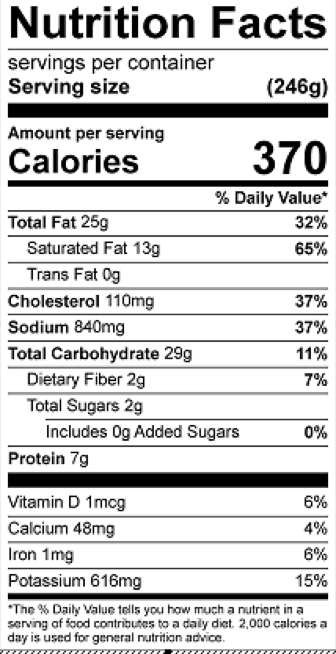
Vitamin C: 14.5 mg

