Fall Harvest Mashed Potatoes
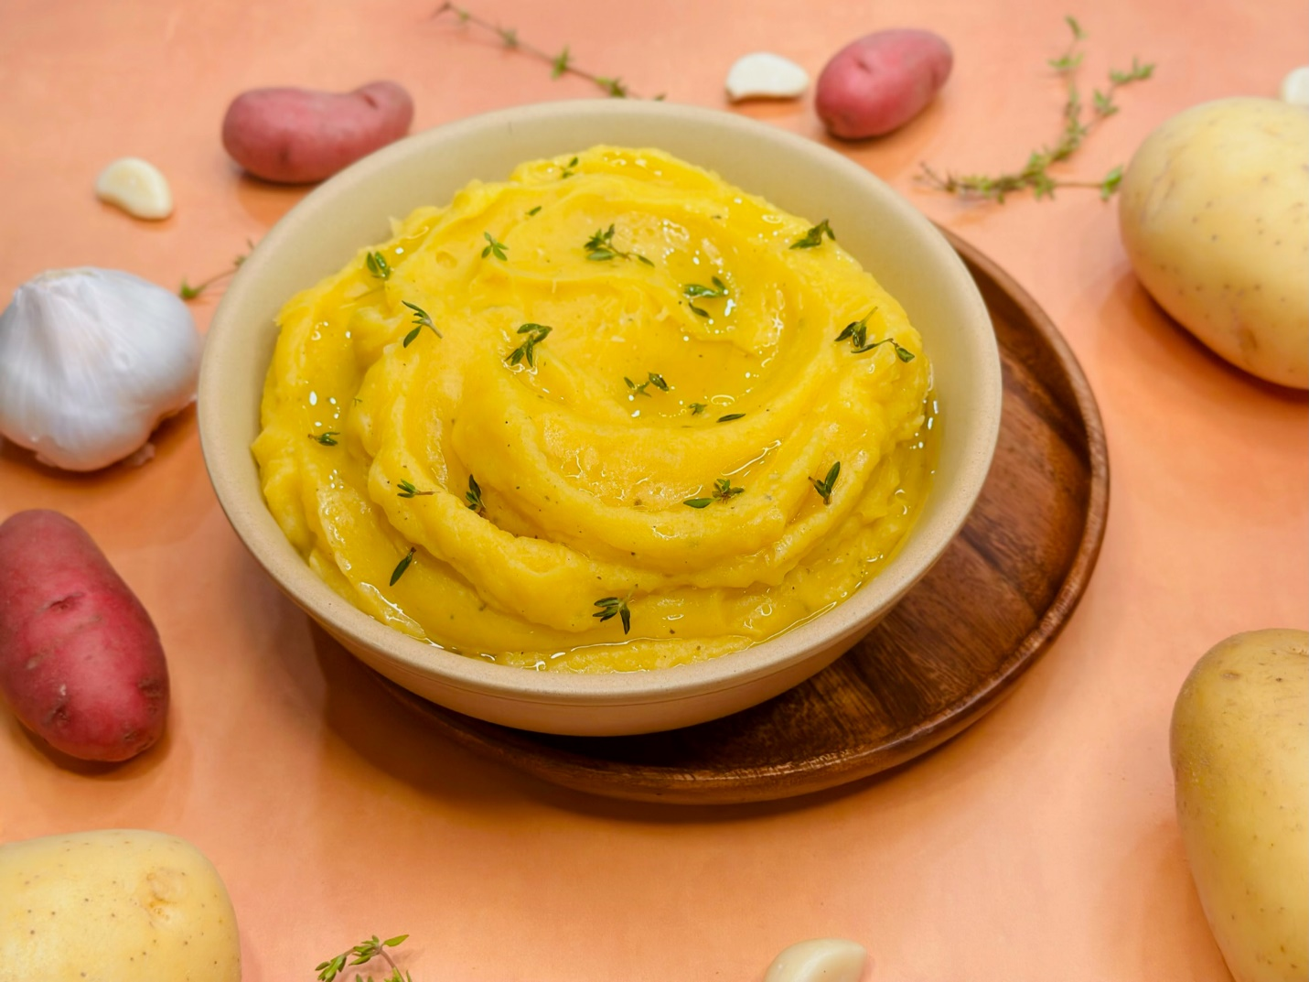

Program: Consumer
Short Description: a vegan, gluten-free, fall flavored side dish delight!
Long Description: creamy yellow mashed potatoes with roasted garlic and butternut squash, drizzled with extra virgin olive oil and topped with chives.
Servings/portion size: 8
Preparation Time: 20 minutes
Cooking Time: 30 minutes
Total Time: 50 minutes
Potato Type: Yellow Potatoes
Course: Breakfast, Brunch, Lunch, Dinner, Side Dish
Ingredients:
- 2 lbs. (1530 g) Yellow Potatoes
- 1 cup (236 ml) Vegetable Stock
- 1 cup (236 ml) Vegan Butternut Squash Soup
- 10 each (30 g) Garlic Cloves, Whole (Roasted)
- 1 tsp (1 g) Sage, Rubbed
- ½ tbsp (9 g) Salt
- ½ tbsp (7 g) Black Pepper, Ground
- 1 tsp (1 g) Thyme Leaves
- As needed Extra Virgin Olive Oil (Garnish)
Preparation:
- Gather all ingredients and equipment needed.
- In a frying pan or skillet, on low medium heat, add oil and garlic cloves and slowly cook until soft and comes to a translucent light golden-brown color.
- Rinse and peel yellow potatoes, then cut into small cubes, and place in a large pot and fill with enough water to cover potatoes. Then turn on to high heat and bring to a boil, then reduce heat to a simmer and cook potatoes for 30 minutes or until they are fork tender. Drain water and shake off excess liquids. And then place potatoes in a bowl, add roasted garlic then using a food mill, hand/stand mixer or a fork, mash potatoes until smooth or desired consistency.
- While waiting for potatoes to cook, in a pot add vegetable stock and vegan butternut squash soup and stir until combined and gently heat to a simmer. Then slightly cool and set aside.
- Add liquids, roasted garlic, rubbed sage, salt, and black pepper to mashed potatoes and fold together until smooth and creamy.
- To serve, place mashed potatoes in a serving dish or platter, drizzle olive oil and garnish with thyme leaves.

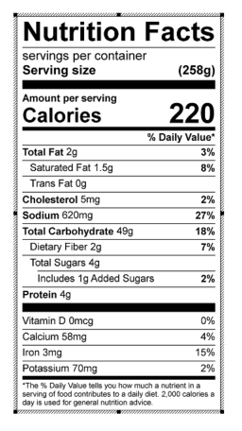
Vitamin C: 32.70 mg

