Easy Leek and Potato Gratin
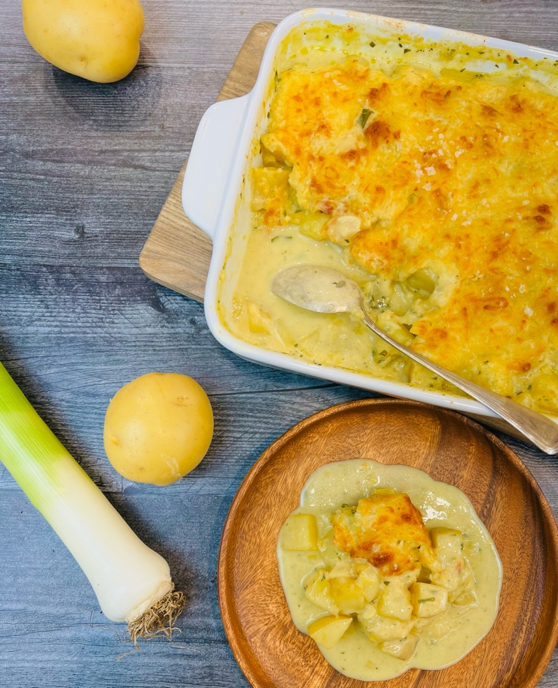
Program: Consumer
Short Description: Simple and delicious, leeks and potatoes baked with cheese and herbs.
Long Description: Tender potatoes, melted leeks, cream cheese and herbs prepared mostly on the stove top so the time to the table is fast.
Servings/portion size: 12
Preparation Time: 10 minutes
Cooking Time: 35 minutes
Total Time: 45 minutes
Potato Type: Fresh Yellow Potatoes
Course: Side, Entrée, Lunch, Dinner

Ingredients:
Leek and Potato Gratin:
- 3 tablespoons (45ml) Extra Virgin Olive Oil
- 4 cups (1kg) Leeks, washed, chopped ¼ inch slices
- 1 tablespoon (9g) Kosher Salt
- 1-1/2 teaspoons (4g) Ground White Pepper
- 1/3 cup (45g) All Purpose Flour
- 5 cups (1200ml) Vegetable Stock or Vegetable Broth
- 6 cups (840g) Yellow Potatoes, cut into 1-1/2 inch cubes
- 1 cup (240ml) Fat-Free Half & Half
- 2 tablespoons (3g) Fresh Thyme, chopped (Dried Thyme can be subbed but only use ½ tablespoon)
- 8 ounces (227g) Low Fat Cream Cheese
- 8 ounces (227g) Shredded Part Skim Mozzarella

Preparation:
- Gather and scale all ingredients.
- In a large heavy-bottomed pot over medium heat, heat the olive oil and begin to cook the leeks. Season the leeks with salt and continue to cook, stirring often, cook the leeks until they begin to become translucent and wilt in size.
- Add the white pepper and the flour and stir. While stirring, gradually add in the vegetable stock, and continue stirring until slightly thick. Add the potatoes and the half and half and allow the mixture to come to a boil and then reduce the heat to a simmer.
- Add the thyme and cook until the potatoes are tender (about 20-25 minutes).
- Mix in the cream cheese and remove from the heat.
- Transfer the mixture to a casserole dish and turn the broiler on your oven on.
- Sprinkle the top of the potatoes with the shredded mozzarella and place under the broiler for 2-3 minutes or until the top is golden and bubbly.
- Allow the casserole to cool slightly before serving.
- Serve immediately.

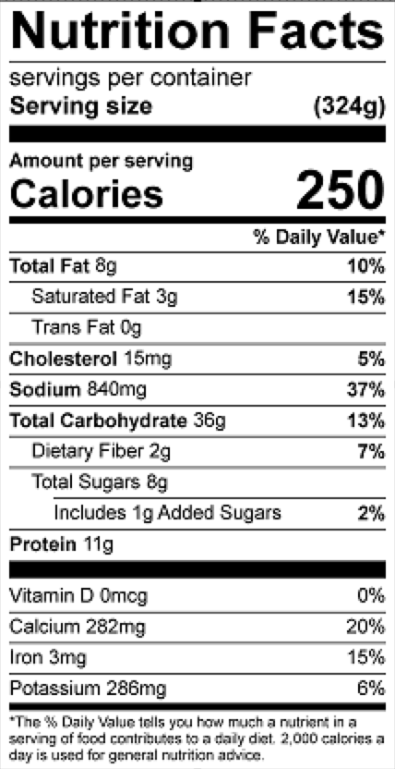
Vitamin C: 22 mg

