Chesapeake Bay Potato Chip Mac & Cheese
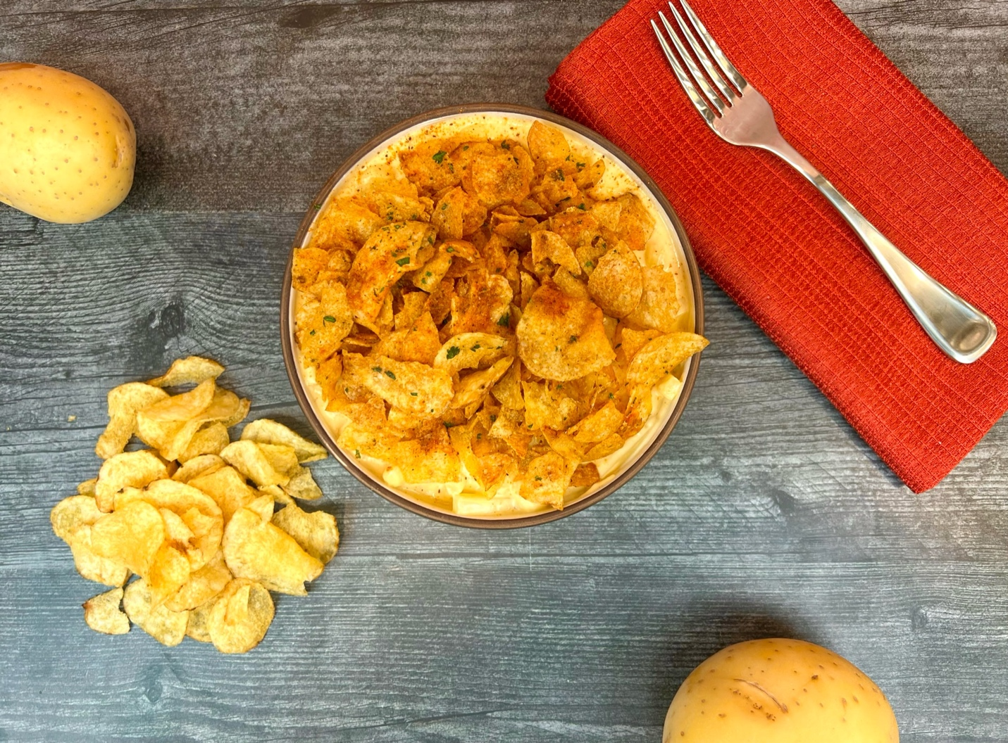
Program: Consumer
Short Description: Creamy mac and cheese made better with potato chips!
Long Description: Creamy and cheesy macaroni studded with pieces of tender cooked potatoes and topped with crispy seasoned kettle chips.
Servings/portion size: 12
Preparation Time: 15 minutes
Cooking Time: 30 minutes
Total Time: 45 minutes
Potato Type: Fresh Yellow Potatoes/Potato Chips
Course: Entrée, Lunch, Dinner, Side Dish

Ingredients:
Mac and Cheese:
- 1 pound (453g) Cavatappi (Corkscrew) Pasta (Other macaroni pasta can be subbed), cooked, cooled
- 8 ounces (227g) Yellow Potatoes, cut into ½ inch cubes, cooked, cooled
- 3 cups (720ml) Half & Half
- 1 cup (240ml) Heavy Cream
- 1 teaspoon (6g) Sea Salt
- 1-3/4 cup (198g) Colby Jack Cheese, shredded
- 2 teaspoons (12g) Old Bay Seasoning
Crispy Kettle Chip Topping:
- 1 tablespoon (15ml) Vegetable Oil
- 2 tablespoons (28g) Unsalted Butter
- 4 each (15g) Garlic, chopped fine
- 8-1/2 ounces (240g) Sea Salt Kettle Chips, slightly crushed
- 2 teaspoons (12g) Old Bay Seasoning
- 2 tablespoons (4g) Parsley, chopped
Preparation:
- Gather and scale all ingredients.
- Boil the pasta in boiling water until just tender (about 8-10 minutes), drain, and set aside.
- Boil the potatoes until just tender as well, drain and set aside.
- In a large pot over medium-high heat, combine the half & half with the heavy cream. Bring the pot to a boil and reduce the heat to medium. When the cream is reduced by about half (5-6 minutes), add the salt, cheese, and old bay. Stir to combine and adjust the consistency slightly with a little water if need be.
- Stir in the pasta and cooked potatoes gently until both are well coated by the cheese sauce.
- Keep the mac and cheese warm until ready to serve. In the meantime make the potato chip topping.
- In a large non stick skillet, heat the oil and butter up over medium heat. Add the garlic and swirl the pan until the garlic is fragrant about 15 seconds. Add the chips and stir constantly until the chips are golden. Season the chips with the old bay and remove them from the heat. Add the parsley and stir to combine. Allow the potato chip topping to cool slightly before using.
- When ready to serve portion some of the mac and cheese into serving bowls and top with the potato chip topping.
- Serve right away and enjoy!

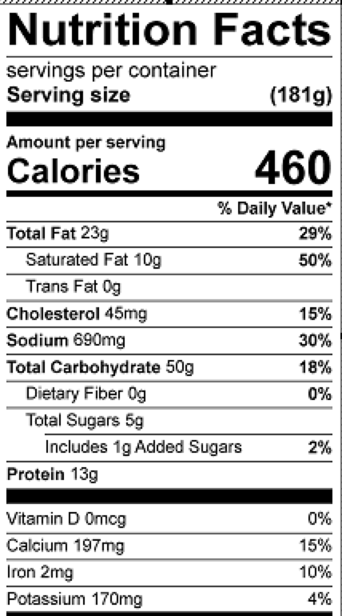
Vitamin C: 8.8 mg

