Apple Spiced Potato Muffins
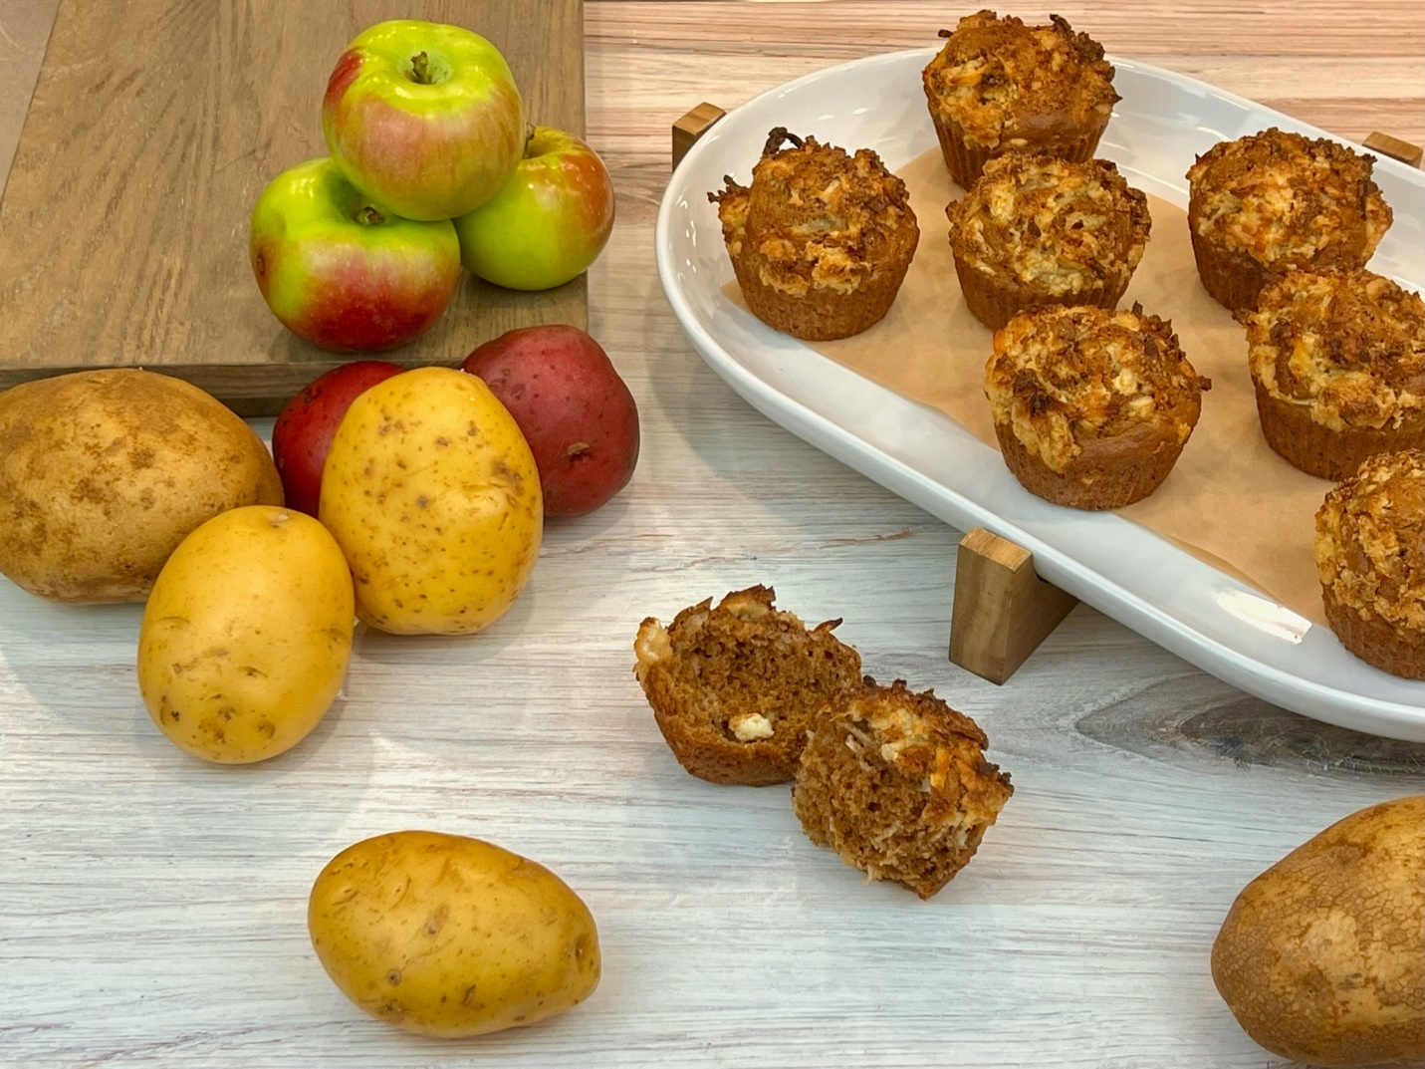
Program: Consumer
Short Description: Fuel your workouts with this performance-driven sweet treat
Long Description: Whole wheat muffins with spiced apples and shredded potatoes, topped with a potato cream cheese streusel.
Servings/portion size: 12
Preparation Time: 10 minutes
Cooking Time: 20 minutes
Total Time: 30 minutes
Potato Type: Dehydrated Potato Hash Brown Shreds
Course: Breakfast, Brunch, Lunch, Dinner, Snack, Side, Dessert
Ingredients:
Muffin:
- 1 ½ cups (204 g) Whole Wheat Flour
- ¼ cup (60 g) Potato, Dehydrated Hash Brown Shreds
- 1 ½ cups (150 ml) Water, Hot
- 2 tsp (5 g) Cinnamon
- 1 tsp (4 g) Baking Soda
- ½ tsp (3 g) Baking Powder
- ½ tsp (5 g) Salt
- 1 cup (118 g) Apples (Shredded)
- ½ cup (118 ml) Buttermilk
- ½ cup (100 g) Brown Sugar
- ¼ cup (59 ml) Vegetable Oil
- 2 ea. (126 g) Eggs, Large
- 1 tsp (5 ml) Vanilla Extract
Potato Cream Cheese Streusel: (Optional)
- ½ cup (100 g) Brown Sugar
- ½ cup (68 g) Flour, All Purpose
- 4 oz (113 g) Cream Cheese
- ¼ cup (60 g) Potato, Dehydrated Hash Brown Shreds

Preparation:
- Gather and scale all ingredients.
- Preheat the oven to 350°F (176°C).
- To rehydrate dehydrated hash browns, add hash browns in a bowl, then in a small pot, add water and heat till simmers and pour over hash browns and cover, and let sit for 12 minutes, and drain excess water or follow manufactures instructions. Then divide the rehydrated hash browns into two equal portions and set aside.
- In a large bowl, gently whisk flour, spices, baking soda, baking powder, and salt. Then add in one of the portions of hash browns that you set aside of rehydrated hash browns and toss to fully coat.
- In a separate large bowl, whisk shredded apples, buttermilk, brown sugar, oil, eggs, and vanilla extract.
- Add the buttermilk mixture into the flour mixture. Using a spatula, fold ingredients until just combined. Do not overmix.
- To make potato cream cheese streusel, cut the cream cheese into small cubes and place it in a small bowl, add brown sugar, all-purpose flour, and second portion hydrated hash brown shreds that was set aside, then gently mix until fully combined.
- Place muffin/cupcake liner into a standard muffin pan and lightly spray with pan spray (optional).
- Use a 2 oz or ¼ cup portion scoop and scoop into liners on a muffin pan and top off the muffin batter with potato cream cheese streusel roughly 2 tbsps.
- Place the pan into the preheated oven and bake for 16-18 minutes or until an inserted toothpick comes out clean. Remove muffins from oven, place on a cooling/wire rack, and let cool. Then enjoy.
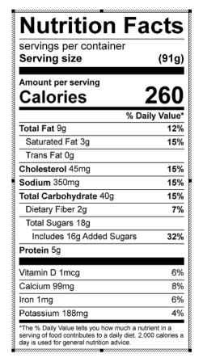
Vitamin C: 0.02 mg

