Alfredo Scalloped Potatoes
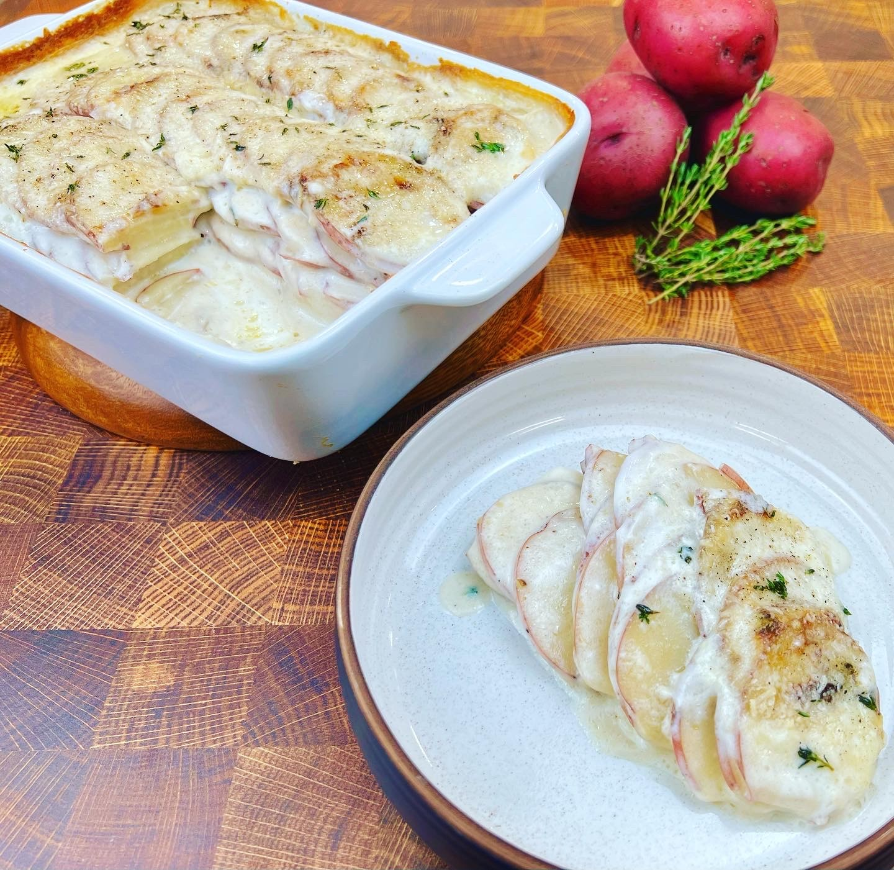

Program: Consumer
Short Description: Alfredo sauce and potatoes, a way to enjoy potatoes with parmesan and garlic.
Long Description: Thinly sliced red potatoes, slathered in a creamy Alfredo sauce with grated parmesan cheese and garlic that’s baked to perfection.
Servings/portion size: 8
Preparation Time: 30 minutes
Cooking Time: 45 minutes
Total Time: 75 minutes
Potato Type: Red Potatoes
Course: Breakfast, Brunch, Lunch, Dinner, Appetizer, Side Dish
Ingredients:
- 2.5 lbs. (1400 g) Red Potatoes
- 1 qt (946 ml) Milk
- ½ cup (45 g) Grated Parmesan Cheese
- ½ tbsp (8 g) Salt
- ½ tbsp (4 g) Ground White Pepper
- ½ tbsp (1 g) Fresh Thyme
- 1 tbsp (5 g) Garlic, Granulated
Roux:
- 1.5 oz (42 g) Butter
- 1.5 oz (42 g) All Purpose Flour

Preparation:
- Gather all ingredients and equipment needed.
- Preheat oven to 350°F (176°C).
- Using a mandolin or a large sharp knife, slice red potatoes thin. Then evenly layer sliced potatoes in a casserole dish.
- To make the roux, in a small pot or skillet, on low medium heat, add in butter and let melt, then add in flour and whisk together until mixed. then set aside.
- In a large pot, on medium heat, add milk and slowly let it come to a boil and then reduce heat to a simmer. Then add in white roux while continuously whisking. As soon as sauce begins to thicken add in grated parmesan cheese, granulated garlic, salt, and white pepper. Let sauce continue to simmer until sauce is thick.
- Then pour over sauce on top of evenly layered slice red potatoes until covered with sauce. Then place casserole dish into preheated oven at 350°F (176°C) for 45 minutes or until potatoes are fork tender and top is light golden brown in color.
- Remove from oven and sprinkle fresh thyme leaves and let cool before serving.
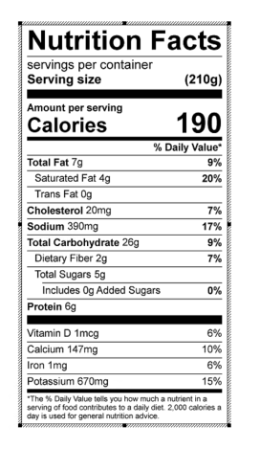
Vitamin C: 10.45 mg

