Potato Crusted Lemon Pepper Salmon
Description: Creamy sour cream whipped potatoes on top of lemon pepper salmon, a great option for a quick dinner at home.
Servings: 6
Preparation Time: 15 minutes
Cooking Time: 15 minutes
Total Time: 30 minutes
Potato Type: Instant Mashed Potatoes (Dehydrated Potatoes) *Fresh, Frozen or Refrigerated Mashed Potatoes can be subbed.
Course: Entree

Ingredients
Buttermilk Whipped Potatoes:
- 1-1/3 cup (320ml) Water
- 1 teaspoon (~1g) Salt
- ¼ cup (56.5g) Unsalted Butter, softened
- ½ cup (120ml) Whole Milk (Any milk can be subbed), cold
- 2-2/3 cup (135g) Instant Mashed Potatoes (Dehydrated Potato Flakes)
- 1/3 cup (80ml) Buttermilk
- ¼ cup (60g) Sour Cream
Lemon Pepper Salmon:
- 1-1/2 pounds (0.68kg) Salmon Filets, skin and pin bones removed Cut into 4-ounce (113g) pieces
- 2 teaspoons (10ml) Olive Oil
- 2 Tablespoons (14g) Lemon Pepper Seasoning
- 2 Tablespoons (6g) Fresh Chives, chopped

Preparation
- To prepare the mashed potatoes heat the water to a boil and add the salt and the butter. When the butter is melted add the cold milk and stir in the instant mashed potato flakes. Allow the mixture to sit for about a minute, then fluff with a fork. Gently fold in the buttermilk and the sour cream. Transfer the potatoes to a pastry bag or a resealable plastic bag with a star tip if desired (you can also gently spoon the mashed potatoes on top of the salmon if you don’t want to be super fancy, but the piping does make it look nice). It’s important the potatoes be creamy but not too loose, otherwise they won’t stay on top of the salmon, and you will have a mess in your air fryer.
- Place your salmon filets on the air fryer rack and lightly coat the filets with the olive oil. Season the salmon all over with the lemon pepper seasoning and arrange/pipe some of the mashed potatoes on top of the salmon.
- Set the air Fryer to 400 F (204 C) and cook the salmon for 12 minutes, this will result in beautiful medium rare pieces of salmon, if you wish your salmon to be well done, cook it for 14 minutes. This of course depends on the starting temperature of your salmon as well as the thickness. Thinner pieces will cook faster as will pieces that aren’t super cold.
- When the timer goes off, remove the salmon, the potatoes should be lightly golden with some crispy bits. And the salmon should be opaque but still moist.
- Plate the salmon and garnish the dish with the fresh chopped chives and some fresh slices of lemon if desired. Serve alongside your favorite side dishes.
*If you don’t feel like using an air fryer this recipe can also be made in a standard home oven, simply build the salmon as described but place it on a nonstick baking sheet. Set the oven to 500 F (260 C) and bake the salmon for 8-10 minutes, the extra heat is needed in a larger over compared to an air fryer but yields similar results.
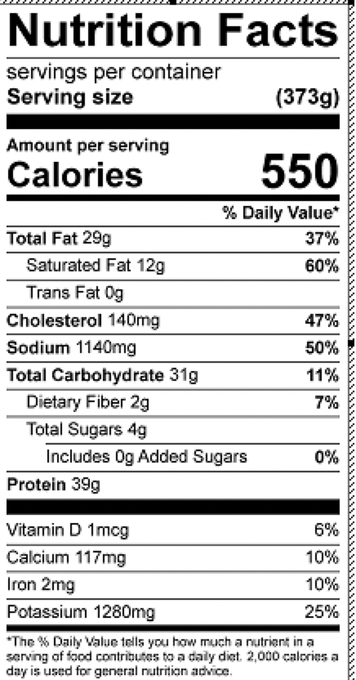
Vitamin C: 28mg

