Green Veggie Twice Baked Potatoes
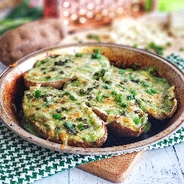
Description: Stuffed potatoes with spinach and peas to green up a creamy, protein-rich cottage cheese filling. Topped with a little Irish white cheddar and chives and baked until bubbling and gooey – a hearty side-dish or even a meal!

Servings/portion size: 4 servings.
Preparation Time: 5 minutes
Cooking Time: 15 minutes
Total Time: 20 minutes
Potato Type: 2 large Russet Potatoes, approximately 1/2 lb. each
Course: Lunch, Dinner, Side Dish

Ingredients
- 2 large Russet potatoes (240g or ½ lb. each), fully cooked (Steps below)
- 3 cups (90g) fresh spinach
- ½ (67g) cup frozen peas, thawed
- 2 tablespoons (30ml) water
- ¾ cup (180ml) 2% cottage cheese
- ½ tsp. (~1g) garlic salt
- 2-oz. (59g) shredded white Irish cheddar cheese
- 2 Tbsp. (~1g) finely chopped chives or green onion tops

Preparation
- To cook the baked potatoes: adjust the rack to the center of the oven. Preheat the oven to 450 °F.
- Rinse the potatoes under cold water and gently scrub the outside of the potatoes with a vegetable brush to remove any excess dirt. Dry the potatoes and pierce lightly with a paring knife about 6-8 times. This will allow steam to escape the potato as its baking.
- Dissolve 2 tablespoons of salt in a ½ cup of warm water in a large bowl. Place the potatoes in the bowl and rub the outside of the potatoes until they are evenly coated. Transfer the potatoes to a wire rack that is set inside the baking sheet. Place the potatoes in the oven and bake for 45 minutes – 55 minutes, or until the center of the largest potato reaches 205 °F.
- Preheat oven to 425 °F.
- Cut cooked baked potatoes in half lengthwise and use spoon to scoop out most of flesh, leaving just a bit around skin to create an oval “bowl.” Reserve scooped out potato for later.
- Add spinach, peas and water to bowl and microwave for 90 seconds or until wilted and cooked through.
- Add cottage cheese to blender along with reserved potato flesh. Add steamed spinach/pea mixture and garlic salt. Blend for 1 minute or until smooth.
- Spoon green mixture into potato skins, piling up as high as will allow without overflowing.
- Sprinkle with cheddar cheese and chives, bake for 15 minutes or until cheese bubbling and lightly browning.

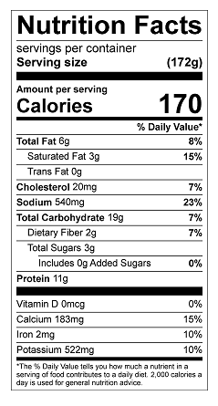
Vitamin C: 22 mg

