Green Up! Potato Smoothie

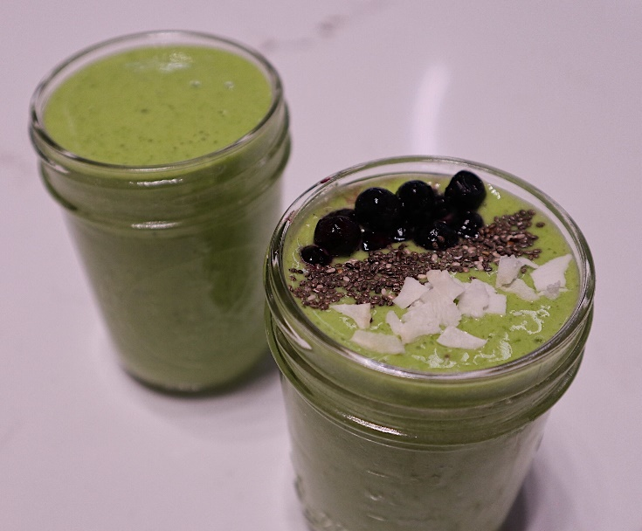

Description: Green up with this potato powered green smoothie!

Recipe by: Anthony Zamora, RD (Created exclusively for Potatoes USA)

Website Link: https://www.potatogoodness.com/recipes/green-up-potato-smoothie/

Prep time: 2 Minutes

Cook time: 30 Seconds

Ready time: 2 Minutes and 30 Seconds

Potato type used: Dehydrated Potato Flakes

Serves: 1 (1 smoothie is 16 ounces)

Prep Method (i.e. grilled, roasted, boiled, etc.): Blended

Course: Pre-Workout, Post-Workout

Ingredients:

- 2 cups spinach
- ½ cup dehydrated potato flakes
- 1 cups orange juice
- ½ banana
- 1 cup frozen pineapple
- 1 scoop of your favorite protein powder (e.g. vanilla)

Preparation:

- Combine all ingredients in a blender. You may add more liquid (orange juice or water) to reach desired consistency.
- Top smoothie with toppings of your choice, including flax seeds, toasted coconut chips or berries.

Nutrition:
Per serving (1 smoothie): Calories 466, Fat: 3 g, Cholesterol: 60 mg, Sodium: 127 mg, Carbohydrates: 86 g, Fiber: 7 g, Potassium: 732 mg, Protein: 31 g, Vitamin C: 240 mg

