Air Fryer Potatoes with Green Goddess Dip
Description: Crispy air fryer potatoes with a zesty, herbaceous dip.
Servings/portion size: 4 serving
Preparation Time: 5 minutes
Cooking Time: 20 minutes
Total Time: 25 minutes
Potato Type: Baby Potatoes
Course: Appetizer / Snack

Ingredients
- 1 lb. / 460 g Petite Potatoes
- 1 ½ tsp / 6 g Garlic Powder
- 2 ½ tsp / 10 g Blackened Seasoning
- 2 tsp / 8 g Dried Oregano
- 1 ½ tsp / 6 g Salt
- 1 tsp / 4 g Black Pepper
- 1 tbsp / 15 ml Olive Oil
- Parsley for Garnish

Green goddess dip
- ¼ cup / 4 g Cilantro
- ¼ cup / 4 g Parsley
- ¼ cup / 4 g Basil
- 2 tbsp / 11 g Green Onion
- 2 cloves / 10 g Garlic
- 1 cup / 16 g Greek Yogurt
- 1 tbsp / 15 ml Apple Cider Vinegar
- 2 tbsp / 30 ml Lime Juice
- ¼ cup / 4 g Olive Oil
- ½ tsp / 2 g Salt
- ½ tsp / 2 g Black Pepper

Additional salt and pepper to taste

Preparation
- Thoroughly rinse and scrub the petite potatoes. Dry then cut each baby potato in half.
- Place halved potatoes in large bowl then drizzle with olive. Add all seasonings and toss or mix until well combined.
- Cook potatoes in Air Fryer at 400 degrees for 10 minutes. Mix potatoes. Allow to cook for an additional 10 minutes or until golden and crisp.
- Garnish with freshly chopped parsley.

Green goddess dip
- Place all ingredients in blender or food processor. Process until smooth and green with tiny specks of herbs.
- Add additional salt and pepper to taste.

Notes
- Halved potatoes should be roughly the same size; if not, feel free to chop further to ensure doneness is consistent.

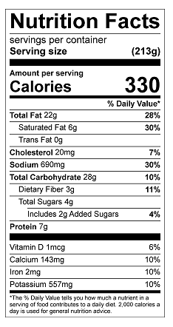
Vitamin C: 12 mg

