Shrimp and Potato Chowder
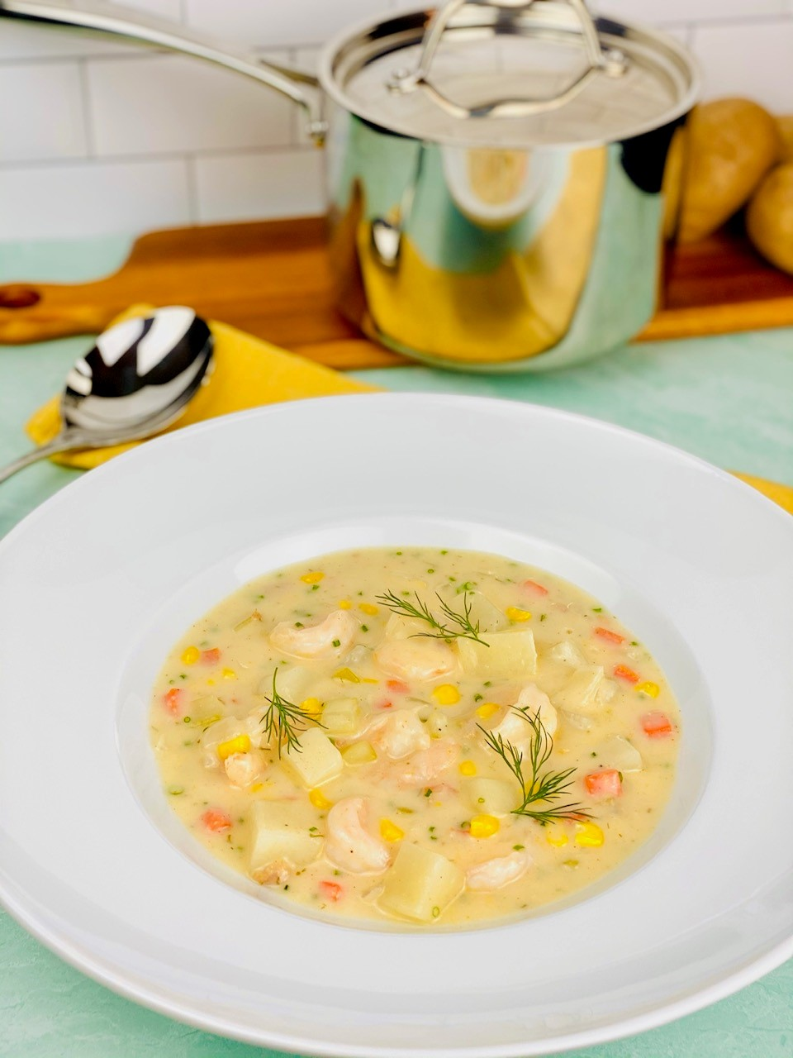
Description: Tender shrimp and yellow potatoes slow simmered in cream based sauce with aromatic vegetables, corn, and fresh herbs
Servings: 4
Preparation Time: 15 minutes
Cooking Time: 45 minutes
Total Time: 60 minutes
Potato Type: Yellow Potatoes
Course: Soup, Entrée, Brunch, Lunch, Dinner

Ingredients
For the Chowder:
- 2 tablespoons (56g) Unsalted Butter
- ½ cup (75g) Yellow Onions, chopped ½ inch dice
- ¼ cup (40g) Celery, chopped ¼ inch dice
- ¼ cup (40g) Carrots, chopped ¼ inch dice
- ¼ cup (40g) Fennel, chopped ¼ inch dice (optional)
- ¼ cup (58g) All Purpose Flour
- 64 ounces (2 liter) Seafood Stock (Vegetable Stock can be subbed)
- ¾ cup (180ml) Heavy Cream
- 2 cups (130g) Yellow Potatoes, diced 1 inch cubes
- 16 ounces (453g) 41/50 Medium Shrimp, peeled and deveined
- 1-1/2 teaspoons (2g) Kosher Salt
- 1 teaspoon (1g) Freshly Ground White Pepper
- ¼ cup (2g) Fresh Chives, chopped
- 1 tablespoon (1g) Fresh Tarragon, chopped
- 1 each Lemon, zested and juiced
Preparation
- In a large pot heat the butter over medium heat.
- When the butter is melted add the onions, celery, carrots, and fennel. Sauté the vegetables, stirring constantly to avoid any color on the vegetables (2-3 minutes).
- Dust the flour across the top of the vegetables and stir the flour into them. Using a whisk, slowly drizzle in the stock, stirring while pouring till combined.
- Stir in the heavy cream and add the potatoes. Bring the soup to a simmer and cook until the potatoes are just fork tender.
- Add in the shrimp and simmer for 3-5 minutes or until the shrimp is opaque and pink.
- Adjust the seasoning with the salt to your liking, the amount of salt you add here will vary depending on how salt the shrimp are.
- Stir in the white pepper, chives, tarragon, lemon zest and lemon juice.
- Serve immediately and enjoy!

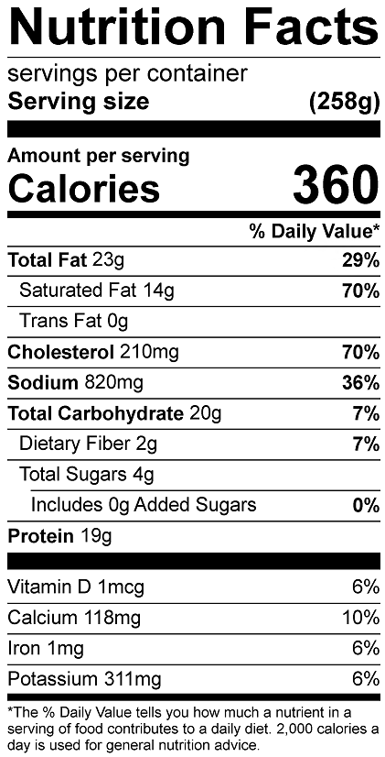

Vitamin C: 9.9mg

