Rosemary Roasted Potatoes w/ Tomatoes and Goat Cheese
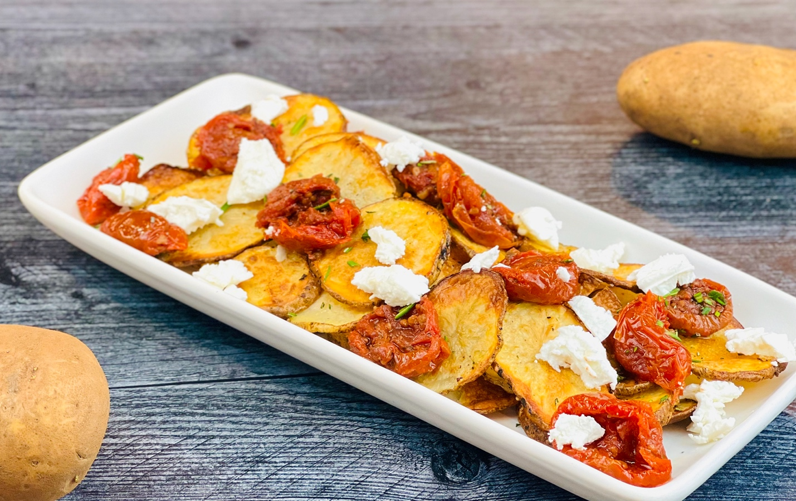
Description: Rosemary roasted slices of russet potatoes, topped with creamy crumbled goat cheese and flavorful marinated tomatoes
Servings: 4
Preparation Time: 10 minutes
Cooking Time: 25 minutes
Total Time: 35 minutes
Potato Type: Fresh Russet Potatoes
Course: Side

Ingredients
Rosemary Roasted Potato Slices:
- 4 each Russet Potatoes, sliced ¼ inch
- 2 tablespoons (30ml) Olive Oil
- 2 teaspoons (2g) Fine Sea Salt
- 1 teaspoon (1g) Freshly Cracked Black Pepper
- 3 teaspoons (3g) Freshly Chopped Rosemary

Marinated Tomatoes:
- 16 ounces (454g) Cherry Tomatoes
- 1 tablespoon Canola Oil
- 4 each (20g) Fresh Garlic, chopped
- 2 teaspoons (3g) Italian Seasoning
- 1 teaspoon (5ml) Red Wine Vinegar
- 1 each Sprig of Basil (optional)
- As Needed Olive Oil (for storing the tomatoes)
Garnish
- 4 ounces Goat Cheese, Crumbled
Preparation
- Preheat the oven to 425 F (218 C)
- To make the tomatoes (which can be made any time in advance). Toss the tomatoes in the canola oil and garlic. Place them on a baking sheet and bake for about 10-12 minutes, they should begin to burst a little and get slightly charred. Remove from the oven and sprinkle with the Italian seasoning and red wine vinegar.
- Consolidate the tomatoes into a small jar or crock and nestle the basil into the center of the container. Pour enough olive oil over the tomatoes to cover and set aside at room temp until ready to use. If making this well in advance be sure to store the tomatoes in the refrigerator (should last 7-10 days.
- In a large bowl toss the potato slices with the olive oil, sea salt, and black pepper. Place in a single layer onto a baking sheet lined with aluminum foil or parchment paper. Place in the oven and bake for 20-25 minutes or until golden and crispy on the outside. Remove from the oven and sprinkle immediately with the chopped rosemary.
- To serve arrange the crispy, hot potatoes on a plate/platter and top with some of the roasted tomatoes. Top with the crumbled goat cheese and serve right away.
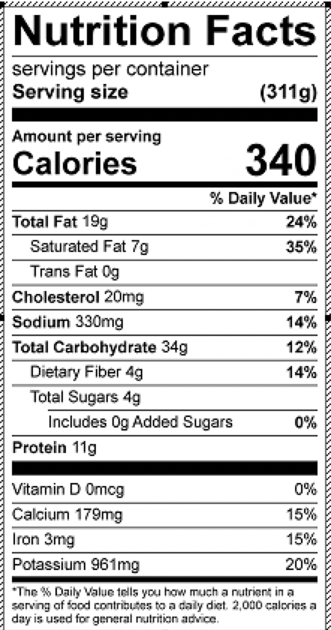
Vit C: 25.8mg

