Roasted Red Potatoes with Asparagus, Beets, Salmon and Lemon-Horseradish Cream
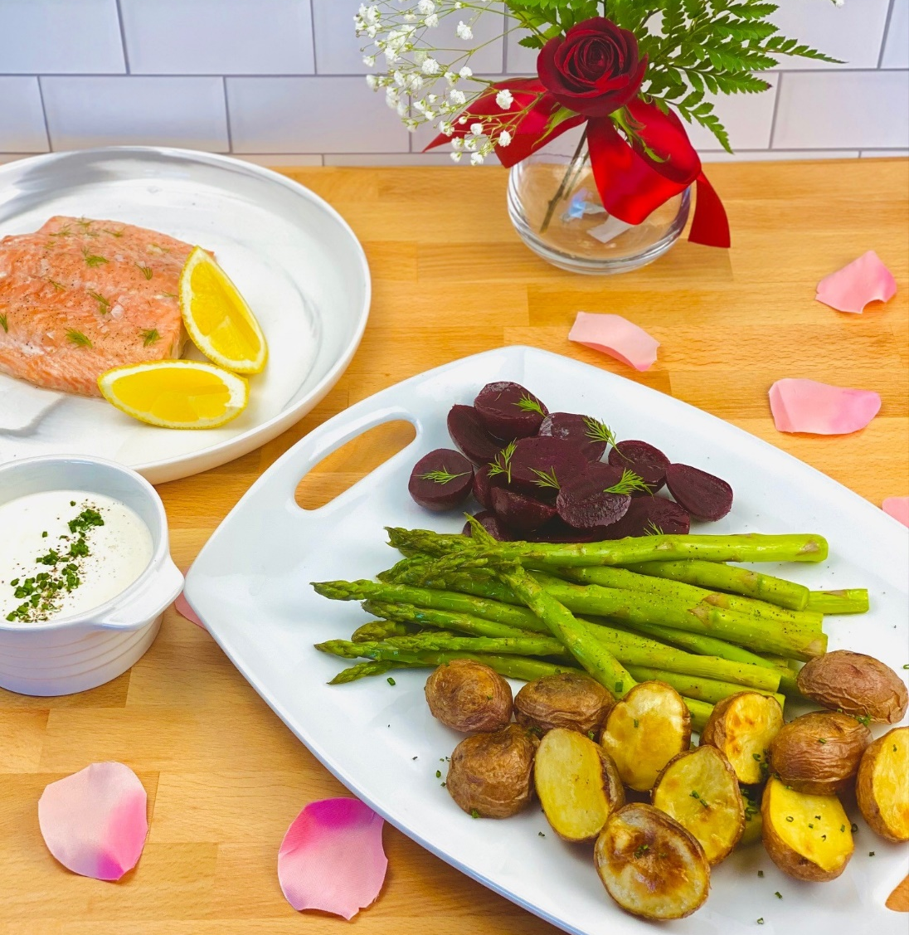
Description: Crispy roasted potatoes are coupled with tender asparagus, sweet beets, and flakey salmon served with a flavorful and creamy horseradish sauce.
Servings: 4
Preparation Time: 20 minutes
Cooking Time: 30 minutes
Total Time: 50 minutes
Potato Type: Red Potatoes
Course : Entree
Ingredients
For the Roasted Red Potatoes:
- 1 lb. (453g) Petite Red Potatoes, cut in half
- 2 tablespoons (30ml) Olive Oil
- 1 teaspoon (2g) Sea Salt
- 1 teaspoon (1g) Freshly Ground Black Pepper
- 1 each Lemon Zested
For the Beets:
- 1 lb. (453g) Beets, peeled and quartered
- 2 teaspoons (10ml) Olive Oil
- ½ teaspoon (1g) Sea Salt
- 1 tablespoon (15ml) Red Wine Vinegar
- 1 tablespoon (1g) Chopped Dill
For the Asparagus:
- ½ lb. (227g) Asparagus, trimmed
- 2 teaspoons (10ml) Olive Oil
- 1 teaspoon (1g) Sea Salt
For the Salmon:
- 1 lb. (453g) Wild Salmon Filets
- 1 tablespoon (2g) Lemon Pepper Seasoning
For the Horseradish Cream:
- 1 cup (240ml) Sour Cream
- 2 tablespoons (30ml) Lemon Juice
- 1 each Zest of one lemon
- 2 tablespoons (30ml) Prepared Horseradish
Garnish:
- ¼ cup (8g) Fresh Chives, chopped

Preparation
- Preheat the oven to 400 °F (204 °C)
- To prepare the potatoes and beets, in two separate bowls, combine the ingredients for the potatoes and in the other combine the ingredients for the beets. Place them on a aluminum foil lined baking sheet and place in the oven for 30-35 minutes or until the root vegetables are tender.
- When the potatoes and beets are done, place the asparagus on the baking sheet, drizzle with the olive oil and season with the salt. Return the pan to the oven and roast for 6-8 minutes or until the asparagus is bright green. Remove the veggies from the oven and prepare the salmon.
- On another baking sheet place the salmon. Season the salmon with the lemon pepper seasoning and place in the oven for 8-10 minutes. While the salmon is roasting, prepare the sauce by combining all the ingredients for the sauce in a bowl and stirring well to combine.
- Once the salmon reaches an internal temperature of 145 °F remove it from the oven, alternatively if the salmon is opaque and pink it’s ready. If you see too much white fat being squeezed out of the salmon, that means its being overcooked, remove it immediately.
- To serve plate some of each of the vegetables on a plate. Nestle a portion of salmon on top of the vegetables and spoon some of the sauce on top of the salmon. Garnish the entire dish with some of the chopped chives. Enjoy!
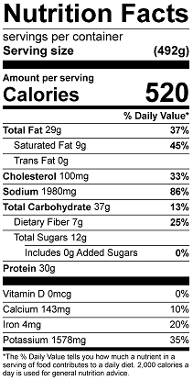
Vitamin C: 22.7mg

