Potato Tart with Roasted Tomatoes and Feta
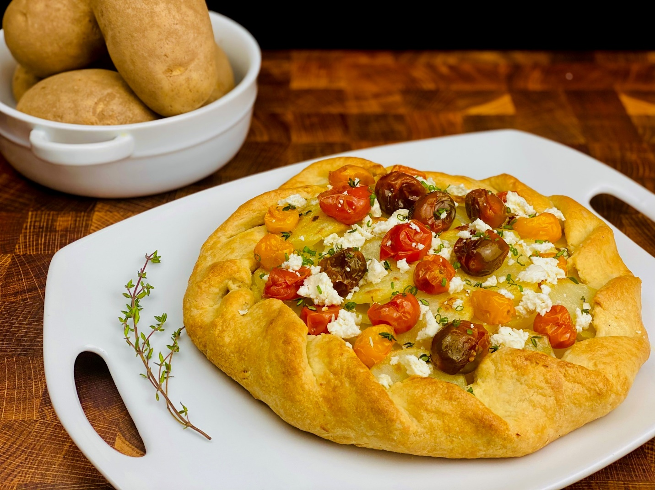
Description: Russet potatoes scented with garlic, layered with fresh herbs in a flakey crust then topped with slow roasted cherry tomatoes.
Servings: 4
Preparation Time: 45 minutes
Cooking Time: 30 minutes
Total Time: 75 minutes
Potato Type: Russet Potatoes
Course : Entrée, Brunch, Lunch, Dinner

Ingredients
For the Potatoes:
- 1 lb. (454g) Russet Potatoes, peeled and sliced ¼ inch thick
- 6 cups (1440ml) Cold Water
- 2 teaspoons (4g) Sea Salt
- 5 each (25g) Garlic Cloves, peeled
- ½ each Lemon
For the Tomatoes:
- 1 pint (467g) Cherry Tomatoes
- 1 tablespoon (15ml) Olive Oil
- ½ teaspoon (1g) Sea Salt
- ½ teaspoon (1g) Freshly Ground Black Pepper

- 1/2 each (14.1 ounce) Refrigerated Pie Shell
- 1/3 cup (6g) Fresh Chives, chopped (Green Onions can be subbed)
- ¼ cup (60 ml) Heavy Cream
- ¼ cup (4g) Parmesan Cheese, grated
- ¼ cup (20g) Feta Cheese, crumbled

Preparation
- To prepare the potatoes, place the potatoes in a large pot and cover with the water. To the water add the salt, garlic cloves, and lemon. Place the pot over medium high heat and bring to a boil. Reduce the heat to a simmer and cook the potatoes for 10-12 minutes or until they are just fork tender but not falling apart. Drain the potatoes, discard the lemon and garlic. Allow the potatoes to cool completely.
- Drizzle the olive oil over the tomatoes in a small pan. Season with the salt and pepper and place into a 325 °F oven for 20 minutes. Remove from the oven and allow to cool to room temp before using. (This step can be done up to 3 days in advance)
- Roll out the pie crust on a non-stick baking sheet. Arrange a layer of potatoes in the center of the pie crust. Sprinkle a layer of the chopped chives or green onions on the potatoes, then lay a layer of potatoes followed by a sprinkle of chives and repeat again with another layer of potatoes.
- To finish the tart, fold one edge of the pie crust slightly over the edge of the potatoes. Take the edge of the pie crust next to the edge that was just folded and fold it over. Continue with this all around the tart.
- Lightly brush the cream all around the edge of the tart, and also on the exposed portion of potatoes. Sprinkle the tart with the grated parmesan cheese.
- Place the tart in a 400 °F (204 °C) oven for 18-20 minutes or until the tart is golden brown. Remove the tart from the oven and sprinkle it with feta cheese. Allow the tart to cool for 7-8 minutes. Garnish the top of the tart with roasted tomatoes and a sprinkling of chopped chives or green onions. To serve slice the tart into 4 portions and enjoy!

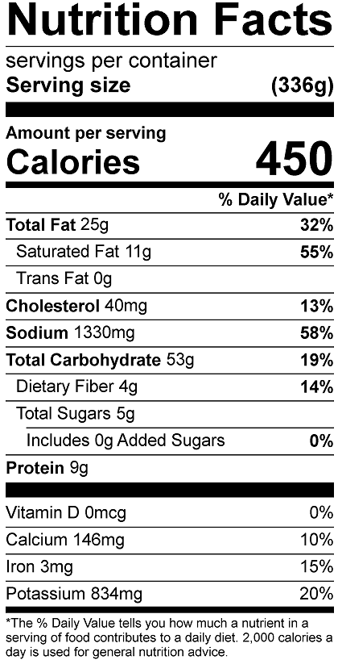

Vitamin C: 45.1mg

