Pancetta Roasted Potatoes with Rosemary and Grilled Parmesan-Artichoke Chicken
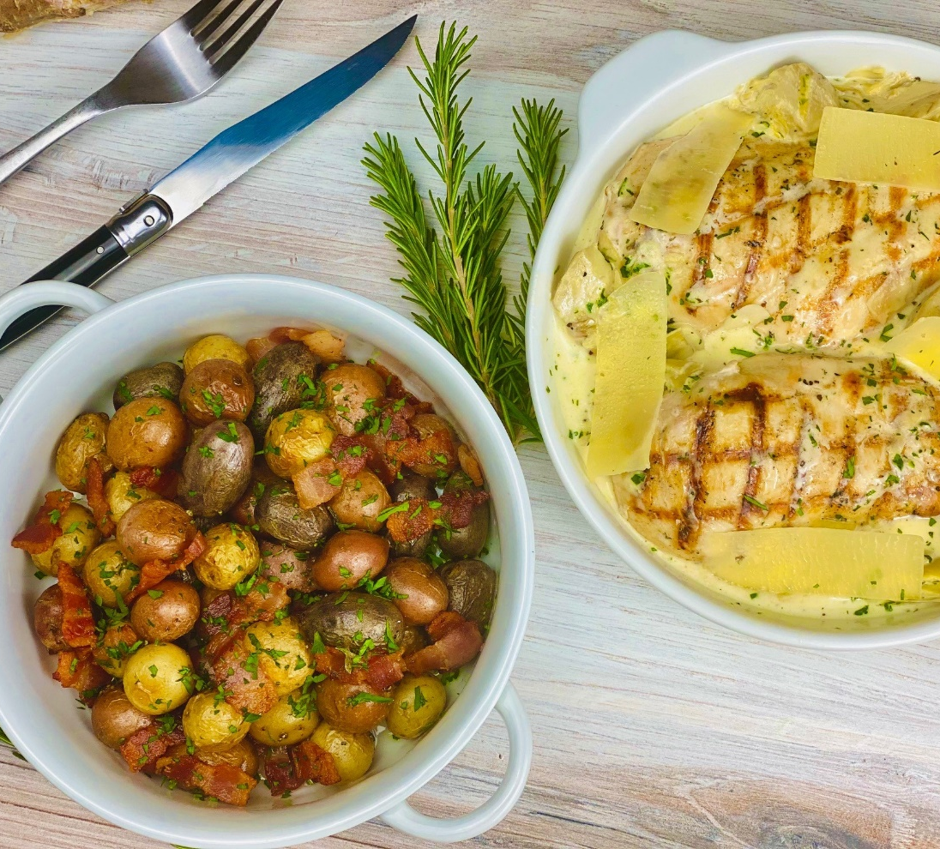
Description: Crispy pancetta and petite potatoes are roasted in the oven together with fresh rosemary. The perfect pairing for grilled chicken in a creamy parmesan and artichoke cream sauce.
Servings: 4
Preparation Time: 15 minutes
Cooking Time: 30 minutes
Total Time: 45 minutes
Potato Type: Petite Potatoes
Course: Entree

Ingredients
For the Pancetta Potatoes:
- 6 ounces (180g) Pancetta, diced fine
- 1 lbs. (~500g) Petite Potatoes, washed and dried
- ½ tablespoon (7ml) Olive Oil
- 1 tablespoon (2g) Fresh Rosemary, chopped
- 1 teaspoon (2g) Fine Sea Salt
For the Chicken:
- 24 ounces (680g) Chicken Breast, Boneless/Skinless
- 1 teaspoon (5ml) Olive Oil
- 1 teaspoon (2g) Fine Sea Salt
- ½ teaspoon (1g) Freshly Ground Black Pepper
- 1 cup (240ml) Chicken Stock or Broth
- 1/2 cup (120ml) Heavy Cream
- 14 ounces (240g) Canned Artichokes, Drained (about 2 cans)
- ½ cup (15g) Parmesan Cheese, finely grated
- 1 tablespoon Fresh Parsley, chopped
- 1-1/2 tablespoons Freshly Squeezed Lemon Juice
- As Needed Parmesan Cheese, large peels

Preparation
- Preheat the oven to 400 °F (204 °C)
- To prepare the potatoes; in a large non-stick pan over medium-high heat crisp the pancetta and remove from the pan. Add the olive oil and the potatoes and cook for 3-5 minutes before placing the entire pan in the oven. Cook the potatoes in the oven for 8-10 minutes or until they are fork-tender. Remove from the oven, allow to rest for 3-5 minutes, and add the crispy pancetta to the potatoes. Season the potatoes with rosemary and sea salt. Keep warm until ready to serve.
- To prepare the chicken; rub each breast with olive oil, then season with salt and pepper. Grill the breast over high heat in a grill pan or on an outdoor grill, conversely, the chicken can be simply pan seared if a grill is not available. After the chicken has nice grill marks, it can be placed in the oven for 8-10 minutes or until the juices run clear and the internal temperature of the chicken breast is 155 °F. The chicken will continue to carry overcook as well as finish in the oven one more time before serving so take care not to overcook the chicken.
- To make the sauce, combine the stock and the heavy cream in a medium pot. Place the pot over medium-high heat and cook for 6-7 minutes or until the volume of the cream and stock have reduced by 50%. Remove the sauce from the heat and stir in the artichoke hearts and the shredded parmesan cheese. Once fully incorporated stir in the parsley and lemon juice.
- Place the chicken in a serving dish that is oven safe. Pour the sauce over the chicken breast and place in the oven for 5 minutes. Remove from the oven and garnish the dish with parmesan peels. Serve the chicken alongside the marble potatoes. Enjoy!
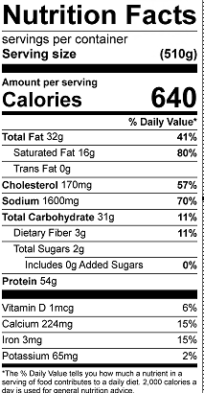
Vitamin C: 8.7mg

