Loaded Twice Baked Potato with Grilled New York Strip Steak
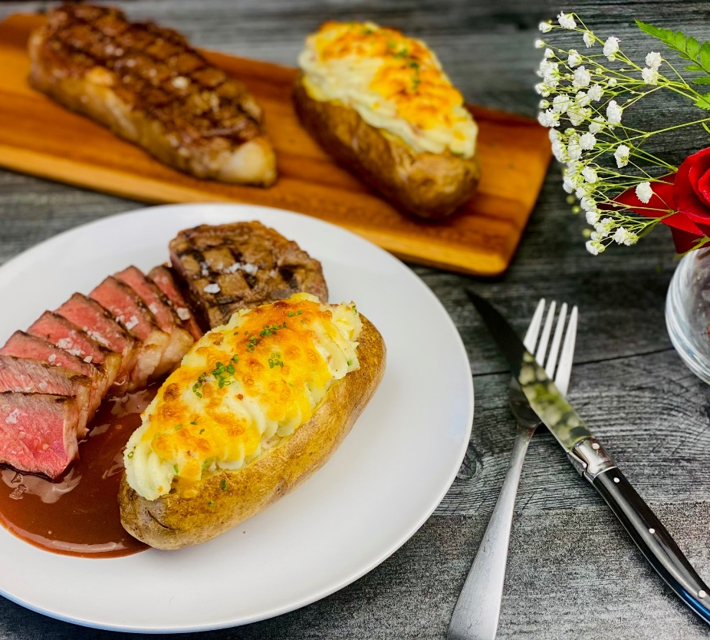
Description: Decadent and richly whipped potatoes placed back in the potato shell and baked again. The absolute perfect pairing with a grilled steak and a red wine sauce.
Servings: 4
Preparation Time: 20 minutes
Cooking Time: 60 minutes
Total Time: 80 minutes
Potato Type: Russets
Course: Entree

Ingredients
For the Twice Baked Potato:
- 2.2lbs (1 kg) Russet Potatoes, washed (approx. 4x 8-ounce potatoes)
- 1 tablespoon (15ml) Olive Oil
- ¼ cup (60ml) Whole Milk, warm
- 2 tablespoons Unsalted Butter, softened
- ½ cup (120ml) Sour Cream
- ½ cup (75g) Shredded Cheddar Cheese
- ¼ cup (8g) Chopped Chives (Green Onions can be subbed)
- 1/3 cup (60g) Bacon, chopped, cooked
- ¼ cup (38g) Shredded Cheddar Cheese
- 1 teaspoon Ground White Pepper
- 1-1/2 teaspoons Kosher Salt
For the Steak
- 2 lbs. (907g) New York Strip Steak
- 1 tablespoon (15ml) Olive Oil
- 1/2 tablespoon (2g) Kosher Salt
- 2 teaspoons (2g) Freshly Ground Black Pepper
For the Red Wine Sauce
- 1 teaspoon (5ml) Olive Oil
- 2 tablespoons (30g) Shallots, chopped fine
- 1 tablespoon (10g) Tomato Paste
- 1 cup (240ml) Dry Red Wine
- 4 cups (960ml) Beef Stock or Broth
- 1 each Thyme Sprig
- 2 tablespoons (3g) Corn Starch
- ¼ cup (60ml) Cold Water

Preparation
- Preheat the oven to 400 °F (204 °C)
- To prepare the potatoes, wash and scrub the russet potatoes under cold running water. Dry the potatoes thoroughly and place them onto a baking sheet with a wire rack if you do not have a rack it’s ok. Pierce the potatoes lightly with the tip of a knife or the tines of a fork. Place the potatoes into the oven and cook them for 45 minutes or until the potatoes are fork-tender, if you want to be really accurate an internal thermometer should reach 205 °F (96 °C). Remove from the oven and brush the skins of the potato with olive oil. Allow the potatoes to cool for about 15 to 20 minutes or until they are cool enough to handle.
- Lay the potato flat on a cutting board and remove the top ¼ of the potato so you have a place to scoop out the cooked flesh of the potato. Remove the potato pulp from the inside of the potato leaving a ½ inch thickness on the potato shell. Place all the cooked potato pulp into a bowl. Add the milk and butter and whisk the potatoes until they are light and fluffy. The amount of milk you need could vary depending on how much potato you got out of each potato. Once the potatoes are light and fluffy mix in the sour cream, ½ cup of cheese, chives, bacon, salt, and pepper. Stir this until combined and well mixed. Split this filling up into four portions, one for each potato. Spoon the filling into each potato shell. The tops of the potatoes can be used for another use or they can be discarded. Place the stuffed potatoes back on the baking sheet with the rack, sprinkle the ¼ cup of cheese on top of the stuffed potatoes. Return the potatoes to the oven for 8-10 minutes or until the cheese is melted and the inside of the potato is hot.
- To prepare the sauce, heat the olive oil in a small saucepan over medium heat. Add the shallots and cook them for 30 seconds to a minute until the shallots are translucent. Stir in the tomato paste and cook for another 30 seconds. Add the red wine and reduce the volume by 50 percent (about 5 minutes). Add the beef stock and thyme. Cook the sauce until the total volume reduces by 75%, this should take about 15-20 minutes and should be done while the potatoes are in the oven. Mix the corn starch with the water and whisk the mixture into the sauce. Remove the thyme and keep the sauce warm until ready to serve.
- To prepare the steaks, remove the steaks from the fridge about an hour prior to preparing so they are at room temp. Rub the steaks with olive oil, and season them with salt and pepper. Grill the steaks on a grill or sear them in a cast-iron pan over high heat. Cook the steaks for about 4-5 minutes on each side, and place in the oven or finish on the grill. The internal temperature of the steaks should be 115-120 °F for Medium Rare, 120-125 °F for Medium, 125-130 °F for Medium Well, and 130-135 °F Well Done. As the meat rests, the temperature will continue to rise (about 5-10 °F), this is called carry-over cooking. Be sure to allow the steaks to rest for 5-7 minutes before slicing.
- To serve, slice the steaks against the grain, and arrange them on serving plates next to the twice-baked potatoes. Spoon some of the prepared sauce under the steak. Pair with a nice red wine and enjoy!
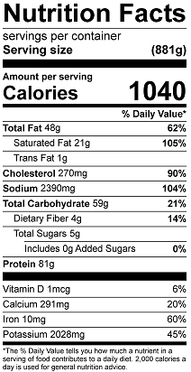
Vitamin C: 16.55mg

