Garlicky Potatoes and Green Beans with Lemon-Tarragon Roasted Chicken
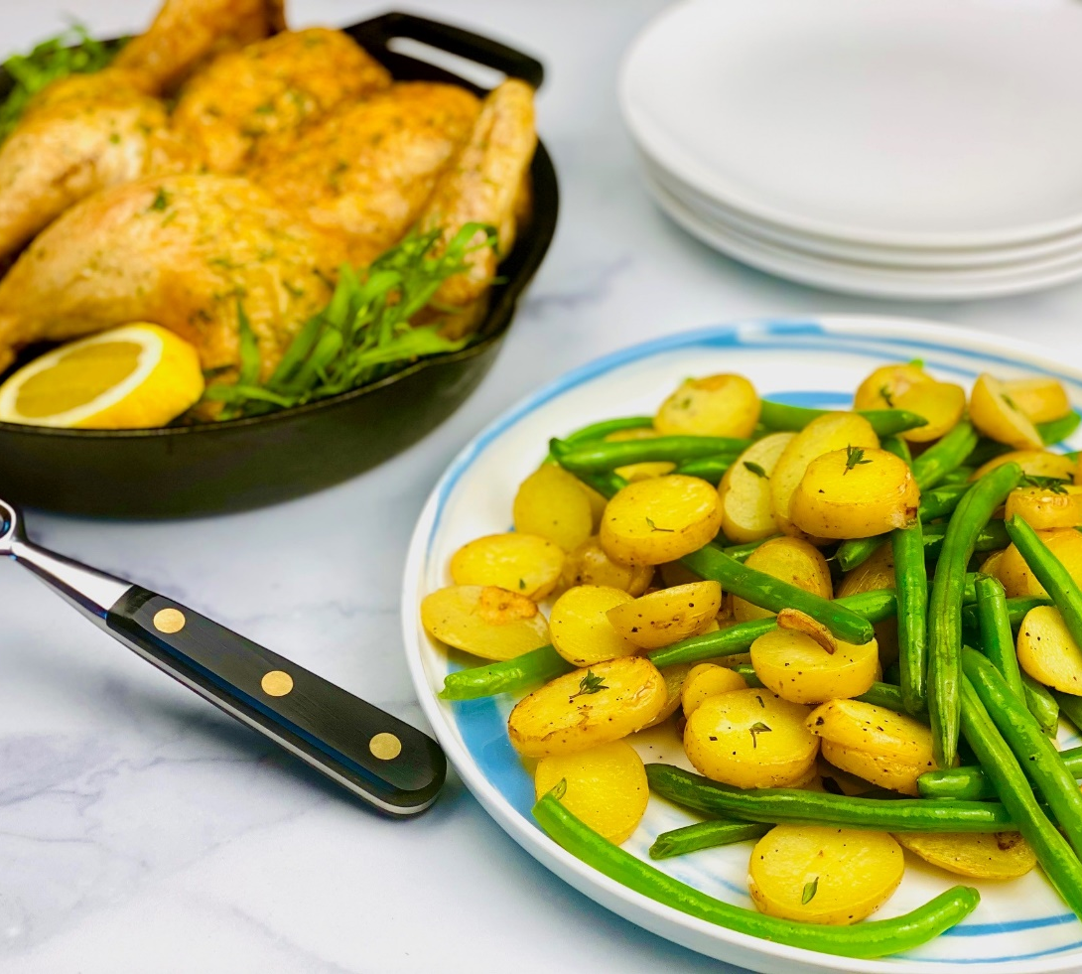
Description: Crispy potatoes cooked in rendered chicken fat along with tender green beans, garlic and shallots, served alongside a juicy roast chicken with lemon and tarragon.
Servings: 4
Preparation Time: 20 minutes
Cooking Time: 45 minutes
Total Time: 65 minutes
Potato Type: Yellow Potatoes
Course: Entree

Ingredients
For the Roasted Lemon-Tarragon Chicken:
- 1-2 lbs. (.5-1kg) Whole Chicken
- 2 Tablespoons (30 ml) Olive Oil
- 1 Tablespoon (2g) Kosher Salt
- 2 teaspoons (4g) Freshly Ground Black Pepper
- 1 each Fresh Lemon, sliced in half
- 1 each Head of Garlic, sliced in half
- 1 bunch Fresh Tarragon
For the Potatoes and Green Beans:
- 1 lbs. (452g) Yellow Potatoes, sliced 1/4-inch rounds
- 2 Tablespoons (30ml) Melted Chicken Fat from the roasted chicken (olive oil can be subbed if desired)
- 2 each Garlic Cloves, thinly sliced
- 2 Tablespoons (5g) Shallots, freshly chopped
- 2 cups (150g) Green Beans, trimmed
- 1 teaspoon (2g) Kosher Salt
- ½ teaspoon (1g) Fresh Ground Black Pepper
- 1 teaspoon (1g) Fresh Thyme, chopped
For the Lemon and Herb Sauce:
- 1-1/2 cups (360ml) Chicken Stock
- 2 Tablespoons (3g) Corn Starch
- ¼ cup (60ml) Cold Water
- 1 Tablespoon (15ml) Freshly Squeezed Lemon Juice
- 2 Tablespoons (2g) Fresh Parsley, chopped
- ½ teaspoon (1g) Fresh Ground Black Pepper

Preparation
- Preheat the oven to 400 °F (204 °C)
- To prepare the Chicken, remove the chicken from the fridge about an hour before preparing it. Allow it to come to room temp. Rub the outside of the chicken with the olive oil and season the cavity of the bird with the salt and pepper. Stuff the cavity with the lemon that has been cut in half, the fresh tarragon, and the head of garlic which has also been cut in half. Trussing the chicken (or tying the bird up) is optional but it will promote more even cooking. If you choose to not truss the chicken simply place the bird on a baking sheet fitted with a wire rack, then place in the oven. If trussing, take a folded piece of butcher twine and align the middle part of the string where the fold was to the tail of the chicken. With the breasts facing upwards wrap the string around tail then loop the string around each end of each drumstick, cross the strings across each other and pull tight to bring the legs together. Wrap the string up and around the crease between the leg and breast, be sure to do this on both sides. Flip the bird over, being careful not to empty all the aromatics in the cavity of the bird. Cross the strings around the lower back of the chicken and flip the bird over once more. Both ends of the string should now be positioned under the wings. Tuck the tips of the wings under the back of the chicken. Bring the ends of the string together tying the wings against the sides of the breast. Make a simple knot to secure the bird and your chicken is trussed. It can now be placed on a baking sheet with a wire rack and into the 400 °F (204 °C) oven. Roast the chicken for about 45 minutes or until a thermometer reads 155 °F (69 °C). The bird will continue to carry over cook as it rests, meaning the temperature will continue to rise slightly once its out of the oven, by the time it fully rests the temperature should be at 165 °F (74 °C) and perfectly moist. Keep the bird warm until ready to serve. Remove some of the melted chicken fat from the pan for the potatoes.
- For the potatoes heat the melted chicken fat in a large non-stick pan over medium high heat. Add the sliced potatoes and sauté for about 5 minutes, once the potatoes are golden, add the garlic and shallots, continue to cook the potatoes until the garlic and shallots are caramelized and golden brown. Add the green beans and cook for about 30 seconds. Place a lid on the pan and allow the vegetables to steam for about 2-3 minutes. The green beans should be bright green. Turn off the heat and season the vegetables with the salt, pepper, and thyme. Keep the vegetables warm while the sauce is made.
- To prepare the sauce, heat the chicken stock in a medium pan over medium-high heat. In a small bowl combine the corn starch and the water. Whisk the corn starch mixture into the hot stock and stir continuously until the sauce thickens slightly. Whisk in the lemon juice, parsley, and pepper.
- To serve, plate some of the chicken along with the potatoes and green beans, spoon some of the sauce over the chicken, serve with a crisp white wine and enjoy.

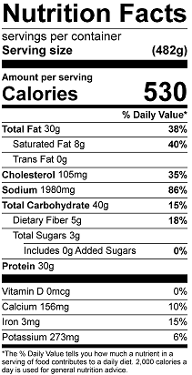
Vitamin C: 23.6mg

