Chili Spiked Shrimp with Pesto Marinated Potatoes
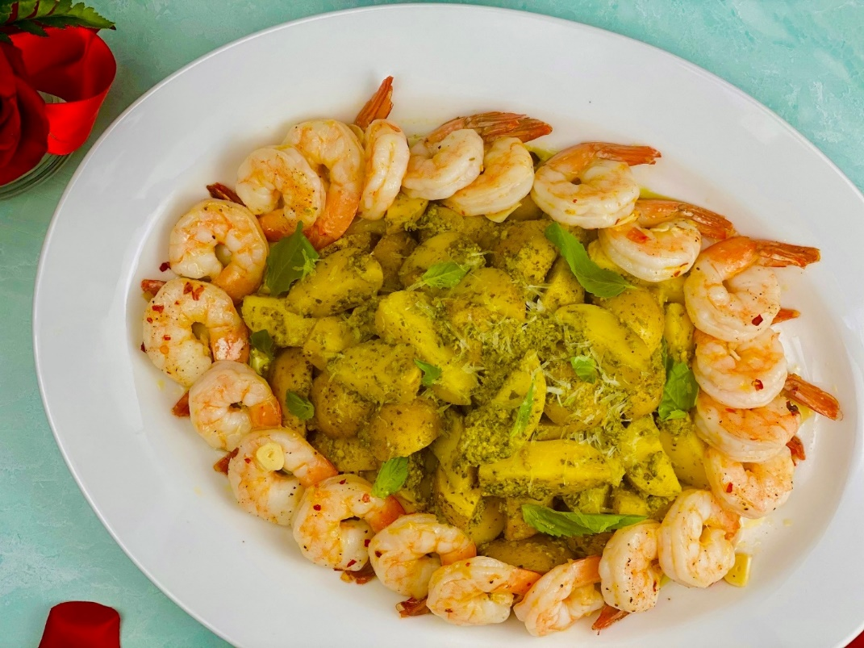
Description: Plump and tender shrimp, sauteed in chili flakes and garlic served with creamy yellow potatoes that have been tossed in basil pesto.
Servings: 4
Preparation Time: 10 minutes
Cooking Time: 25 minutes
Total Time: 35 minutes
Potato Type: Yellow Potatoes
Course : Entree

Ingredients
For the Pesto Potatoes:
- 1.5 lbs. (680g) Yellow Potatoes, cut in quarters
- 6 cups (1440ml) Cold Water
- 2 teaspoons (4g) Sea Salt
- 5 each (25g) Garlic Cloves, peeled
- ½ each Lemon
- 6 ounces (170g) Prepared Basil Pesto
For the Shrimp:
- 1 lbs. (453g) 21/25 Jumbo Shrimp, peeled and deveined
- 1 tablespoon (15ml) Olive Oil
- ½ teaspoon (1g) Crushed Red Chili Flakes
- 3 each (15g) Garlic Cloves, peeled and sliced thin
Garnish:
- ¼ cup (8g) Fresh Basil Leaves, picked
- ¼ cup (4g) Parmesan Cheese, grated

Preparation
- To prepare the potatoes, place the potatoes in a large pot and cover with water. To the water add the salt, garlic cloves, and lemon. Place the pot over medium-high heat and bring to a boil. Reduce the heat to a simmer and cook the potatoes for 20-25 minutes or until they are fork-tender. Drain the potatoes, discard the lemon and garlic. Transfer the potatoes to a bowl and toss together with the pesto. Keep the potatoes warm until ready to serve.
- To prepare the shrimp, clean the shrimp if it has not already been done. In a large nonstick pan, heat the olive oil over medium-high heat. Add the chilies and garlic. Allow the aromatics to cook for about a minute before adding the shrimp. Once cooked the shrimp will become opaque, this will take about 3-5 minutes.
- To plate arrange the potatoes in the center of a serving platter. Place the shrimp around the perimeter of the potatoes and serve right away. Enjoy.

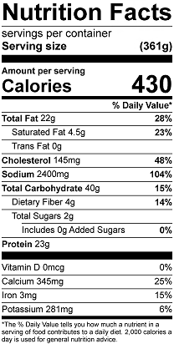

Vitamin C: 13.9mg

