Sour Cream and Green Onion Potato Chip Gratin
Description: Rich, decadent, and fun. This potato gratin has all the flavor of sour cream and onion chips with layers of sour cream, green onions, sliced russet potatoes, bubbly cheddar cheese and of course potato chips.
Servings: 8
Preparation Time: 30 minutes
Cooking Time: 20 minutes
Total Time: 50 minutes
Potato Type: Russet Potatoes and Potato Chips
Course: Entrée or Side Dish

Ingredients
Sour Cream and Onion Potato Chip Gratin:
- 1 tablespoon (15g) Unsalted Butter, softened
- 1-1/2 pounds (0.68kg) Russet Potatoes, sliced ¼ inch thick
- As Needed Cold Water
- 2 tablespoons (9g) Salt
- 16 ounces (453g) Sour Cream
- ¼ cup (60ml) Heavy Cream
- 6 ounces (170g) Sour Cream and Onion Potato Chips, crumbled
- 1 cup (60g) Green Onions, sliced
- ½ pound (226g) Shredded Cheddar Jack Cheese
Garnish:
- 2 tablespoons (30ml) Sour Cream (Optional)
- ½ teaspoon (~1g) Fresh Chives, chopped
Preparation
- Rub the inside of an oven safe casserole dish (that will fit in your air fryer) with the softened butter.
- In a pot, add the sliced russet potatoes and cover them with water. Add the salt and bring the pot to a boil over medium high heat. Reduce the heat to a simmer and allow the potatoes to cook for 8-10 minutes. At this stage they should be fork tender but not falling apart.
- Drain the potatoes well and spread them out on a baking sheet to slightly cool them.
- While the potato slices are cooling mix the sour cream together with the heavy cream and set aside.
- To build the gratin, begin with a layer of the sliced potatoes, followed by a layer of the sour cream mixture, then the crushed potato chips, then the green onions, and finally a layer of cheese. Repeat these steps until you have three layers and end on the cheese layer. Make sure you leave enough space in the casserole dish to allow the casserole to bubble without spilling over into the air fryer (otherwise its quite the mess).
- Place the casserole into the air fryer and cook at 400 F (204 C) for 18-20 minutes. The casserole should be bubbling, and the cheese should be melted and golden.
- Remove the casserole from the air fryer and top with a final layer of crushed chips. Garnish the casserole with a dollop of sour cream and a sprinkling of fresh chives.
- Its best to allow the gratin to cool for about 5-10 minutes before serving.
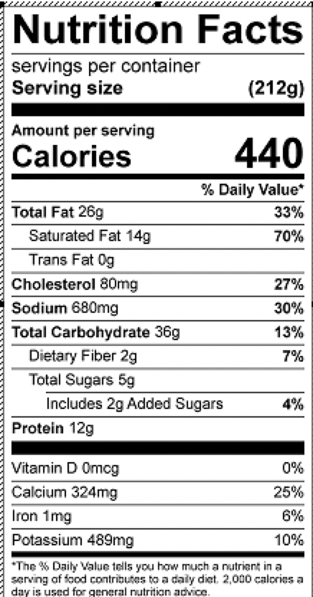
Vitamin C: 6.3mg

