Miso Honey Glazed Hash Brown Bites
Description: Crispy petite hash brown clusters tossed in a sweet and slightly salty glaze with miso, sesame, honey, garlic, and ginger.
Servings: 6
Preparation Time: 10 minutes
Cooking Time: 20 minutes
Total Time: 30 minutes
Potato Type: Frozen Tater Drums
Course: Appetizer, Snack, Side Dish

Ingredients
Hash Brown Bites:
- 1-1/2 pounds (0.68kg) Frozen Tater Drums, Tots, Barrels, etc.
- As Needed Nonstick Coconut Oil Spray
Miso-Honey Glaze:
- 2 tablespoons (30ml) White Miso (Yellow Miso can be subbed)
- 1 teaspoon (3g) Ground Ginger
- 1 each (5g) Garlic Clove, finely chopped
- 1 tablespoon (15ml) Honey
- 2 teaspoons (10ml) Sesame Oil
- 1 teaspoon (5ml) Rice Vinegar
Garnish:
- ¼ cup (20g) Sliced Green Onions
- 1 tablespoon (14g) Toasted Sesame Seeds
Preparation
- Arrange the frozen potatoes on a baking sheet and evenly spray them with a light misting of nonstick spray, any spray can be used here instead of coconut oil if desired.
- Set the air fryer to 425 F (218 C), Arrange the potatoes in an even layer in the air fryer, you may have to do two batches depending on the size of your air fryer.
- Cook the frozen potatoes in the air fryer for 18-20 minutes or until they are golden and crispy.
- While they are cooking make the glaze by combining the miso, ginger, garlic, honey, sesame oil, and vinegar in a small bowl until well combined.
- As soon as the potatoes are crispy, remove them from the air fryer and transfer them to a large bowl. Add the glaze and toss quickly to combine, be carefully not to break up the potatoes. Arrange the potatoes on a serving platter and garnish them with the sesame seeds and green onions. Enjoy immediately.
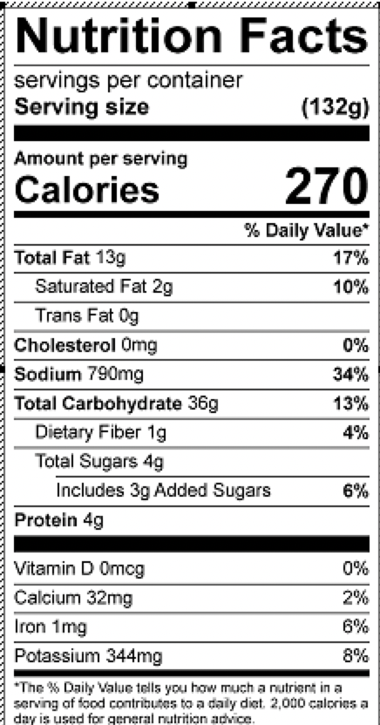
Vitamin C: 5.5mg

