Cajun Spiced Steak Fries with Bayou Sauce
Description: Crispy and thick wedge cut fries seasoned with spicy cajun seasoning and served with a creamy and tangy dip with some smoky heat.
Servings: 4
Preparation Time: 15 minutes
Cooking Time: 20 minutes
Total Time: 35 minutes
Potato Type: Russet Potatoes
Course: Appetizer, Snack, Side Dish

Ingredients
Cajun Steak Fries:
- 1-1/2 pounds (0.68kg) Russet Potatoes, washed, dried and cut into wedges
- 2 teaspoons (10ml) Olive Oil
- 1-1/2 tablespoons (12g) Cajun Seasoning
- 1 teaspoon (1g) Salt (optional)
- 2 tablespoons (7g) Green Onions, sliced
Bayou Sauce:
- 1/2 cup (120ml) Sour Cream
- ¼ cup (60ml) Mayonnaise
- 1 tablespoon (15ml) Hot Sauce
- 2 teaspoons (10g) Smoked Paprika
- 2 teaspoons (8g) Ranch Dressing Mix (Ranch Seasoning)
- ½ teaspoon (~1g) Cayenne Pepper
- ½ tablespoon (7ml) Lemon Juice

Preparation
- Slice the potatoes lengthwise into wedges, you should be able to get 8 to 12 wedges per potato depending on the size. Make sure the wedges aren’t too big to fit into your air fryer in an even layer.
- Place the potatoes in a medium sized bowl and drizzle them with the olive oil, stir to combine and then season liberally with the Cajun seasoning, then adjust with the salt (depending on the saltiness of your seasoning, you can omit the salt). Transfer the fries to the air fryer basket and cook them at 425 F for 25 minutes, you will want to open the air fryer about 15 minutes into the cook time and give the potatoes are flip to promote even browning. When the potatoes are done, they should be golden and crispy with a fluffy interior.
- While the potatoes are cooking, make the dipping sauce by combining the sour cream, mayo, hot sauce, smoked paprika, ranch powder, cayenne, and lemon juice. Mix thoroughly and keep cold until ready to serve.
- Arrange the crispy fries on a serving plate alongside the dipping sauce. Garnish with sliced green onions and enjoy.
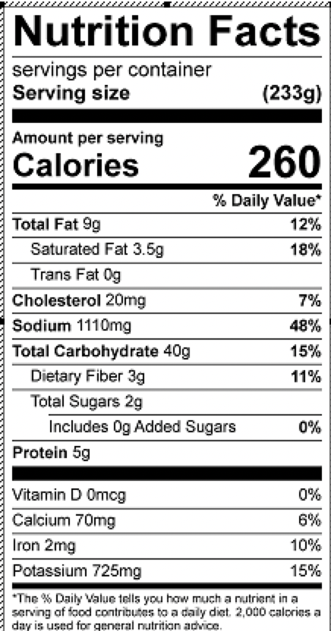
Vitamin C: 11.5mg

