Potato, Kale, and Chicken Chowder
Description: Rotisserie chicken breast, hearty red potatoes, baby kale, lemon, crushed red pepper, and rosemary are combined in a thick and creamy broth. Promised to keep you warm on a cold day.
Servings: 12
Preparation Time: 20 minutes
Cooking Time: 30 minutes
Total Time: 50 minutes
Potato Type: Red Potatoes
Course: Soup

Ingredients
Potato, Kale, and Chicken Chowder:
- 3 tablespoons (43g) Unsalted Butter
- ½ cup (75g) Yellow Onions, diced
- 2-1/2 tablespoons (20g) All Purpose Flour
- 2 quarts (1.89L) Chicken Stock
- 2 cups (300g) Red Potatoes, cut into ½ inch pieces
- 2 cups (270g) Rotisserie Chicken Breast, shredded
- 1 cup (240ml) Heavy Cream
- 1/ teaspoon (~1g) Crushed Red Pepper Flakes
- 2 cups (134g) Baby Kale
- 3 tablespoons (45ml) Lemon Juice
- 2 teaspoons (2g) Salt
- 2 teaspoons (2g) Freshly Ground Black Pepper
- 1 tablespoon (2g) Fresh Rosemary, chopped
Preparation
- In a heavy bottomed pot or Dutch oven, heat the butter over medium high heat. Add the onions and cook them until they are soft and translucent (about 2-3 minutes), stir them regularly and try to avoid color on the onions and reduce the heat as needed to prevent them from browning.
- When the onions are soft reduce the heat, add the flour and stir until the flour is all hydrated by the onions and butter. Continue to cook the flour in the onions and butter, stirring regularly for 1-2 minutes.
- Add the chicken stock a little at a time until all the stock has been added, its best to do with a whisk to ensure a smooth and creamy soup.
- Add the potatoes, and allow the soup to simmer, stirring occasionally for 18-20 minutes or until the potatoes are fork tender.
- Add the chicken and the cream and allow the soup to simmer for about 5 minutes. Remove the soup from the heat and stir in the red pepper flakes, kale, lemon juice, salt, pepper and rosemary.
- Serve the soup right away or transfer to a slow cooker and keep warm throughout the game. Note: this recipe can also be made in a slow cooker, simply follow the steps all the way through step 4, allow it to cook for 1-2 hours then continue with step 5.
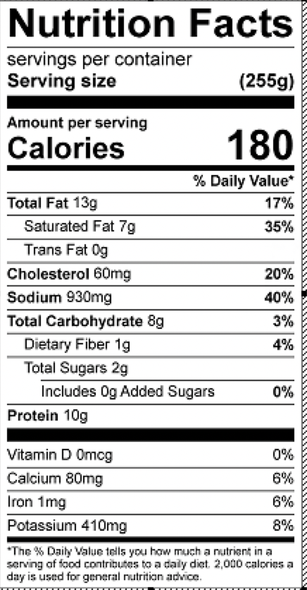
Vitamin C: 7.7mg

