Pot Roast and Mashed Potato Grinders
Description: Tender pot roast, fluffy mashed potatoes and pickled vegetables served in buttered Hawaiian rolls. Make a batch and serve at any get together.
Servings: 4
Preparation Time: 30 minutes
Cooking Time: 20 minutes
Total Time: 50 minutes
Potato Type: Instant Mashed Potatoes (Fresh or Refrigerated Mashed Potatoes can be subbed)
Course: Entrée/Sandwich

Ingredients
Buttermilk Whipped Potatoes:
- 1-1/3 cup (320ml) Water
- 1 teaspoon (~1g) Salt
- ¼ cup (56.5g) Unsalted Butter, softened
- ¾ cup (180ml) Whole Milk (Any milk can be subbed), cold
- 2-2/3 cup (135g) Instant Mashed Potatoes (Dehydrated Potato Flakes)
- 1/3 cup (80ml) Buttermilk
- ¼ cup (60g) Sour Cream
Sandwich Ingredients:
- 12 ounces (340g) Prepared Beef Pot Roast
- 1-1/2 cups (360ml) Prepared Brown Gravy, jarred
- ½ cup (128g) Giardiniera vegetables, jarred
- 3 tablespoons (37.5g) Unsalted Butter, softened
- 1x 12-ounce package (336g) Hawaiian Rolls
Preparation
- To prepare the mashed potatoes heat the water to a boil and add the salt and the butter. When the butter is melted add the cold milk and stir in the instant mashed potato flakes. Allow the mixture to sit for about a minute, then fluff with a fork. Gently fold in the buttermilk and the sour cream. Keep warm until ready to use.
- Gently heat the pot roast in the gravy over medium-low heat. Until the meat is tender, and the sauce is bubbling. Keep warm.
- To prepare the rolls slice them so three rolls are connected. Slice them down the tops of the rolls without slicing all the way through. Carefully spread the butter on the exposed sides of the connected rolls and toast them in a pan or on a griddle for about 1-2 minutes over medium-high heat. The rolls will get golden brown and crispy on the sides, be sure to griddle the bottom side of the bun, no need to butter the bottom but griddling the bottom makes the rolls sturdier.
- To Assemble the sandwiches, spoon some mashed potatoes into the toasted rolls. A quick tip is to transfer the potatoes to a resealable bag, or a pastry bag fitted with a star tip, this step isn’t necessary, but it will make them look pretty and a little neater. Spoon the pot roast and the gravy on top of the mashed potato buns, followed by some of the pickled vegetables.
- Serve right away and enjoy.
Pro tip: if tailgating bring the rolls toasted, the pot roast and mashed in a dual crockpot and the vegetables on ice. Assemble at the game or make a build your own sandwich station.
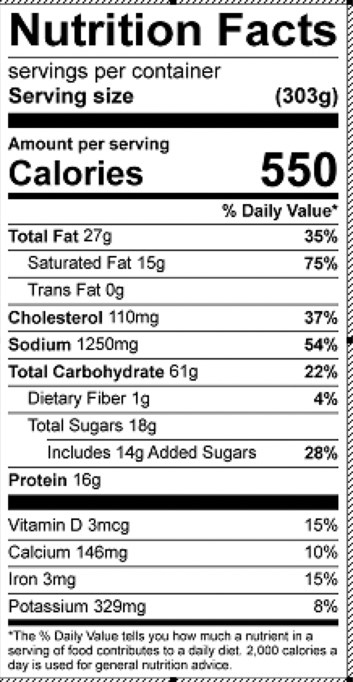
Vitamin C: 14.6mg

