Porky BBQ Kettle Chip Nachos
Description: Crispy and crunchy BBQ kettle chips topped with smoky pulled pork, melted queso, tomatoes, black olives and green onions. Easy and perfect for tailgating or watching the game at home.
Servings: 8
Preparation Time: 20 minutes
Cooking Time: 15 minutes
Total Time: 35 minutes
Potato Type: Potato Chips
Course: Appetizer/Snack

Ingredients
Porky BBQ Kettle Chip Nachos:
- 8.5 ounces (241g) BBQ Flavor Kettle Chips
- 1 cup (240ml) Prepared Queso Dip
- 1.5 pounds (0.68kg) Prepared Pulled Pork
- 1.5 cups (360ml) BBQ Sauce
- ¼ cup (60ml) Sour Cream
- ½ cup (75g) Tomatoes, diced
- ¼ cup (45g) Sliced Black Olives, canned
- ¼ cup (11g) Green Onions, sliced
- ¼ teaspoon (~1g) BBQ Spice Rub (Optional)
Preparation
- Preheat the oven to 350 F (177 C).
- Arrange the chips on a baking sheet, and bake the chips for about 3-5 minutes, this will crisp them up slightly and make them taste a little fresher, this step is optional but well worth it.
- Heat up the queso either in the microwave or on the stove top.
- Reheat the pork per the manufacturer’s instructions or make your own pulled pork. Once the pork is hot, add the BBQ sauce and stir gently to combine.
- To plate up, arrange a bed of the warm BBQ chips on a serving platter, top the chips with the melted queso, followed by the bbq pulled pork, the sour cream, the olives, tomatoes, and green onions. If using sprinkle a little bbq seasoning over the top to give the nachos an extra punch of flavor.
- Serve right away and enjoy.
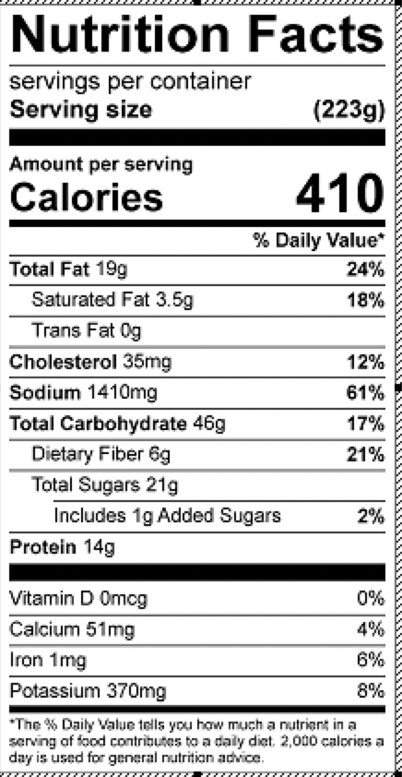
Vitamin C: 1.8mg

