Bread and Butter Pickle Potato Salad
Description: Super creamy potato salad, spiked with sweet bread and butter pickles, tangy red onions, and luscious yellow potatoes
Servings: 12
Preparation Time: 20 minutes
Cooking Time: 20 minutes
Total Time: 40 minutes
Potato Type: Yellow Potatoes
Course: Side Dish

Ingredients
Potato Salad:
- 2-1/4 pounds (1 kg) Yellow Potatoes, cut into 1-inch cubes
- As Needed Cold Water
- 2 tablespoons Salt
- 3 each (15g) Garlic Cloves, smashed
- ¼ cup Champagne Vinegar (Rice Vinegar can be subbed)
- 3/4 cup (180ml) Mayonnaise
- ¼ cup (60ml) Yellow Mustard
- ½ cup (120ml) Sour Cream
- 1/3 cup (47g) Bread and Butter Pickles, diced ¼ inch
- 1/3 cup (47g) Red Onions, diced ¼ inch, rinsed with cold water
- 2 tablespoons (3g) Fresh Dill, chopped
- 2 teaspoons (3g) Celery Seed
- ¼ cup (26g) Green Onions, sliced
- 2 teaspoons Salt
- 2 teaspoons Freshly Ground Black Pepper
Preparation
- In a large heavy bottomed pot, add the potatoes, enough cold water to just cover the potatoes by an inch, the salt, and garlic. Turn the heat onto high. When the water comes to a boil, reduce the heat to a simmer and cook the potatoes until they are a little more than fork tender but not falling apart (about 20-25 minutes). Drain the potatoes and spread them out evenly on a baking sheet to help them cool more rapidly. Sprinkle the potatoes with the vinegar while they are still slightly warm. While the potatoes cool, make the dressing.
- In a large bowl, combine the mayonnaise, yellow mustard, sour cream, diced pickles, onions, dill, celery seed, green onions, salt and black pepper. Combine the ingredients until they are well mixed and set aside.
- When the potatoes are fully cooled, add them to the bowl with the dressing and mix well to combine. The potato salad is ready to serve but is even better after 1 or 2 days in the fridge. Before serving garnish with green onions and a couple slices of bread and butter pickles so your guests have an idea of what is in it.
Pro Tip: It’s important to get in there and mash up some of the spuds which will result in a creamy potato texture in the sauce.
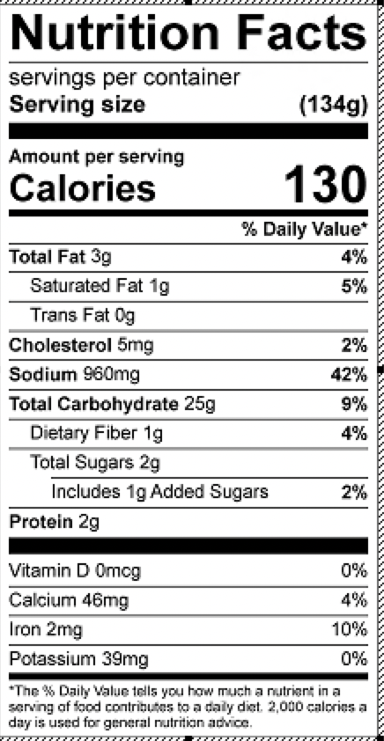
Vitamin C: 15.2mg

