Tuscan Chicken Gnocchi Casserole
Description: Smoky pieces of grilled chicken breast tossed in creamy alfredo sauce with roasted tomatoes, basil, and mozzarella cheese then topped with fluffy gnocchi and herbed breadcrumbs.
Servings: 8
Preparation Time: 35 minutes
Cooking Time: 20 minutes
Total Time: 55 minutes
Potato Type: Potato Gnocchi
Course: Entree

Ingredients
Grilled Chicken Alfredo Filling:
- 11 ounces (0.31kg) Frozen Grilled Chicken Breast (You can also grill and dice your own chicken at home)
- 24 fluid ounces (720ml) Prepared Alfredo Sauce
- ¼ cup (60ml) Whole Milk
- 2 tablespoons (2g) Fresh Basil, chopped
- 14.5 ounces (408g) Fire Roasted Tomatoes, canned, drained
- 1/3 cup (75g) Shredded Mozzarella Cheese
- ¼ cup (22.5g) Grated Parmesan Cheese
- teaspoon (1g) Freshly Ground Black Pepper
Gnocchi Topping:
- 1 pound (0.45kg) Prepared Potato Gnocchi (Found in the dry pasta aisle)
- 2 tablespoons (28g) Unsalted Butter, softened
- 1/4 cup (30g) Panko Breadcrumbs
- 1 teaspoon (1g) Granulated Garlic
- 2 tablespoons (7g) Freshly Parsley, chopped
Preparation
- Preheat the oven to 400 F (204 C)
- In a large bowl combine the chicken with the alfredo sauce, milk, basil, drained tomatoes, mozzarella, parmesan, and black pepper.
- Transfer the mixture to an oven safe casserole dish. Set aside while you prepare the gnocchi.
- Bring a pot of water to a boil, add in the gnocchi and boil for 5-7 minutes or until the gnocchi are tender. They should float when they are done. Strain the gnocchi and lightly toss in the softened butter.
- Arrange the gnocchi on top of the casserole.
- Combine the breadcrumbs, garlic, and parsley in a small bowl. Sprinkle the top of the casserole with the herb bread crumb mixture and sprinkle it evenly over the gnocchi.
- Bake the casserole at 375 F (190 C) for 25-30 minutes or until the top is golden brown and the casserole is bubbling.
- Remove from the oven and allow the casserole to rest for about 5-7 minutes before enjoying.
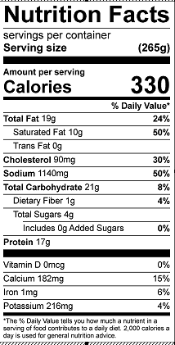
Vitamin C: 2.3mg

