Spuddy Joe Potato Casserole
Description: A zesty filling made with ground turkey, spices and tomatoes, topped with creamy mashed potatoes, cheese, and jalapenos then baked until bubbly.
Servings: 6
Preparation Time: 20 minutes
Cooking Time: 25 minutes
Total Time: 45minutes
Potato Type: Instant Mashed Potatoes (Dehydrated Potato Flakes)
Course: Entree

Ingredients
Buttermilk Mashed Potatoes:
Buttermilk Whipped Potatoes:
- 1-1/3 cup (320ml) Water
- 1 teaspoon (~1g) Salt
- ¼ cup (56.5g) Unsalted Butter, softened
- ¾ cup (180ml) Whole Milk (Any milk can be subbed), cold
- 2-2/3 cup (135g) Instant Mashed Potatoes (Dehydrated Potato Flakes)
- 1/3 cup (80ml) Buttermilk
- ¼ cup (60g) Sour Cream
Turkey Sloppy Joe Filling:
- 1 tablespoon (15ml) Vegetable Oil
- 1-1/2 pounds (0.68kg) Ground Turkey (85/15)
- ¾ cup (115g) Yellow Onion, diced
- ½ cup (75g) Green Bell Pepper, diced
- 1 cup (240ml) Diced Tomatoes, canned
- 3 each (15g) Garlic Cloves, chopped
- 1 teaspoon (~1g) Chili Powder
- 1 teaspoon (1g) Salt
- 1 teaspoon (1g) Black Pepper
- ½ cup (120ml) Ketchup
- 2 tablespoons (30ml) Yellow Mustard
- 1/3 cup (80ml) BBQ Sauce
- 3 tablespoons (45ml) Tomato Paste
- 1 tablespoon (2g) Brown Sugar
- 1 tablespoon (15ml) Apple Cider Vinegar
- 1 teaspoon (5ml) Worcestershire Sauce (Optional)
Garnishes:
- 1/3 cup Shredded Cheddar Cheese
- As Needed Sliced Jalapenos (optional)
Preparation
- Preheat the oven to 425 F (218 C).
- To prepare the mashed potatoes heat the water to a boil and add the salt and the butter. When the butter is melted add the cold milk and stir in the instant mashed potato flakes. Allow the mixture to sit for about a minute, then fluff with a fork. Gently fold in the buttermilk and the sour cream. Set the mashed potatoes aside until the filling is ready to be topped.
- To make the filling heat a large heavy bottomed skillet such as a well-seasoned cast iron skillet over medium high heat. Add the vegetable oil and then add the turkey. Stir the turkey with spoon to get it to break up and begin to brown. Once the turkey is nice and brown, add the onion and bell peppers. Cook the vegetables until they are soft and translucent, about 3-5 minutes. Add the tomatoes, garlic, chili powder, salt, pepper, ketchup, mustard, bbq sauce, tomato paste, brown sugar, vinegar, and Worcestershire if using. Allow the filling to come to a boil and reduce to a simmer. Simmer the filling for about 20 minutes. The consistency should be adjusted with about ½ cup of water at this stage. The filling should resemble pasta sauce, not too thick and not too loose.
- Now it’s time to top the filling with the mashed potatoes. Leave the filling right in the cast iron skillet and either pipe the mashed potatoes on top using a pastry bag or resealable storage bag with a star tip. Alternatively, you can simply spoon the potatoes on top too (it will still taste great).
- Bake the casserole in the oven for 10-12 minutes or until the cheese is melted and the potatoes are a little golden.
- Serve right away and enjoy!
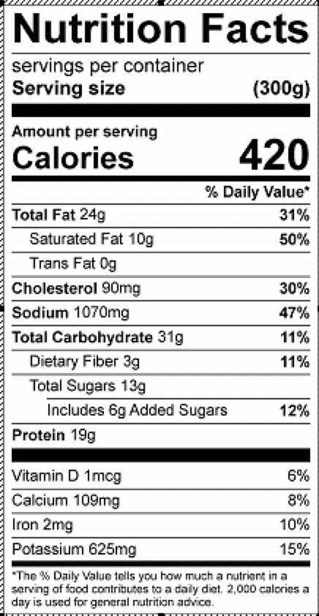
Vitamin C: 29mg

