Roasted Chicken and Mashed Potato Casserole
Description: Tender rotisserie chicken with the savory chicken gravy and creamy buttermilk mashed potatoes baked in the oven and served piping hot.
Servings: 8
Preparation Time: 15 minutes
Cooking Time: 20 minutes
Total Time: 35 minutes
Potato Type: Instant Mashed Potatoes
Course : Entree

Ingredients
Roasted Chicken Filling:
- 1-1/2 pound (0.68kg) Rotisserie Chicken Meat, pulled/shredded
- 18 fluid ounces (540ml) Prepared Homestyle Chicken Gravy
- ¼ cup (60ml) Heavy Cream
- 1 teaspoon (2g) Ground Black Pepper
Buttermilk Whipped Potatoes:
- 1-1/3 cup (320ml) Water
- 1 teaspoon (~1g) Salt
- ¼ cup (56.5g) Unsalted Butter, softened
- ¾ cup (180ml) Whole Milk (Any milk can be subbed), cold
- 2-2/3 cup (135g) Instant Mashed Potatoes (Dehydrated Potato Flakes)
- 1/3 cup (80ml) Buttermilk
- ¼ cup (60g) Sour Cream
Garnish:
- 2 teaspoons Parsley, chopped
Preparation
- Preheat the oven to 400 F (204 C)
- Remove the skin of the rotisserie chicken and pull the meat off the bones until all the meat has been removed. Set aside 1-1/2 pounds of meat, this should equal roughly one chicken, however they may vary in size.
- Heat two jars of prepared chicken gravy over medium heat until its hot. If needed add a little water to thin it out slightly. Add the pulled chicken meat to the hot gravy and stir in the cream to combine. Remove from the heat while you prepare the mashed potatoes.
- To prepare the mashed potatoes heat the water to a boil and add the salt and the butter. When the butter is melted add the cold milk and stir in the instant mashed potato flakes. Allow the mixture to sit for about a minute, then fluff with a fork. Gently fold in the buttermilk and the sour cream.
- Transfer the chicken and gravy mixture to an oven safe casserole dish. Spoon the mashed potatoes on top of the chicken and gravy mixture. If desired you can put the mashed potatoes into a pastry bag fitted with a star tip and decoratively pipe the potatoes on top of the casserole, either way is fine and equally as delicious.
- Bake the casserole for 15-18 minutes or until the casserole is bubbling and the potatoes are slightly golden on top.
- Allow the casserole to rest for about 5-7 minutes before serving, sprinkle the casserole with the chopped parsley and enjoy!
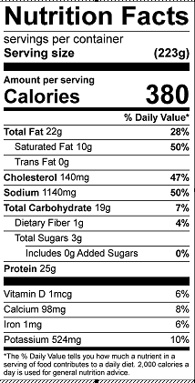
Vitamin C: 13.7mg

