Ham and Cheese Potato Soup
Description: Potatoes, ham, and cheddar cheese slow simmered in cream then finished with fresh chives.
Servings: 12
Preparation Time: 20 minutes
Cooking Time: 35 minutes
Total Time: 55 minutes
Potato Type: Yellow Potatoes (red or white potatoes could be subbed)
Course: Soup, Entree

Ingredients
Potato, Ham and Cheese Soup:
- 3 tablespoons (43g) Unsalted Butter
- ½ cup (75g) Yellow Onions, diced
- 2-1/2 tablespoons (20g) All Purpose Flour
- 2 quarts (1.89L) Vegetable Stock
- 2 cups (300g) Yellow Potatoes, cut into ½ inch pieces
- 1 cup (135g) Ham, diced ½ inch pieces
- 1 cup (240ml) Heavy Cream
- 1 cup (113g) Shredded Cheddar Cheese
- ½ cup (120ml) Sour Cream
- 2 teaspoons (2g) Salt
- 2 teaspoons (2g) Freshly Ground Black Pepper
- ¼ cup (12g) Fresh Chives, chopped
Preparation
- In a heavy bottomed pot or Dutch oven, heat the butter over medium high heat. Add the onions and cook them until they are soft and translucent (about 2-3 minutes), stir them regularly and try to avoid color on the onions and reduce the heat as needed to prevent them from browning.
- When the onions are soft reduce the heat, add the flour and stir until the flour is all hydrated by the onions and butter. Continue to cook the flour in the onions and butter, stirring regularly for 1-2 minutes.
- Add the vegetable stock a little at a time until all the stock has been added, its best to do with a whisk to ensure a smooth and creamy soup.
- Add the potatoes, and allow the soup to simmer, stirring occasionally for 18-20 minutes or until the potatoes are fork tender.
- Add the ham and the cream and allow the soup to simmer for about 5 minutes. Remove the soup from the heat and stir in the cheese, sour cream, salt, pepper, and chives (Feel free to reserve some cheese and chives for garnishing if you’d like).
- Serve the soup right away or transfer to a slow cooker and keep warm throughout the game. Note: this recipe can also be made in a slow cooker, simply follow the steps all the way through step 4, allow it to cook for 1-2 hours then continue with step 5.
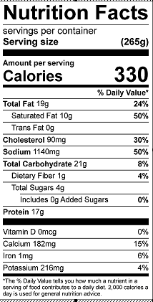
Vitamin C: 2.3mg

