Beef and Broccoli Baked Potatoes
Description: Tender beef stir fry with broccoli, ginger, carrots, garlic, and soy sauce stuffed into a fluffy baked potato.
Servings: 4
Preparation Time: 30 minutes
Cooking Time: 45 minutes
Total Time: 75 minutes
Potato Type: Russet Potato
Course: russets

Ingredients
Baked Potatoes:
- 4 each Russet Potatoes (5.3 ounces each or 150g)
- 1 tablespoon (15ml) Vegetable Oil
- 2 teaspoons (2g) Kosher Salt
Beef and Broccoli Stir Fry:
- 2 tablespoons (18g) Cornstarch
- 2 tablespoons (30ml) Cold Water
- ½ teaspoon (~1g) Garlic Powder
- 1 pound (0.45kg) Sirloin, cut into strips about ¼ inch thick
- 2 tablespoons (30ml) Vegetable Oil
- 4 cups (600g) Broccoli Florets, fresh
- ½ cup (75g) Carrots, cut into half-moons about ¼ inch thick
- 1/3 cup (80ml) Reduced Sodium Soy Sauce
- 2 tablespoons (25g) Brown Sugar
- 1 teaspoon (6g) Ground Ginger
Cornstarch Slurry
- 1 tablespoon (9g) Cornstarch
- ½ cup (120ml) Beef Stock (Beef Broth)
Garnishes:
- 1 tablespoon (13g) Sesame Seeds (optional)
Preparation
- Preheat the oven to 400 F (204 C).
- To prepare the baked potatoes, pierce the potatoes with the tines of a fork or the tip of a knife. Place the potatoes into the oven directly on the oven rack. After about 40 minutes of cooking, remove the potatoes and brush them evenly with the vegetable oil. Sprinkle them with the kosher salt and return them to the oven for about 5 minutes. This will crisp the skin. The best way to check the potatoes for doneness is with an internal thermometer. The temp should read 205 F (96 C) remove the potatoes from the oven and keep warm.
- To prepare the stir fry, combine the cornstarch with the water and garlic powder in a medium bowl. Add the beef sirloin and toss to combine, allow the meat to sit for about 10 minutes. The beef stir fry can be made while the potatoes bake in the oven.
- In a large skillet over medium-high heat, heat the vegetable oil and begin to sear the beef. Stir the beef often but not so often that it doesn’t brown. Cook the beef until the desired doneness is achieved. Remove the beef and keep it warm. Add the broccoli and the carrots to the pan and cook for 3-5 minutes or until the broccoli is tender but still green.
- Add the cooked beef to the pan with the broccoli and carrots. In a container combine the soy sauce, brown sugar, ginger, and cornstarch slurry to the pan. To make the cornstarch slurry combine the beef stock with the cornstarch and whisk to combine. Once the sauce thickens in the pan, turn off the heat and get ready to serve.
- To serve the baked potatoes, cut down the center of each potato lengthwise, press the potato on both ends to “fluff” the potato. Once the potato is open, you can spoon some of the beef and broccoli stir fry into each potato. Sprinkle with sesame seeds if desired and serve right away.
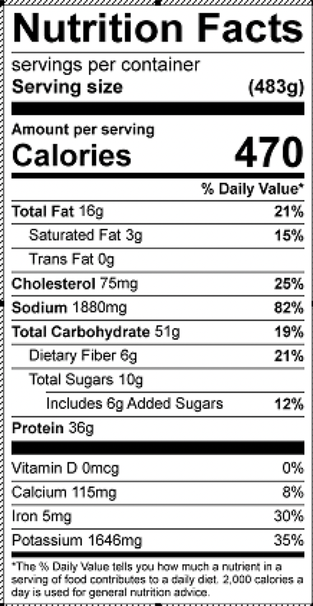

Vitamin C: 150mg

