Fall Harvest Fruit and Nut Salad with Crispy Tater Drums and Spicy Maple Dressing
Description: Mixed greens, topped with tart apples, pecans, sunflower seeds, roasted brussels sprouts and crispy tater drums. Served with a chili-maple vinaigrette.
Servings: 4
Preparation Time: 15 minutes
Cooking Time: 30 minutes
Total Time: 45 minutes
Potato Type: Frozen Tater Drums
Course : Salad

Ingredients
Roasted Brussel Sprouts:
- 1 pound (0.45kg) Brussels Sprouts, quartered
- 1 tablespoon (15ml) Olive Oil
- 1 teaspoon (2g) Salt
- ½ teaspoon (1g) Fresh Ground Black Pepper
Crispy Tater Drums:
- ½ pound (0.22kg) Frozen Tater Drums
- ½ teaspoon (1g) Salt
Chili Maple Vinaigrette:
- 1/3 cup (80ml) Red Wine Vinegar
- 1 teaspoon (1g) Dijon Mustard
- ¼ cup (32g) Maple Syrup
- 1 tablespoon (4g) Smoked Paprika
- ½ teaspoon (~1g) Salt
- ¼ teaspoon (~1g) Cayenne Pepper
- ½ cup (120ml) Vegetable Oil (the oil can be adjusted depending on how sharp or mild you like your dressing)
Salad:
- 6 cups (180g) Mixed Greens, washed and dried
- 1 cup (140g) Green Apples, peeled and cut into thin strips
- ¼ cup (32g) Chopped Pecans
- ¼ cup (32g) Sunflower Seeds
- 1/3 cup (80ml) Prepared Chili Maple Vinaigrette (recipe above)
Preparation
- Preheat the oven to 400 F (204 C)
- To roast the brussels sprouts, cut them into quarters and drizzle with olive oil and toss. Season the brussels sprouts with the salt and toss again to combine. Place them on a baking sheet lined with aluminum foil. Roast the sprouts for 15-20 minutes or until they are slightly brown and crispy, yet still appear bright green. Allow them to cool spread out in a thin layer on a cool baking sheet.
- To bake the tater drums place them on a baking sheet and bake for 20-25 minutes or until golden and crispy. Remove from the oven and season with salt.
- To make the dressing, combine the red wine vinegar with the Dijon and maple syrup. Stir in the paprika, salt and cayenne. While whisking slowly drizzle the oil into the maple mixture. When all the oil has been incorporated into the dressing, set it aside. The dressing can be made up to 4 days in advance.
- To assemble the salad, place 1-1/2 cups of mixed greens down on each serving plate. Top with 4 ounces (120g) Roasted brussels sprouts followed by ¼ cup (30g) thinly sliced apples, 1 tablespoon (15g) of chopped pecans, 1 tablespoon (15g) sunflower seeds, and ½ cup (35g) of crispy tater drums. Drizzle 1-1/2 tablespoons (20ml) of the dressing over each salad and enjoy.
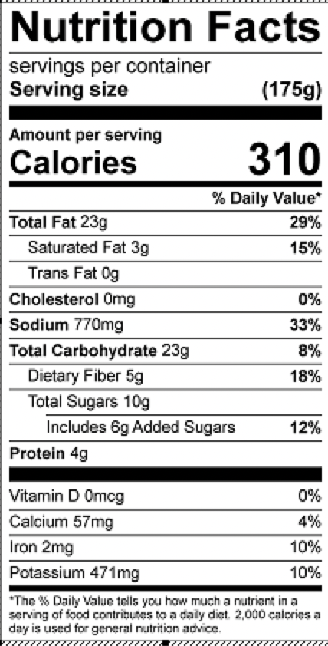
Vitamin C: 51mg

