Chicken and Potato Fall Harvest Salad
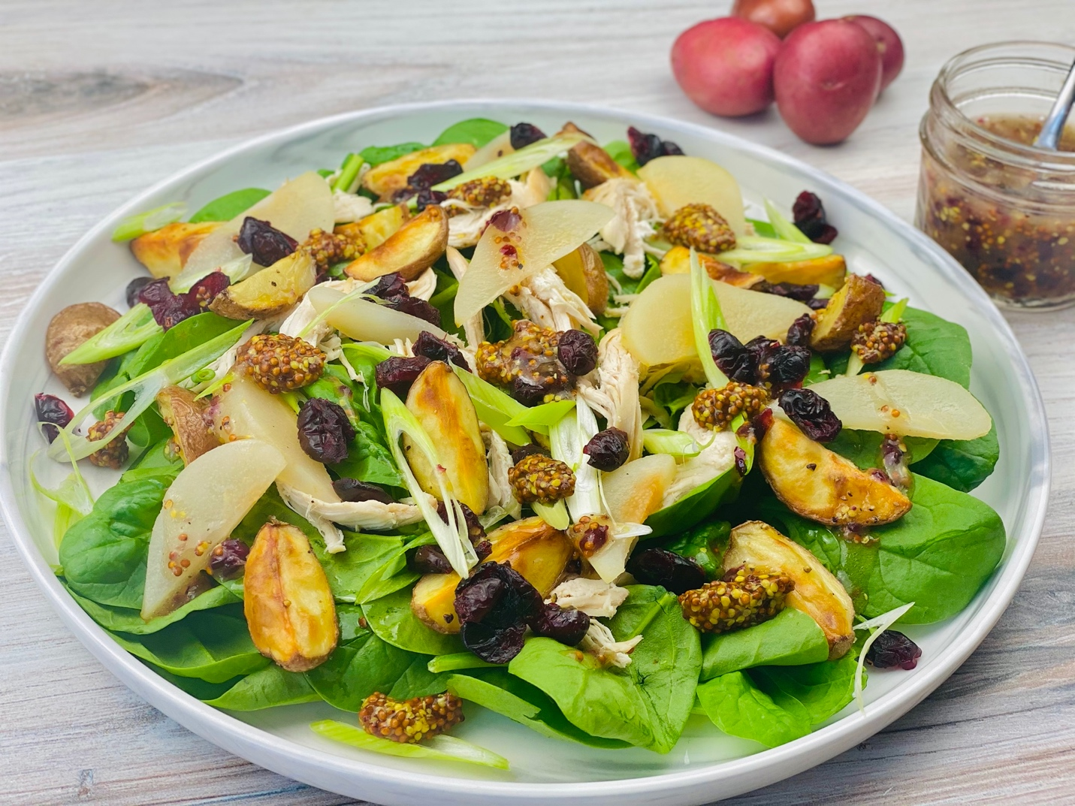
Description: Tender chicken breast, crispy roasted red potatoes, fresh pears, and green onions on a bed of tender baby spinach, served with a fruity cranberry-mustard dressing.
Servings: 4
Preparation Time: 15 minutes
Cooking Time: 30 minutes
Total Time: 45 minutes
Potato Type: Red Potatoes
Course: Salad

Ingredients
Roasted Red Potatoes:
- 1 pound (0.45kg) Baby Red Potatoes, quartered (Regular red potatoes can be subbed)
- 1 tablespoon (15ml) Olive Oil
- 1 teaspoon (2g) Salt
Cranberry Mustard Dressing:
- 1/3 cup (80ml) Red Wine Vinegar
- ¼ cup (32g) Dried Cranberries, finely chopped
- 1 teaspoon (5g) Honey
- ½ teaspoon (~1g) Salt
- 3 tablespoons (45g) Whole Grain Mustard Seeds
- ¼ teaspoon (1ml) Pure Vanilla Extract
- ½ cup (120ml) Vegetable Oil (the oil can be adjusted depending on how sharp or mild you like your dressing)
Salad:
- 6 cups (180g) Baby Spinach, washed and dried
- 1 pound (0.45kg) Rotisserie Chicken Breast, pulled and shredded
- 1 cup (140g) Fresh Pears, peeled and sliced thin
- ½ cup (65g) Dried Cranberries
- ½ cup (50g) Green Onions, sliced
- 1/3 cup (80ml) Prepared Cranberry-Mustard Dressing (recipe above)
Preparation
- Preheat the oven to 400 F (204 C)
- To roast the potatoes, cut the potatoes and drizzle with olive oil and toss. Season the potatoes with the salt and toss again to combine. Place the potatoes on a baking sheet lined with aluminum foil. Roast the potatoes for 25-30 minutes or until they are golden and crispy. Allow the potatoes to cool until ready to use.
- To make the dressing, combine the red wine vinegar with the honey and allow the mixture to hydrate for about 5 minutes. Mix in the salt, mustard seeds and the vanilla. While whisking slowly drizzle the oil into the cranberry mixture. When all the oil has been incorporated into the dressing set it aside. The dressing can be made up to 4 days in advance.
- To assemble the salad, place 1-1/2 cups of baby spinach down on each serving plate. Top the spinach with 4 ounces (120g) Roasted Chicken Breast, followed by ½ cup (120g) roasted potatoes, ¼ cup (35g) of sliced pears, 2 tablespoons (16g) of dried cranberries, and 2 tablespoons (12g) of green onions. Drizzle 1-1/2 tablespoons (20ml) of the dressing over each salad and enjoy.
Variation:
When you have extra roasted turkey on hand, try substituting it in place of the roasted chicken.
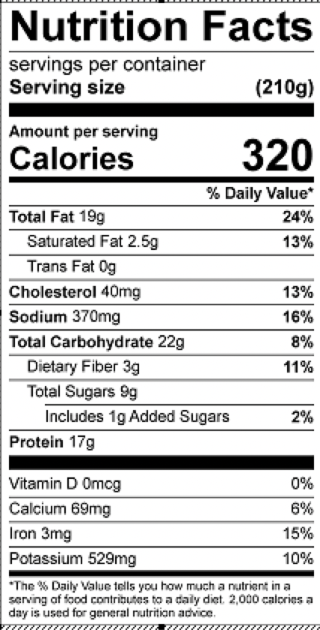
Vitamin C: 18.4mg
Vitamin B6: .6mg

